Odsek Visoka ICT škola,  
Akademija tehničko-umetničkih strukovnih studija,  
Beograd

Furnishop

Smer: Internet tehnologije

Modul: Web programiranje

Predmet: Web programiranje PHP 2

Mihailo Ilić 41/19

Sadržaj

1. Uvod 3

1.1 Korišćeni programski jezici/tehnologije 3

1.2 Opis funkcionalnosti 3

1.2 Template 5

2. Organizacija 5

2.1 Šema baze podataka 6

2.2 Struktura projekta 7

2.2.1 app 7

2.2.2 database 8

2.2.3 public 9

2.2.4 resources 10

2.2.5 Ostatak projekta 11

2.3 Slike stranica i opisi funkcionalnosti 12

2.3.1 Home 12

2.3.2 Shop 13

2.3.3 Product 14

2.3.4 Lookbook 15

2.3.5 Sign In 16

2.3.6 Registration 16

2.3.7 Contact 17

2.3.8 About Author 17

2.3.9 cart.php 18

2.3.10 Admin panel - Dashboard 19

2.3.11 Admin panel Logs 19

2.3.12 Admin panel Users 20

2.3.13 Admin panel Lookbook 21

2.3.14 Admin panel – Products 22

2.3.15 Admin panel - Subcategories 23

2.3.16 Admin panel – Collections & Colors 23

3. Kodovi 24

3.1 app/Exceptions 24

3.1.1 Handler.php 24

3.2 app/Http/Controllers 25

3.2.1 AdminCollectionColorController.php 25

3.2.2 AdminController.php 29

3.2.3 AdminDashboardController.php 30

3.2.4 AdminLookbookController.php 31

3.2.5 AdminProductController.php 36

3.2.6 AdminSubcategoryController.php 44

3.2.7 AdminUserController.php 49

3.2.8 BaseController.php 53

3.2.9 CartController.php 54

3.2.10 ContactController.php 57

3.2.11 Controller.php 59

3.2.12 ErrorController.php 59

3.2.13 HomeController.php 59

3.2.14 LogController.php 61

3.2.15 LoginController.php 62

3.2.16 LookbookController.php 63

3.2.17 ProductController.php 64

3.2.18 RegisterController.php 68

3.3 app/Http/Middleware 69

3.3.1 IsAdmin.php 69

3.3.2 IsGuest.php 70

3.3.3 IsUser.php 71

3.3.4 UserLinks.php 71

3.4 app/Http/Requests 73

3.4.1 AdminCreateCollectionCategoryRequest.php 73

3.4.2 AdminCreateLookbookIdeaRequest.php 74

3.4.3 AdminCreatePorductRequest.php 74

3.4.4 AdminCreateSubcateogryRequest.php 75

3.4.5 AdminEditFeaturedCateogry.php 76

3.4.6 AdminEditLookbookIdeaRequest.php 77

3.4.7 AdminEditProductRequest.php 78

3.4.8 AdminEditUserRequest.php 79

3.4.9 LoginRequest.php 80

3.4.10. RegisterRequest.php 81

3.4.11. SendMessageRequest.php 82

3.5 app/Http/Mail 83

3.5.1 ContactForm.php 83

3.6 app/Http/Models 84

3.6.1 Cart 84

3.6.2 Category 84

3.6.3 CategoryProduct 85

3.6.4 Collection 85

3.6.5 Color 86

3.6.6 ColorProduct 86

3.6.7 Image 86

3.6.8 Log 87

3.6.9 LogCategory 87

3.6.10 Lookbook 88

3.6.11 LookbookItem 88

3.6.12 Menu 89

3.6.13 Product 89

3.6.14 Productimage 90

3.6.15 Role 90

3.6.16 SliderImage 91

3.6.17 User 91

3.7 App/Http/View/Components/Product.php 92

3.8 public/js 92

3.8.1 custom.js 92

3.8.2 cart.js 96

3.8.3 product.js 98

3.8.4 shop.js 100

3.9 public/admin-assets/js 105

3.9.1 product.js 105

3.9.2 lookbook.js 109

3.10 resources/views/components/product 112

3.11 resources/views/errors/error 112

3.12 resources/views/main/contact-form 113

3.13 views/resources/admin/layout 114

3.14 views/resources/admin/fixed 115

3.14.1 footer 115

3.14.2 head 115

3.14.3 nav 116

3.14.4 scripts 116

3.14.5 sidebar 117

3.15 views/resources/admin/pages 117

3.15.1 dashboard 117

3.15.2 log 119

3.16 views/resources/admin/pages/collections_colors 121

3.16.1 collections_colors 121

3.16.2 collectoins_colors_create 123

3.17 views/resources/admin/pages/lookbook 125

3.17.1 lookbook 125

3.17.2 lookbook_create_idea 128

3.17.3 lookbook_edit_idea 130

3.18 views/resources/admin/pages/products 133

3.18.1 product_create 133

3.18.2 product_edit 136

3.18.3 products 140

3.19 views/resources/admin/pages/subcategories 144

3.19.1 subcategories 144

3.19.2 subcategory_create 147

3.20 views/resources/admin/pages/users 149

3.20.1 user_edit 149

3.20.2 users 150

3.21 views/resources/front/layout 153

3.22 views/resources/front/fixed 154

3.22.1 floating 154

3.22.2 footer 157

3.22.3 head 160

3.22.4 header 161

3.22.5 ie 164

3.22.6 scripts 164

3.23 views/resources/front/pages 164

3.23.1 author 164

3.23.2 contact 166

3.23.3 home 168

3.24 views/resources/front/pages/auth 175

3.24.1 login 175

3.24.2 register 176

3.25 views/resources/front/pages/products 178

3.25.1 lookbook 178

3.25.2 product 181

3.25.3 shop 185

3.26 views/resources/front/pages/user/cart 190

3.27 routes/web.php 193

# 1. Uvod

## 1.1 Korišćeni programski jezici/tehnologije

Za potrebe sajta korišćene su sledeće tehnologije:

* HTML, CSS
* Bootstrap
* JavaScript + jQuery
* PHP, Laravel 8
* Apache + MySQL
* PhpStorm

## 1.2 Opis funkcionalnosti

Domen koji aplikacija pokušava da reši je **onlajn prodavnica nameštaja**. Korisnici mogu da pretražuju i razgledaju proizvode i dodaju ih u korpu. Takođe, mogu da pristupe odeljku sa pripremljenim idejama za uređenje doma gde su označeni svi proizvode koji mogu da se kupe. Administratori su posebni korisnici koji imaju pristup admin panelu, odnosno kompletan pristup unosu, izmeni, brisanju korisnika, proizvoda, potkategorija itd.

Funkcionalnosti sajta se mogu svrstati u sledeće kategorije:

* Organizacija i struktura projekta u skladu sa MVC arhitekturom, koristi se front layout za glavni deo sajta, a potpuno drugi layout za admin panel
* **Galerija proizvoda sa dinamičkom stranicom o pojedinačnom proizvodu**, a sadržaj se preuzima iz baze
* **Filtriranje, pretraga, sortiranje i straničenje proizvoda u galeriji proizvoda**, sve se obavlja jednim upitom na osnovu izabranih kriterijuma bez osvežavanja stranice
* **Korpa** koja je povezana sa korisničkim nalogom, sa ukupnom sumom i opcijama za brisanje i izmenu količine
* **Lookbook (odeljak sa idejama za uređenje)** – za svaku ideju korisniku su označeni proizvodi koje je moguće kupiti i linkovi ka istim
* **Registracija i logovanje od strane korisnika**, sve se proverava regularnim izrazima, a sve stranice za korisnike/administratore su zaštićene od neautorizovanih posetilaca
* **Kontakt forma** – prosleđivanje poruka na definisanu imejl adresu web aplikacije
* **Administratorske funkcionalnosti**, obuhvataju stranice gde administratori mogu dodavati i brisati proizvode, potkategorije itd., a takođe imaju uvid i opcije vezane za korisničke naloge i logove
* **Zapisivanje ključnih događaja** poput grešaka u aplikaciji, logovanja i registracije korisnika, kao i dodavanja proizvoda u korpu
* **Forme za dodavanje i izmenjivanje proizvoda i ostalih resursa**, uključujući i uploadovanje više slika, a unos se proverava i na klijentu i na serveru regularnim izrazima

## 1.2 Template

Za izradu front dela sajta je korišćen templejt koji se može videti na linku:

[Furnitica - Minimalist Furniture HTML Template Preview - ThemeForest](http://preview.themeforest.net/item/furnitica-minimalist-furniture-html-template/full_screen_preview/22646068)

Za izradu admin panela korišćen je templejt koji se može videti na linku:

[Light Bootstrap Dashboard: Free Bootstrap 4 Admin Template @ Creative Tim (creative-tim.com)](https://www.creative-tim.com/product/light-bootstrap-dashboard)

# 2. Organizacija

## 2.1 Šema baze podataka

## 2.2 Struktura projekta

### 2.2.1 app

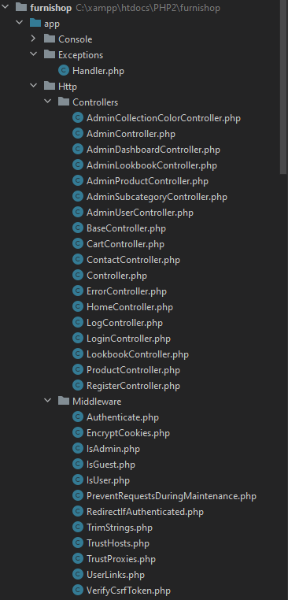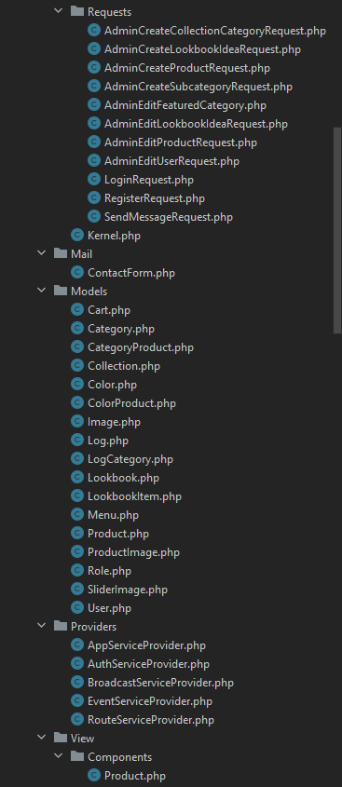

### 2.2.2 database

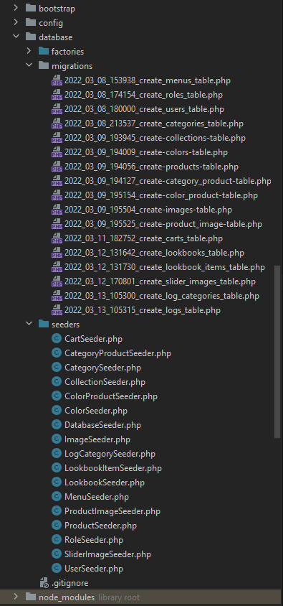

### 2.2.3 public

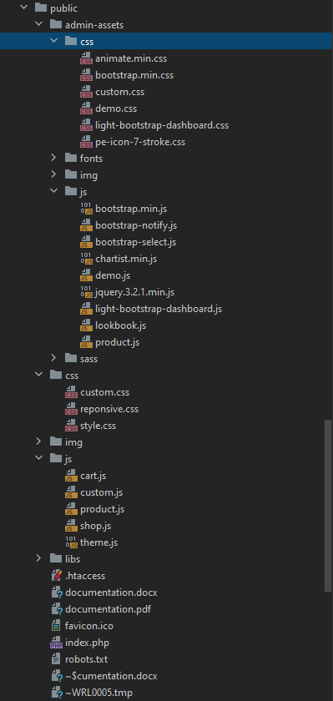

### 2.2.4 resources

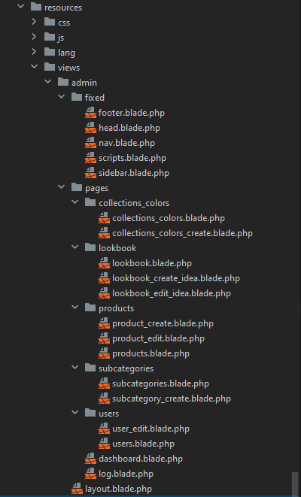

### 2.2.5 Ostatak projekta

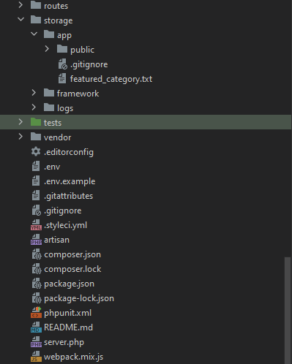

## 2.3 Slike stranica i opisi funkcionalnosti

### 2.3.1 Home

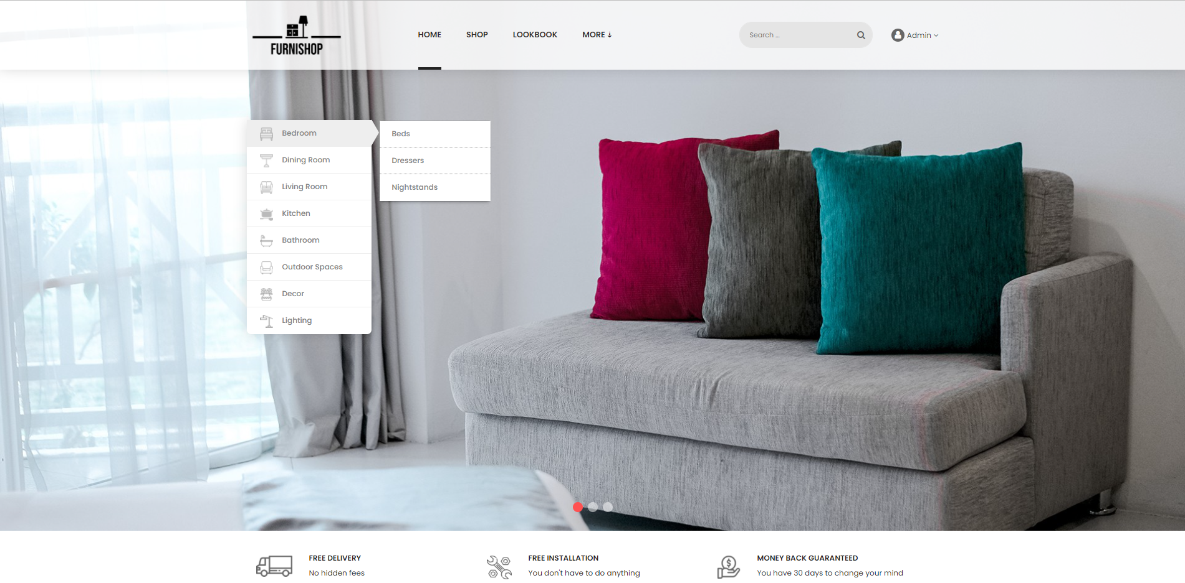

Na ovoj stranici se nalazi slajder, za koji su slajdovi dinamički učitani iz baze. Takođe, ovde se nalaze linkovi ka kategorijama i potkategorijama.

Navigacija se učitanava iz baze, a tu su i korisnički linkovi u zavisnosti od toga da li je korisnik administrator, korisnik ili samo posetilac. Za sve stranice namenjene koristnicima ili administratoru vrši se provera u middlewareu i vrši se redirekcija za neautorizovan pristup.

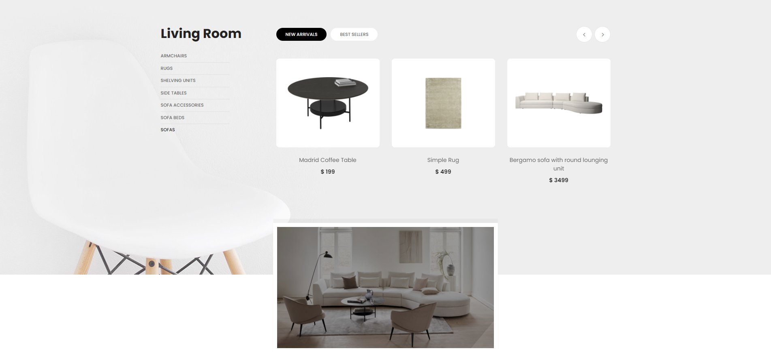

Administrator može izabrati glavnu kategoriju koja će se nalaziti na početnoj stranici, zajedno sa proizvodima i lookbook linkovima, ukoliko ih ima.

### 2.3.2 Shop

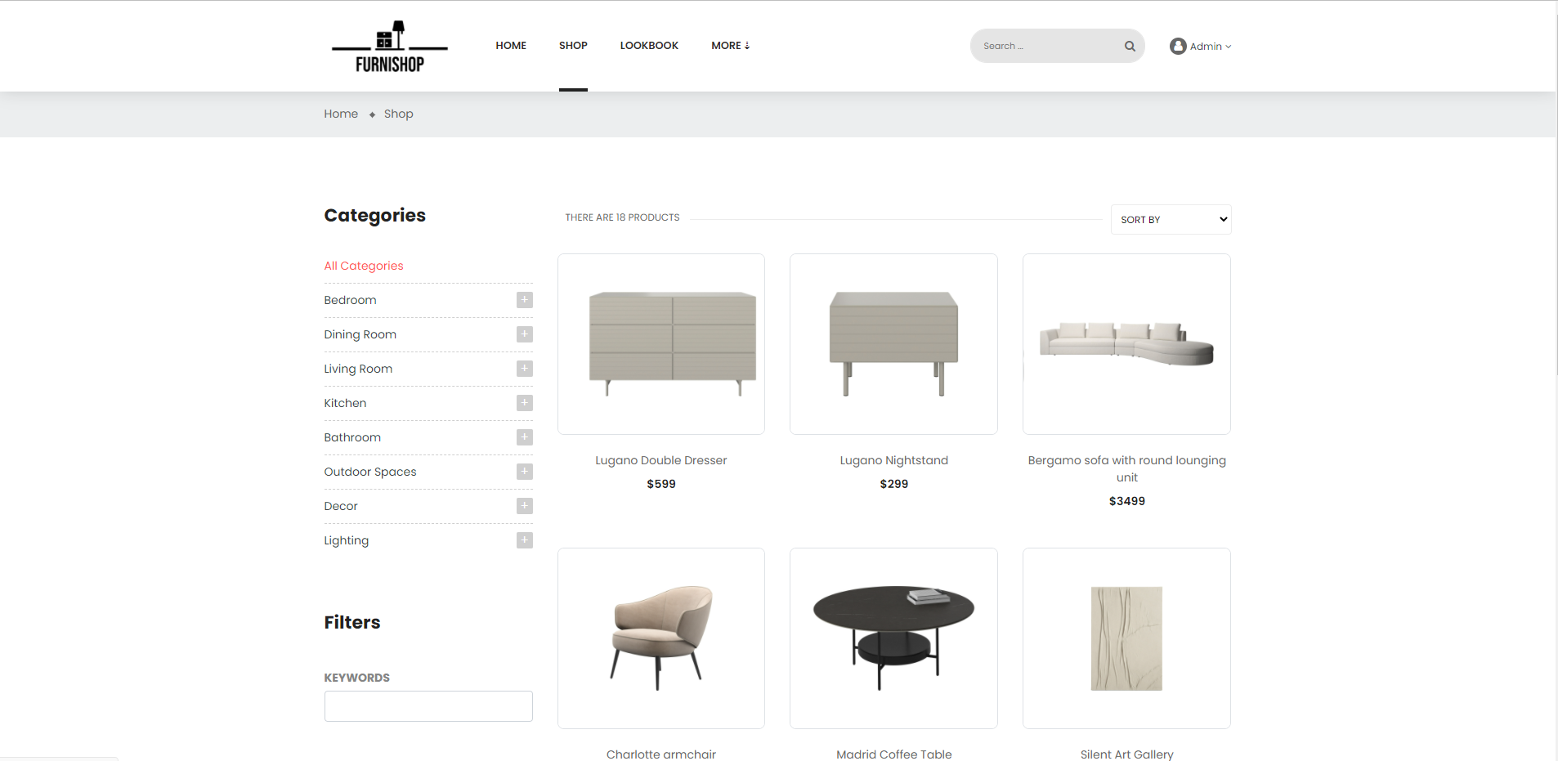

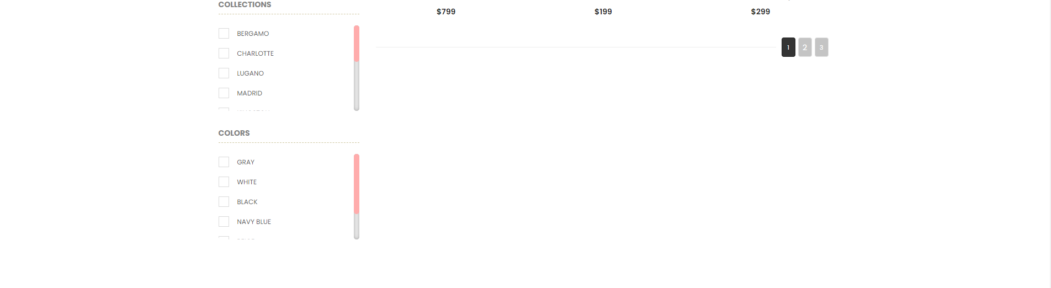

Na ovoj stranici se mogu videti svi proizvodi. Sve kategorije, kolekcije, boje i sami proizvodi se čitaju iz baze. Ovo se realizuje preko AJAX-a.

Moguće je filtriranje po kategorijama, kolekcijama i bojama. Tu je i mogućnost sortiranja, pretrage, kao i straničenje.

Za sve ove kriterijume serveru se šalje ajax zahtev i tako dobijaju svi željeni podaci, a lista se osvežava prilikom svake interakcije korisnika sa ovim poljima.

Klikom na drugu kategoriju URL adresa se dinamički pomoću JS prepravlja u onu u skladu sa izabranom kategorijom ali se stranica ne osvežava.

Klikom na proizvod odlazi se na stranicu za više informacija o tom proizvodu.

### 2.3.3 Product

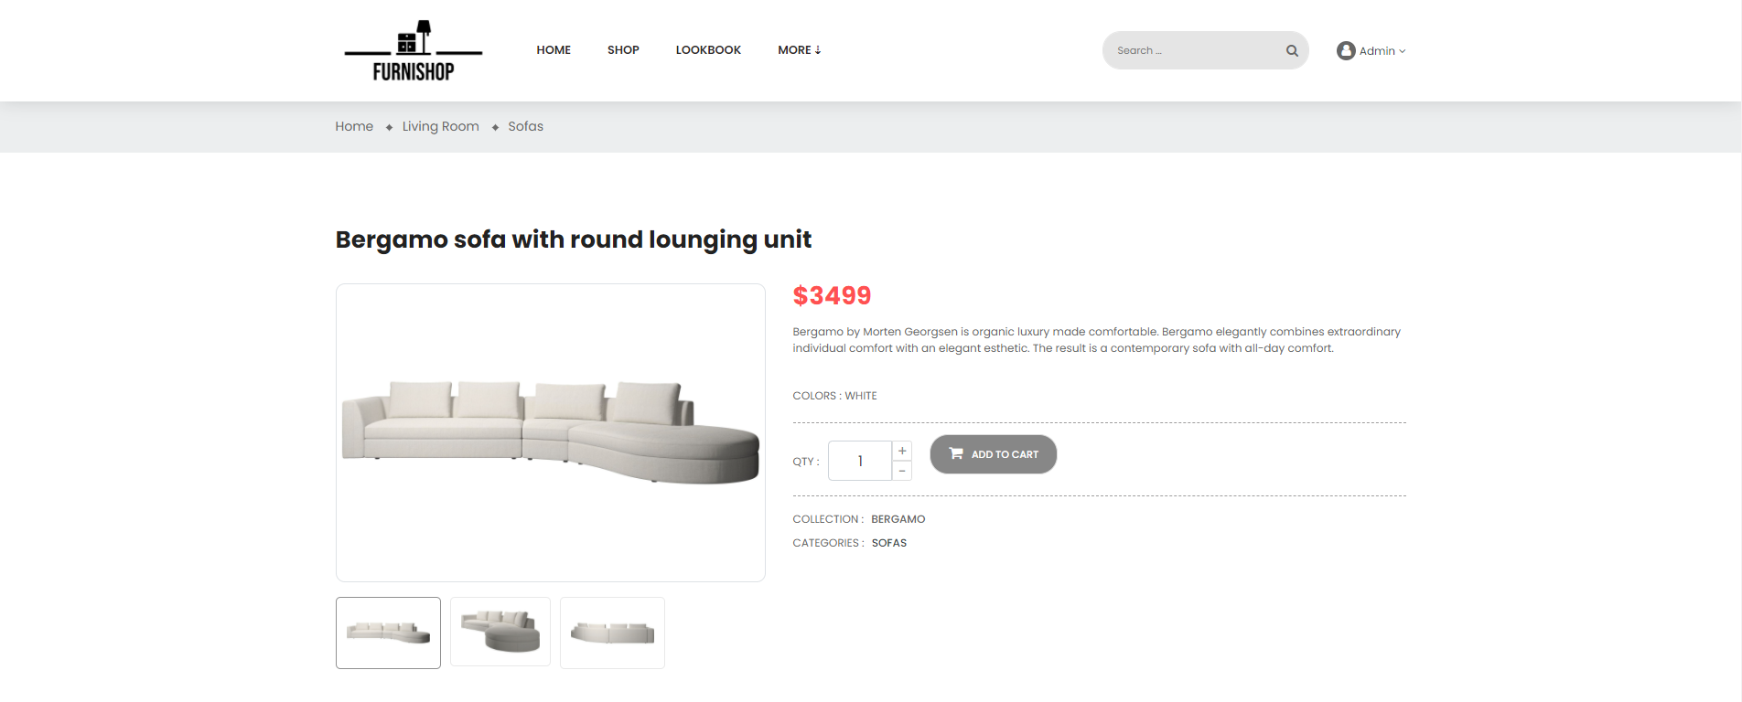

Ova stranica se dinamički popunjava u zavisnosti od toga koji je proizvod izabran.

Postoji i opcija za dodavanje u korpu zajedno sa količinom, a ako korisnik nije ulogovan onda će klikom na taster doći do redirekcije ka stranici za logovanje.

### 2.3.4 Lookbook

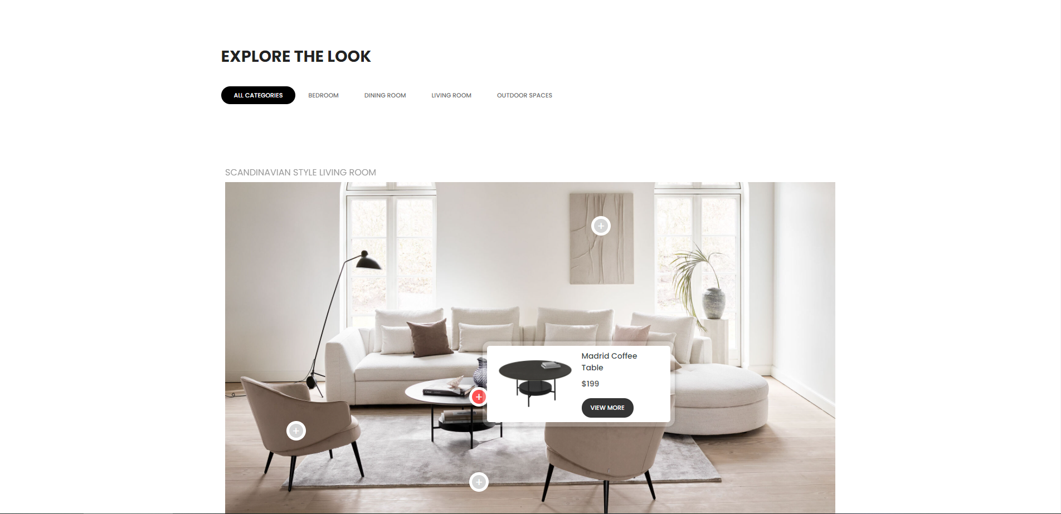

Na ovoj stranici korisniku se prikazuju ideje u uređenju doma, zajedno sa pinovima. Prelaskom miša preko obeleženg mesta prikazuje se proizvod koji se može kupiti.

Moguće je filtrirati ideje po kategoriji.

### 2.3.5 Sign In

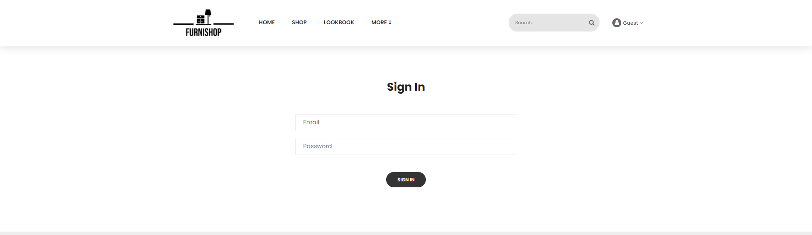

Na ovoj stranici posetioci se mogu ulogovati, a kredencijali se proveravaju i na klijentu i na serveru.

### 2.3.6 Registration

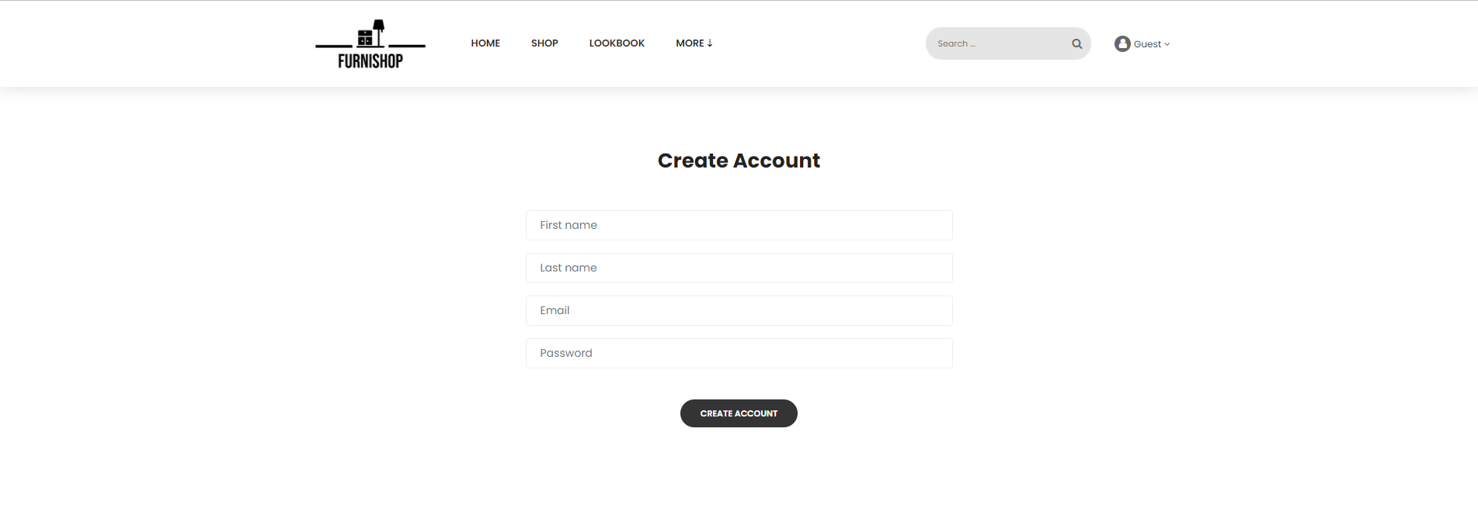

Ovde se vrši registracija novih korisnika, sva polja se proveravaju na oba kraja (na serverskoj strani postoji klasa za custom request). Takođe ne mogu se registrovati dva naloga sa istom imejl adresom, a krajnji korisnik će biti obavešten o ishodu registracije.

### 2.3.7 Contact

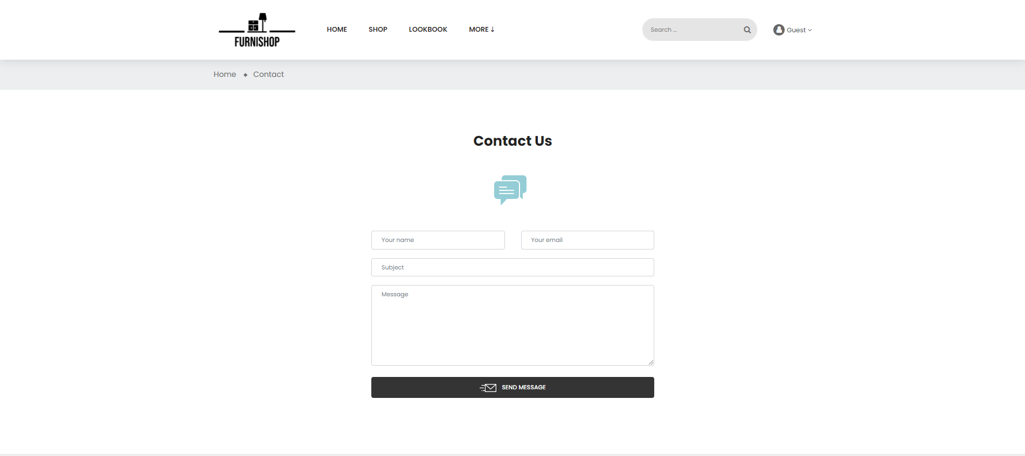

Na ovoj stranici moguće je kontaktirati administratore. Sva polja se prvo proveravaju i na klijentskoj i na serverskoj strani. Poruka se šalje mejlom na predefinisanu imejl adresu web aplikacije. Korišćen je Google smtp server.

### 2.3.8 About Author

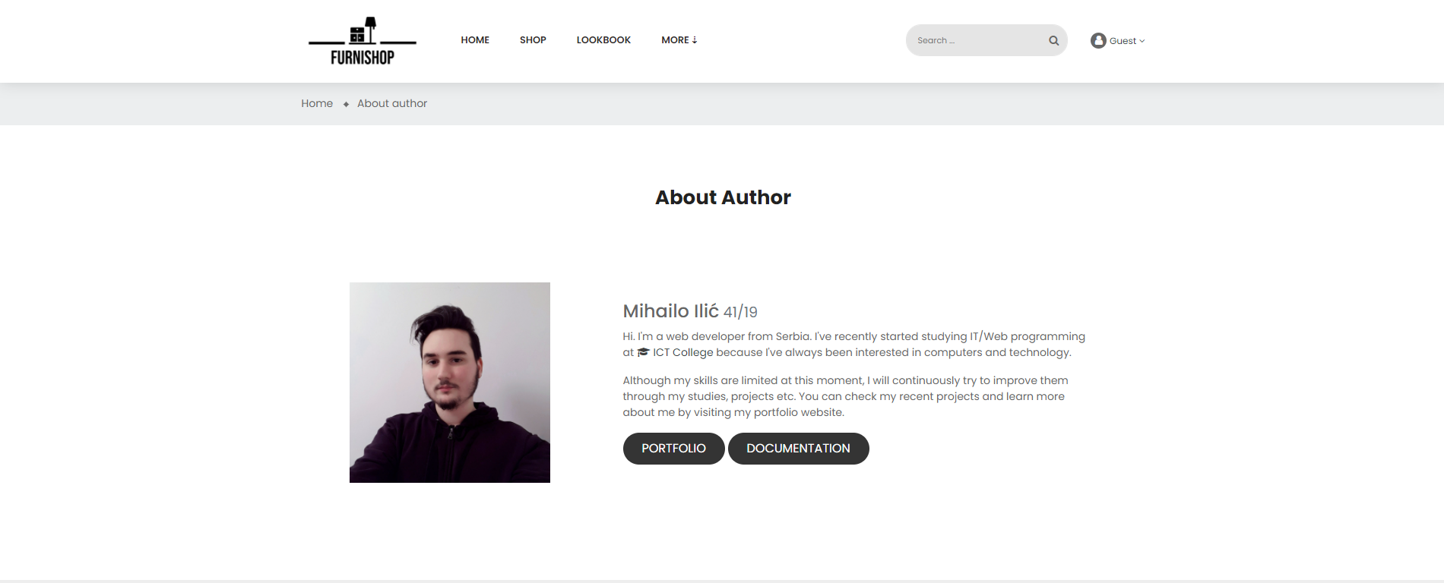

### 2.3.9 cart.php

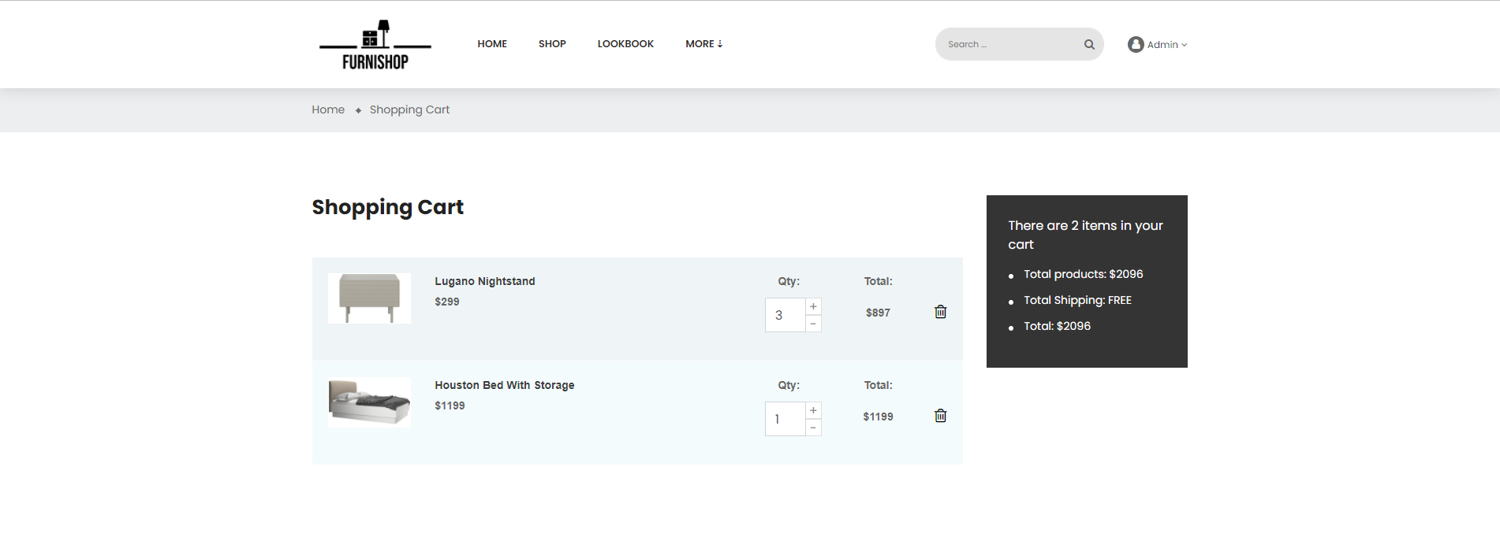

Na ovoj stranici se vidi sadržaj korpe korisnika (ako nema proizvoda u korpi onda se izdaje takva poruka).

Ukupna vrednost se izračunava u JS-u i prikazuje. Preko AJAX-a se realizuje brisanje ili izmena količine.

### 2.3.10 Admin panel - Dashboard

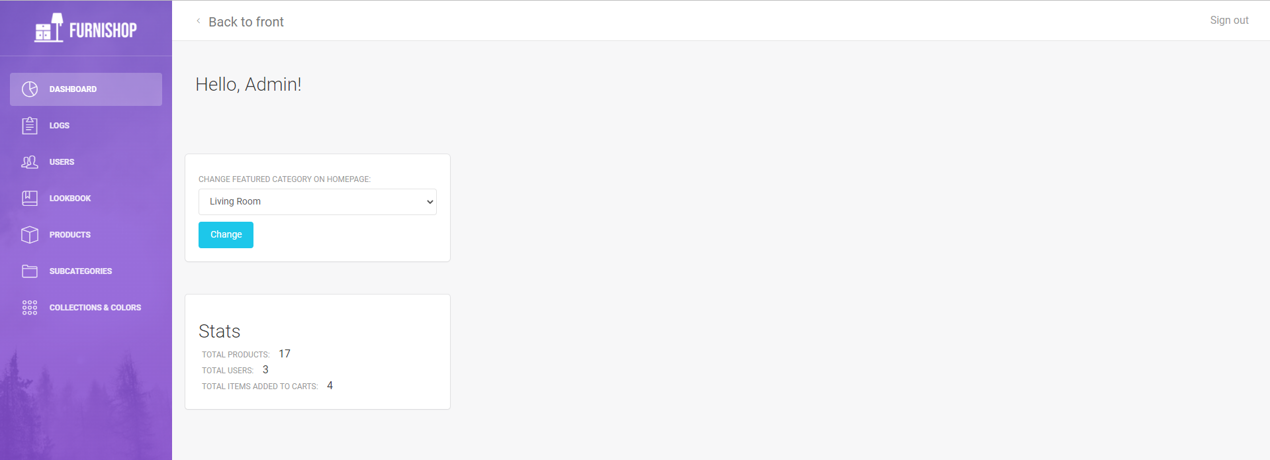

Ova stranica, kao i sve naredne, namenjena je administratoru. Svaki neautorizovani pristup preko URL adrese sprečava se redirekcijom ka stranici index.php.

### 2.3.11 Admin panel Logs

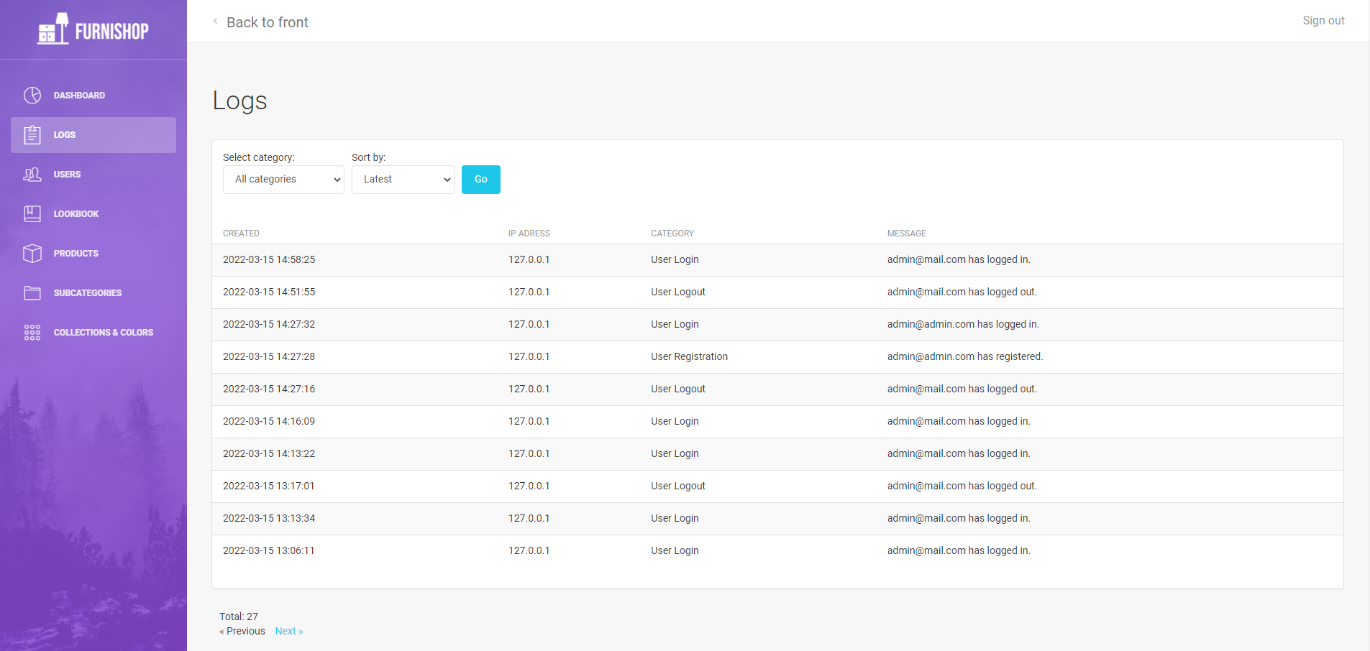

### 2.3.12 Admin panel Users

Ovde se mogu videti korisnici, a moguće je i brisanje i izmena.

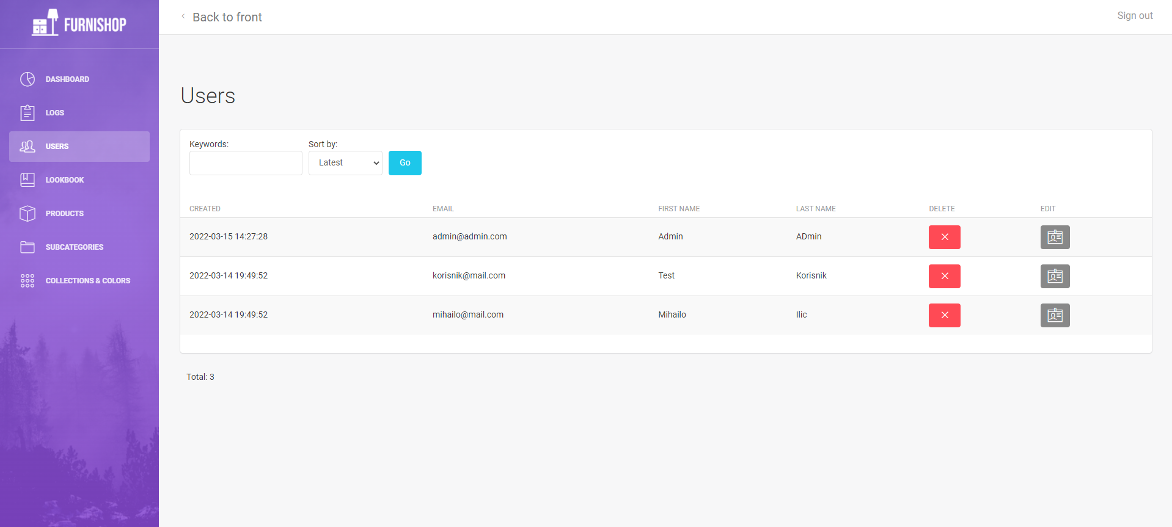

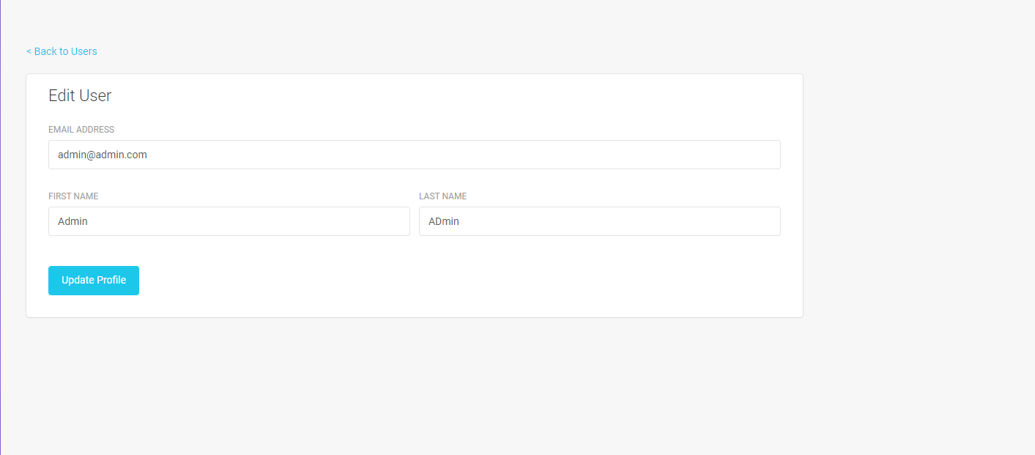

### 2.3.13 Admin panel Lookbook

Ovde se mogu dodavati i brisati nove ideje, a moguća je i izmena pinova.

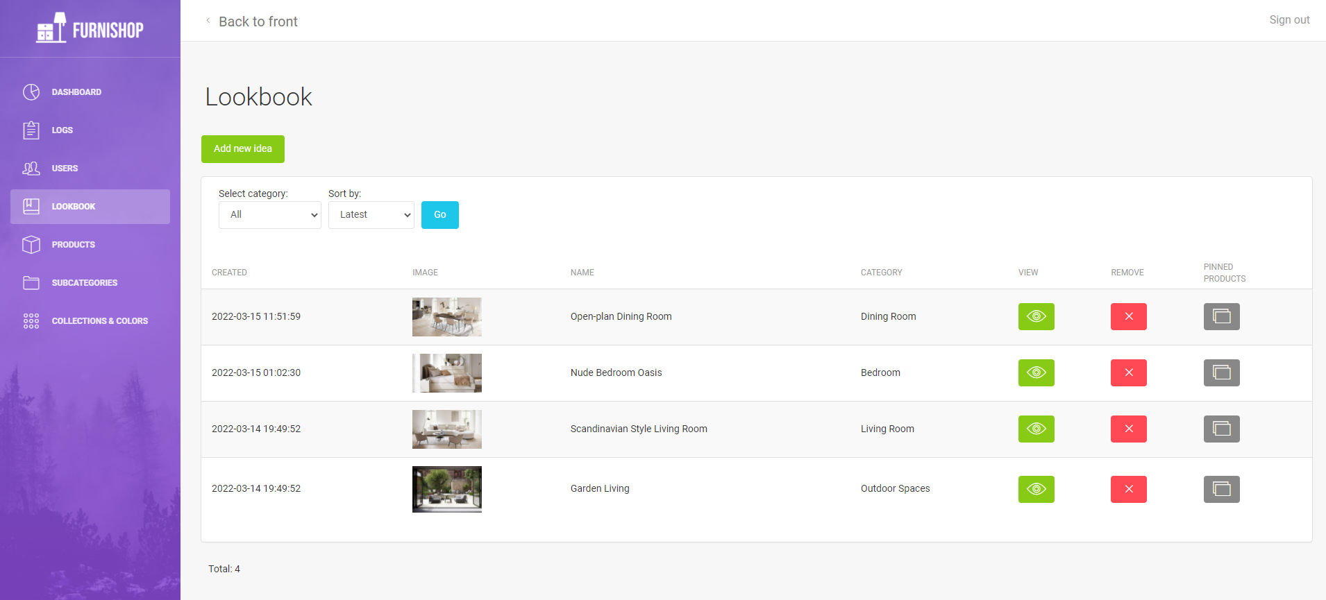

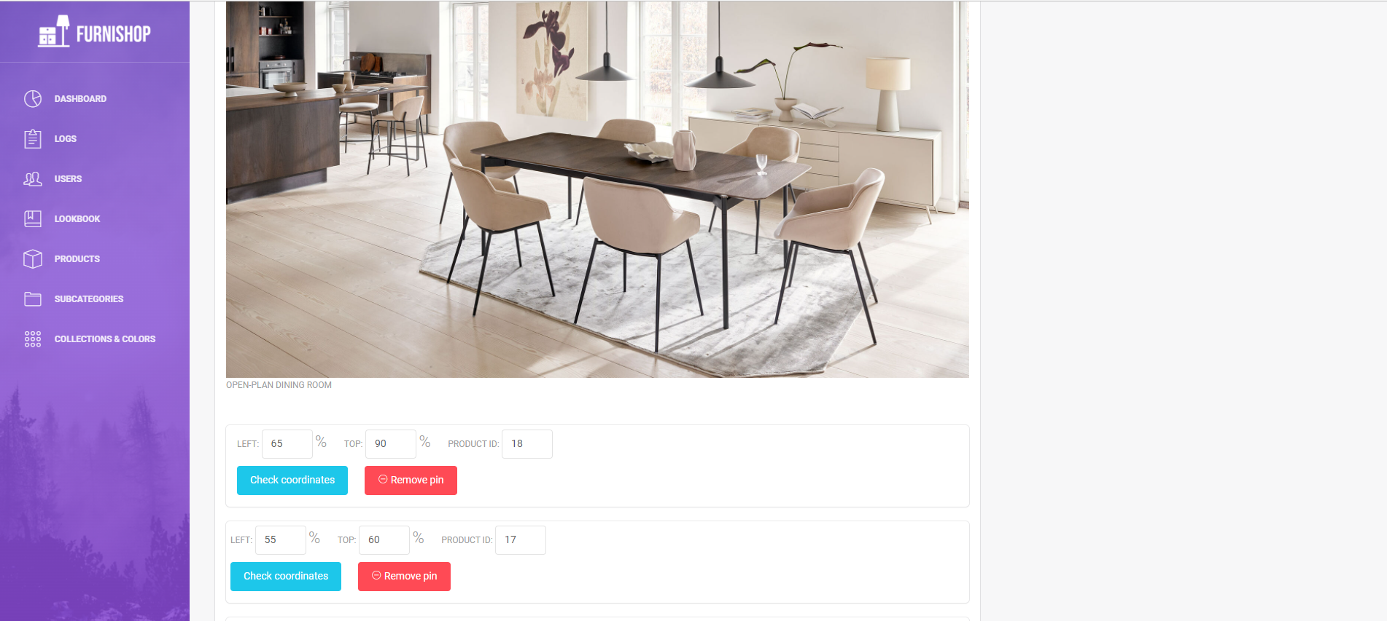

### 2.3.14 Admin panel – Products

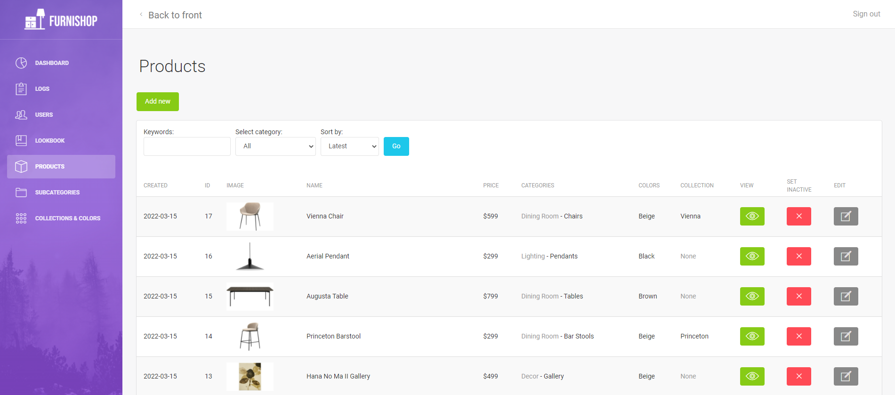

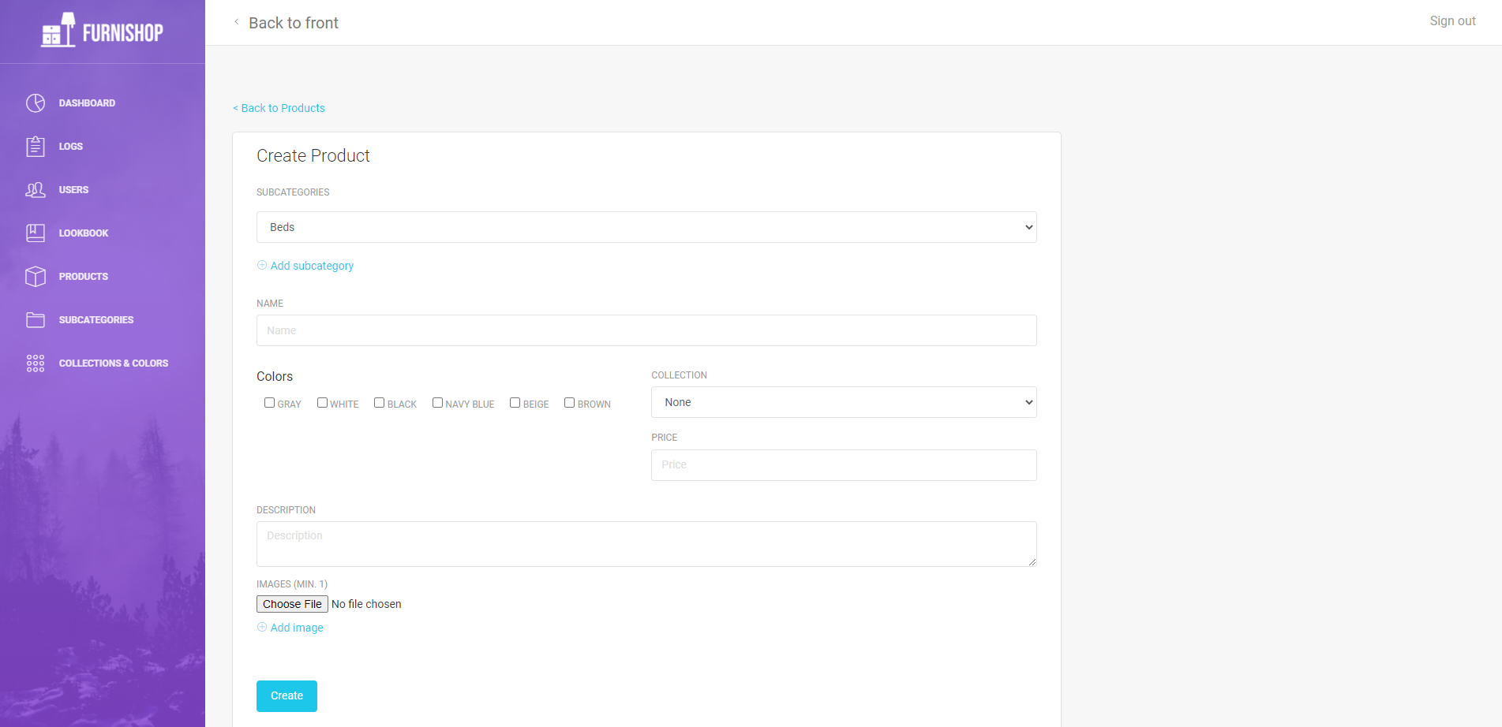

Ovde se mogu dodavati i izmenjivati proizvodi.

### 2.3.15 Admin panel - Subcategories

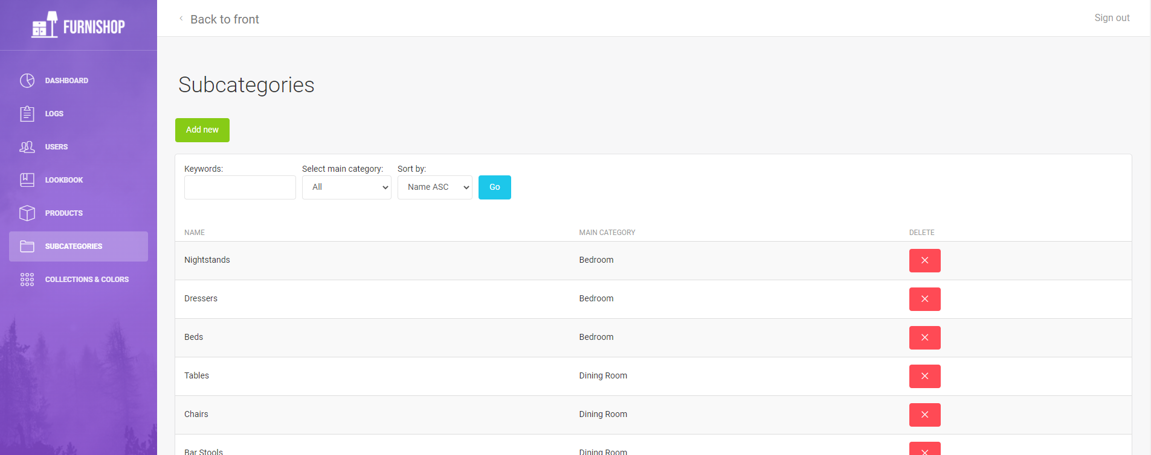

### 2.3.16 Admin panel – Collections & Colors

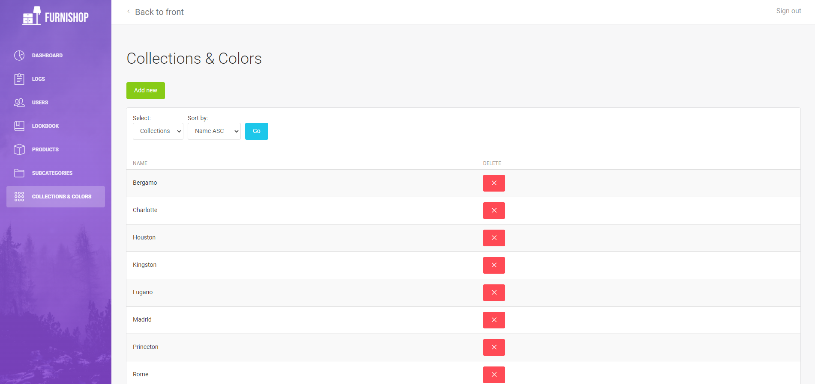

# 3. Kodovi

## 3.1 app/Exceptions

### 3.1.1 Handler.php

<?php  
  
namespace App\Exceptions;  
  
use App\Http\Controllers\ErrorController;  
use Illuminate\Foundation\Exceptions\Handler as ExceptionHandler;  
use Throwable;  
  
class Handler extends ExceptionHandler  
{  
 /**  
 * A list of the exception types that are not reported.  
 *  
 * @var array<int, class-string<Throwable>>  
 */  
 protected $dontReport = [  
 //  
 ];  
  
 /**  
 * A list of the inputs that are never flashed for validation exceptions.  
 *  
 * @var array<int, string>  
 */  
 protected $dontFlash = [  
 'current_password',  
 'password',  
 'password_confirmation',  
 ];  
  
 /**  
 * Register the exception handling callbacks for the application.  
 *  
 * @return void  
 */  
 public function register()  
 {  
 $this->reportable(function (Throwable $e) {  
 //  
 });  
 }  
  
  
 public function render($request, \Throwable $exception)  
 {  
 if ($this->isHttpException($exception)) {  
 if ($exception->getStatusCode() == 404) {  
 return redirect()->route("error", ["code"=>404]);  
 }  
 }  
 return parent::render($request, $exception);  
 }  
  
  
}

## 3.2 app/Http/Controllers

### 3.2.1 AdminCollectionColorController.php

<?php  
  
namespace App\Http\Controllers;  
  
use App\Http\Requests\AdminCreateCollectionCategoryRequest;  
use App\Models\Collection;  
use App\Models\Color;  
use App\Models\Log;  
use App\Models\Product;  
use Illuminate\Http\Request;  
  
class AdminCollectionColorController extends AdminController  
{  
 /**  
 * Display a listing of the resource.  
 *  
 * @return \Illuminate\Http\Response  
 */  
 public function index(Request $request)  
 {  
 $show = $request->show ?? "collection";  
  
 $items = null;  
 if($show == "collection"){  
 $items = Collection::query();  
 }  
 else {  
 $items = Color::query();  
 }  
  
 $column = "name";  
 $order = "asc";  
  
 $sort = request("sort");  
 if($sort){  
 $column = explode("-", $sort)[0];  
 $order = explode("-", $sort)[1];  
 }  
  
 $items = $items->orderBy($column, $order);  
  
 $this->data["items"] = $items->paginate(10);  
 $this->data["show"] = $show;  
  
  
 return view("admin.pages.collections_colors.collections_colors", $this->data);  
 }  
  
 /**  
 * Show the form for creating a new resource.  
 *  
 * @return \Illuminate\Http\Response  
 */  
 public function create()  
 {  
 return view("admin.pages.collections_colors.collections_colors_create", $this->data);  
 }  
  
 /**  
 * Store a newly created resource in storage.  
 *  
 * @param \Illuminate\Http\Request $request  
 * @return \Illuminate\Http\Response  
 */  
 public function store(AdminCreateCollectionCategoryRequest $request)  
 {  
 $table = $request->table;  
 $name = $request->name;  
  
 $msg = "Item created successfully";  
 $class = "info";  
  
 try {  
  
 if($table == "collections") {  
 Collection::create(["name"=>$name]);  
 }  
 else {  
 Color::create(["name"=>$name]);  
 }  
  
 }  
 catch(\Throwable $ex){  
  
 Log::create(["ip"=>request()->ip(), "log_category_id"=>5, "message"=>$ex->getMessage()]);  
  
 $msg = "Internal error";  
 $class = "danger";  
 }  
  
  
 return redirect()->route("admin_collection_color.index")->with([  
 "message" => $msg,  
 "class" => "$class"  
 ]);  
  
  
 }  
  
 /**  
 * Display the specified resource.  
 *  
 * @param int $id  
 * @return \Illuminate\Http\Response  
 */  
 public function show($id)  
 {  
 //  
 }  
  
 /**  
 * Show the form for editing the specified resource.  
 *  
 * @param int $id  
 * @return \Illuminate\Http\Response  
 */  
 public function edit($id)  
 {  
 //  
 }  
  
 /**  
 * Update the specified resource in storage.  
 *  
 * @param \Illuminate\Http\Request $request  
 * @param int $id  
 * @return \Illuminate\Http\Response  
 */  
 public function update(Request $request, $id)  
 {  
 //  
 }  
  
 /**  
 * Remove the specified resource from storage.  
 *  
 * @param int $id  
 * @return \Illuminate\Http\Response  
 */  
 public function destroy($id)  
 {  
 $table = request("table");  
 if(!$table){  
 return redirect()->route("admin_collection_color.index")->with([  
 "message" => "Bad parameters",  
 "class" => "danger"  
 ]);  
 }  
  
 $msg = "The item has been successfully removed";  
 $class = "info";  
  
 try {  
 if($table == "collection"){  
  
 $item = Collection::find($id);  
 }  
 else {  
 $item = Color::find($id);  
 }  
  
 if(!$item){  
 $msg = "Item not found";  
 $class = "danger";  
 }  
 else {  
  
 $existingProducts = Product::whereHas($table, function($q) use ($item ,$table){  
 $q->where(trim($table, "s")."_id", $item->id);  
 })->count();  
  
 if($existingProducts) {  
  
 $msg = "There are products assigned to this item";  
 $class = "danger";  
 }  
 else {  
 $item->delete();  
 }  
  
 }  
  
 }  
 catch(\Throwable $ex){  
  
 Log::create(["ip"=>request()->ip(), "log_category_id"=>5, "message"=>$ex->getMessage()]);  
  
 $msg = "Internal error";  
 $class = "danger";  
 }  
  
  
 return redirect()->route("admin_collection_color.index")->with([  
 "message" => $msg,  
 "class" => "$class"  
 ]);  
 }  
}

### 3.2.2 AdminController.php

<?php  
  
namespace App\Http\Controllers;  
  
use Illuminate\Http\Request;  
  
class AdminController extends Controller  
{  
 public $data = [];  
  
 public function __construct(){  
 $this->data["menu"] = [  
 [  
 "icon" => "pe-7s-graph",  
 "name"=>"Dashboard",  
 "route"=>"admin"  
 ],  
 [  
 "icon" => "pe-7s-note2",  
 "name"=>"Logs",  
 "route"=>"admin.log"  
 ],  
 [  
 "icon" => "pe-7s-users",  
 "name"=>"Users",  
 "route"=>"admin_user.index"  
 ],  
 [  
 "icon" => "pe-7s-notebook",  
 "name"=>"Lookbook",  
 "route"=>"admin_lookbook.index"  
 ],  
 [  
 "icon" => "pe-7s-box2",  
 "name"=>"Products",  
 "route"=>"admin_product.index"  
 ],  
 [  
 "icon" => "pe-7s-folder",  
 "name"=>"Subcategories",  
 "route"=>"admin_subcategory.index"  
 ],  
 [  
 "icon" => "pe-7s-keypad",  
 "name"=>"Collections & Colors",  
 "route"=>"admin_collection_color.index"  
 ],  
  
 ];  
 }  
  
}

### 3.2.3 AdminDashboardController.php

<?php  
  
namespace App\Http\Controllers;  
  
use App\Http\Requests\AdminEditFeaturedCategory;  
use App\Models\Cart;  
use App\Models\Category;  
use App\Models\Product;  
use App\Models\User;  
use Illuminate\Http\Request;  
use Illuminate\Support\Facades\Storage;  
  
class AdminDashboardController extends AdminController  
{  
 public function index(){  
  
 $this->data["featuredCategory"] = Storage::get("featured_category.txt");  
  
 $this->data["categories"] = Category::whereNull("parent_id")  
 ->get();  
  
 $this->data["productCount"] = Product::where("active", true)->count();  
 $this->data["userCount"] = User::where("role_id", 1)->count();  
 $this->data["inCart"] = Cart::sum("quantity");  
  
 return view("admin.pages.dashboard", $this->data);  
 }  
  
 public function changeFeaturedCategory(AdminEditFeaturedCategory $request){  
  
 Storage::put("featured_category.txt", "{$request->category}");  
  
 return redirect()->route("admin")->with([  
 "message" => "Featured category has been successfully changed",  
 "class" => "info"  
 ]);  
  
 }  
  
}

### 3.2.4 AdminLookbookController.php

<?php  
  
namespace App\Http\Controllers;  
  
use App\Http\Requests\AdminCreateLookbookIdeaRequest;  
use App\Http\Requests\AdminEditLookbookIdeaRequest;  
use App\Models\Category;  
use App\Models\Log;  
use App\Models\Lookbook;  
use App\Models\Product;  
use Illuminate\Http\Request;  
use Illuminate\Support\Facades\Storage;  
  
class AdminLookbookController extends AdminController  
{  
  
 public function index(Request $request){  
  
 $this->data["categories"] = Category::whereNull("parent_id")  
 ->get();  
  
 $lookbook = Lookbook::with("category");  
  
 $category= $request->category;  
 if($category){  
 $lookbook = $lookbook->where("category_id", $category);  
 }  
  
 $column = "created_at";  
 $order = "desc";  
  
 $sort = request("sort");  
 if($sort){  
 $column = explode("-", $sort)[0];  
 $order = explode("-", $sort)[1];  
 }  
  
 $lookbook = $lookbook->orderBy($column, $order);  
  
 $this->data["lookbook"] = $lookbook->paginate(10);  
  
  
  
  
 return view("admin.pages.lookbook.lookbook", $this->data);  
 }  
  
  
  
 public function create()  
 {  
 $this->data["categories"] = Category::whereNull("parent_id")  
 ->get();  
  
 return view("admin.pages.lookbook.lookbook_create_idea", $this->data);  
 }  
  
 public function store(AdminCreateLookbookIdeaRequest $request){  
  
  
 $newIdea = [  
 "category_id" => $request->category,  
 "name" => $request->name  
 ];  
  
  
 try {  
  
 $image = $request->file("image");  
 $newIdea["image"] = $image->store("", ["disk"=>"lookbook"]);  
  
 $ideaObj = Lookbook::create($newIdea);  
  
  
 return redirect()->route("admin_lookbook.edit", ["admin_lookbook"=>$ideaObj->id]);  
  
  
  
 }  
 catch(\Throwable $ex){  
  
 Log::create(["ip"=>request()->ip(), "log_category_id"=>5, "message"=>$ex->getMessage()]);  
  
 $msg = "Internal error";  
 $class = "danger";  
 $route = "admin_lookbook.index";  
  
 return redirect()->route($route)->with([  
 "message" => $msg,  
 "class" => "$class"  
 ]);  
 }  
  
  
  
  
 }  
  
 public function destroy($id){  
  
 $msg = "The lookbook idea has been successfully removed";  
 $class = "info";  
  
 try {  
  
 $idea = Lookbook::find($id);  
  
 if(!$idea){  
  
 $msg = "Lookbook idea not found";  
 $class = "danger";  
  
 }  
 else {  
  
 $filename = $idea->image;  
  
 $idea->items()->delete();  
 $idea->delete();  
  
 Storage::disk("lookbook")->delete($filename);  
  
 }  
  
 }  
 catch(\Throwable $ex){  
  
 Log::create(["ip"=>request()->ip(), "log_category_id"=>5, "message"=>$ex->getMessage()]);  
  
 $msg = "Internal error";  
 $class = "danger";  
 }  
  
  
 return redirect()->route("admin_lookbook.index")->with([  
 "message" => $msg,  
 "class" => "$class"  
 ]);  
 }  
  
 public function edit($id){  
  
 $idea = Lookbook::where("id", $id)  
 ->with("items")  
 ->first();  
  
 if(!$idea){  
  
 $msg = "Lookbook idea not found";  
 $class = "danger";  
  
 return redirect()->route("admin_lookbook.index")->with([  
 "message" => $msg,  
 "class" => "$class"  
 ]);  
  
 }  
  
 $this->data["idea"] = $idea;  
  
 return view("admin.pages.lookbook.lookbook_edit_idea", $this->data);  
  
 }  
  
 public function update(AdminEditLookbookIdeaRequest $request, $id){  
  
 $idea = Lookbook::where("id", $id)  
 ->first();  
  
  
  
  
 if(!$idea){  
  
 $msg = "Lookbook idea not found";  
 $class = "danger";  
  
 return redirect()->route("admin_lookbook.index")->with([  
 "message" => $msg,  
 "class" => "$class"  
 ]);  
  
 }  
  
 $msg = "Lookbook idea updated successfully";  
 $class = "info";  
  
 try {  
  
 $pins = $request->pins ?? [];  
 $values = [];  
  
 foreach($pins as $pin){  
  
 $product_id = explode(",", $pin)[2];  
  
 if(!Product::where("id", $product_id)->exists()){  
  
 return redirect()->route("admin_lookbook.edit", ["admin_lookbook"=>$id])->with([  
 "message" => "Product ID $product_id doesn't exist",  
 "class" => "danger"  
 ]);  
  
 }  
  
 $values[] = [  
 "lookbook_id"=>$idea->id,  
 "position_x"=>explode(",", $pin)[0],  
 "position_y"=>explode(",", $pin)[1],  
 "product_id"=>$product_id  
 ];  
 }  
  
 $idea->items()->delete();  
 $idea->items()->createMany($values);  
  
  
 }  
 catch(\Throwable $ex){  
  
 Log::create(["ip"=>request()->ip(), "log_category_id"=>5, "message"=>$ex->getMessage()]);  
  
 $msg = "Internal error";  
 $class = "danger";  
 }  
  
  
 return redirect()->route("admin_lookbook.index")->with([  
 "message" => $msg,  
 "class" => "$class"  
 ]);  
  
 }  
  
  
}

### 3.2.5 AdminProductController.php

<?php  
  
namespace App\Http\Controllers;  
  
use App\Http\Requests\AdminCreateProductRequest;  
use App\Http\Requests\AdminCreateSubcategoryRequest;  
use App\Http\Requests\AdminEditProductRequest;  
use App\Models\Category;  
use App\Models\Collection;  
use App\Models\Color;  
use App\Models\Image;  
use App\Models\Log;  
use App\Models\Product;  
use App\Models\ProductImage;  
use Illuminate\Http\Request;  
use Illuminate\Support\Facades\DB;  
  
  
class AdminProductController extends AdminController  
{  
 /**  
 * Display a listing of the resource.  
 *  
 * @return \Illuminate\Http\Response  
 */  
 public function index()  
 {  
 $this->data["categories"] = Category::whereNull("parent_id")  
 ->with("subcategories")  
 ->get();  
  
  
 $products = Product::where("active", true)  
 ->with("images")  
 ->with("colors")  
 ->with("collection")  
 ->with("categories");  
  
  
 $category_id = request("category");  
 if($category_id){  
 $products = $products->whereHas("categories", function($q) use ($category_id){  
 $q->where("category_id", $category_id)  
 ->orWhere("parent_id", $category_id);  
 });  
 }  
  
 $keywords = request("keywords");  
 if($keywords){  
 $products = $products->where("name", "like", "%$keywords%");  
 }  
  
 $column = "created_at";  
 $order = "desc";  
  
 $sort = request("sort");  
 if($sort){  
 $column = explode("-", $sort)[0];  
 $order = explode("-", $sort)[1];  
 }  
  
 $products = $products->orderBy($column, $order);  
  
  
  
  
 $this->data["products"] = $products->paginate(10);  
  
 return view("admin.pages.products.products", $this->data);  
 }  
  
 /**  
 * Show the form for creating a new resource.  
 *  
 * @return \Illuminate\Http\Response  
 */  
 public function create()  
 {  
 $this->data["categories"] = Category::whereNull("parent_id")  
 ->with("subcategories")  
 ->get();  
  
 $this->data["colors"] = Color::all();  
 $this->data["collections"] = Collection::all();  
  
  
 return view("admin.pages.products.product_create", $this->data);  
 }  
  
 /**  
 * Store a newly created resource in storage.  
 *  
 * @param \Illuminate\Http\Request $request  
 * @return \Illuminate\Http\Response  
 */  
 public function store(AdminCreateProductRequest $request)  
 {  
 $newProduct = [  
 "name"=>$request->name,  
 "price" => $request->price,  
 "description" => $request->description,  
 "collection_id" => $request->collection  
 ];  
  
 $subcats = $request->subcategories;  
 $colors = $request->colors;  
  
  
 $msg = "Successfully created product";  
 $class = "info";  
  
 try {  
 DB::beginTransaction();  
  
 $product = Product::create($newProduct);  
 $product->categories()->sync($subcats);  
 $product->colors()->sync($colors);  
  
 foreach($request->file("images") as $i=>$image){  
  
 if(!$image){  
 if($i == 0){  
  
 DB::rollBack();  
  
 return redirect()->route("admin_product.create")->with(["message"=>"First image must not be empty", "class" => "danger"]);  
 }  
 continue;  
 }  
  
 $filename = $image->store("", ["disk"=>"products"]);  
  
 $image = Image::create([  
 "filename"=>$filename,  
 "thumbnail_filename"=>$filename  
 ]);  
  
 ProductImage::create([  
 "product_id"=>$product->id,  
 "image_id"=>$image->id  
 ]);  
 }  
  
 DB::commit();  
  
 }  
 catch(\Throwable $ex){  
  
 DB::rollBack();  
  
 Log::create(["ip"=>request()->ip(), "log_category_id"=>5, "message"=>$ex->getMessage()]);  
  
 $msg = "Internal error";  
 $class = "danger";  
 }  
  
  
 return redirect()->route("admin_product.index")->with([  
 "message" => $msg,  
 "class" => "$class"  
 ]);  
  
  
  
  
 }  
  
 /**  
 * Display the specified resource.  
 *  
 * @param int $id  
 * @return \Illuminate\Http\Response  
 */  
 public function show($id)  
 {  
 //  
 }  
  
 /**  
 * Show the form for editing the specified resource.  
 *  
 * @param int $id  
 * @return \Illuminate\Http\Response  
 */  
 public function edit($id)  
 {  
 $product = Product::where("id", $id)  
 ->with("categories")  
 ->with("colors")  
 ->with("collection")  
 ->first();  
  
 if(!$product){  
  
 return redirect()->route("admin_product.index")->with(["message"=>"Product not found", "class" => "danger"]);  
 }  
  
 $this->data["product"] = $product;  
  
 $this->data["categories"] = Category::whereNull("parent_id")  
 ->with("subcategories")  
 ->get();  
  
 $this->data["colors"] = Color::all();  
 $this->data["collections"] = Collection::all();  
  
  
  
 return view("admin.pages.products.product_edit", $this->data);  
 }  
  
 /**  
 * Update the specified resource in storage.  
 *  
 * @param \Illuminate\Http\Request $request  
 * @param int $id  
 * @return \Illuminate\Http\Response  
 */  
 public function update(AdminEditProductRequest $request, $id)  
 {  
  
 $newProduct = [  
 "name"=>$request->name,  
 "price" => $request->price,  
 "description" => $request->description,  
 "collection_id" => $request->collection  
 ];  
  
 $subcats = $request->subcategories;  
 $colors = $request->colors;  
  
  
 $msg = "Successfully edited product";  
 $class = "info";  
  
 try {  
  
 $product = Product::find($id);  
  
 if(!$product){  
 return redirect()->route("admin_product.index")->with(["message"=>"Product not found", "class" => "danger"]);  
 }  
  
 DB::beginTransaction();  
  
 $product->update($newProduct);  
 $product->categories()->sync($subcats);  
 $product->colors()->sync($colors);  
  
  
  
 if($request->change_images){  
  
 $images = $request->file("images");  
  
 if(!$images){  
  
 DB::rollBack();  
  
 return redirect()->route("admin_product.edit", ["admin_product"=>$id])->with(["message"=>"First image must not be empty", "class" => "danger"])  
 ->withInput();  
 }  
  
 $newImages = [];  
  
 foreach($images as $image){  
  
 if(!$image){  
 continue;  
 }  
  
 $filename = $image->store("", ["disk"=>"products"]);  
  
 $image = Image::create([  
 "filename"=>$filename,  
 "thumbnail_filename"=>$filename  
 ]);  
  
 $newImages[] = [  
 "product_id"=>$product->id,  
 "image_id"=>$image->id  
 ];  
 }  
  
 $product->images()->sync($newImages);  
 }  
  
 DB::commit();  
  
 }  
 catch(\Throwable $ex){  
  
 DB::rollBack();  
  
 Log::create(["ip"=>request()->ip(), "log_category_id"=>5, "message"=>$ex->getMessage()]);  
  
 $msg = "Internal error";  
 $class = "danger";  
 }  
  
  
 return redirect()->route("admin_product.index")->with([  
 "message" => $msg,  
 "class" => "$class"  
 ]);  
 }  
  
 /**  
 * Remove the specified resource from storage.  
 *  
 * @param int $id  
 * @return \Illuminate\Http\Response  
 */  
 public function destroy($id)  
 {  
 $msg = "The product has been successfully set inactive";  
 $class = "info";  
  
 try {  
  
 $product = Product::find($id);  
  
 if(!$product){  
 $msg = "Product not found";  
 $class = "danger";  
 }  
 else{  
 $product->active = false;  
 $product->save();  
 }  
  
  
 }  
 catch(\Throwable $ex){  
  
 Log::create(["ip"=>request()->ip(), "log_category_id"=>5, "message"=>$ex->getMessage()]);  
  
 $msg = "Internal error";  
 $class = "danger";  
 }  
  
  
 return redirect()->route("admin_product.index")->with([  
 "message" => $msg,  
 "class" => "$class"  
 ]);  
 }  
}

### 3.2.6 AdminSubcategoryController.php

<?php  
  
namespace App\Http\Controllers;  
  
use App\Http\Requests\AdminCreateSubcategoryRequest;  
use App\Models\Category;  
use App\Models\Log;  
use App\Models\User;  
use Illuminate\Http\Request;  
use Illuminate\Support\Facades\DB;  
  
class AdminSubcategoryController extends AdminController  
{  
 /**  
 * Display a listing of the resource.  
 *  
 * @return \Illuminate\Http\Response  
 */  
 public function index()  
 {  
 $this->data["mainCategories"] =  
 Category::whereNull("parent_id")  
 ->get();  
  
 $categories = Category::whereNotNull("parent_id");  
  
 $main = request("main-category");  
 if($main){  
 $categories = $categories->where("parent_id", $main);  
 }  
  
  
  
 $keywords = request("keywords");  
 if($keywords){  
 $categories = $categories->where("name", "like", "%$keywords%");  
 }  
  
 $column = "created_at";  
 $order = "desc";  
  
 $sort = request("sort");  
 if($sort){  
 $column = explode("-", $sort)[0];  
 $order = explode("-", $sort)[1];  
 }  
  
 $categories = $categories->orderBy($column, $order);  
  
 $this->data["subcategories"] =  
 $categories  
 ->with("mainCategory")  
 ->paginate(10);  
  
  
  
  
 return view("admin.pages.subcategories.subcategories", $this->data);  
 }  
  
 /**  
 * Show the form for creating a new resource.  
 *  
 * @return \Illuminate\Http\Response  
 */  
 public function create()  
 {  
 $this->data["mainCategories"] =  
 Category::whereNull("parent_id")  
 ->get();  
  
  
 return view("admin.pages.subcategories.subcategory_create", $this->data);  
 }  
  
 /**  
 * Store a newly created resource in storage.  
 *  
 * @param \Illuminate\Http\Request $request  
 * @return \Illuminate\Http\Response  
 */  
 public function store(AdminCreateSubcategoryRequest $request)  
 {  
 $msg = "Successfully created subcategory";  
 $class = "info";  
  
 try {  
  
 Category::create([  
 "parent_id"=>$request->main,  
 "name"=>$request->name  
 ]);  
  
  
 }  
 catch(\Throwable $ex){  
  
 Log::create(["ip"=>request()->ip(), "log_category_id"=>5, "message"=>$ex->getMessage()]);  
  
 $msg = "Internal error";  
 $class = "danger";  
 }  
  
  
 return redirect()->route("admin_subcategory.index")->with([  
 "message" => $msg,  
 "class" => "$class"  
 ]);  
  
 }  
  
 /**  
 * Display the specified resource.  
 *  
 * @param int $id  
 * @return \Illuminate\Http\Response  
 */  
 public function show($id)  
 {  
 //  
 }  
  
 /**  
 * Show the form for editing the specified resource.  
 *  
 * @param int $id  
 * @return \Illuminate\Http\Response  
 */  
 public function edit($id)  
 {  
 //  
 }  
  
 /**  
 * Update the specified resource in storage.  
 *  
 * @param \Illuminate\Http\Request $request  
 * @param int $id  
 * @return \Illuminate\Http\Response  
 */  
 public function update(Request $request, $id)  
 {  
 //  
 }  
  
 /**  
 * Remove the specified resource from storage.  
 *  
 * @param int $id  
 * @return \Illuminate\Http\Response  
 */  
 public function destroy($id)  
 {  
  
 $msg = "Category successfully removed";  
 $class = "info";  
  
 $cat = Category::whereNotNull("parent_id")  
 ->find($id);  
  
 if(!$cat){  
 $msg = "Category not found";  
 $class = "danger";  
 }  
 else if(count($cat->products)){  
  
 $msg = "There are products assigned to this category";  
 $class = "danger";  
  
 }  
 else {  
  
  
 try {  
  
 $cat->delete();  
  
  
 }  
 catch(\Throwable $ex){  
 Log::create(["ip"=>request()->ip(), "log_category_id"=>5, "message"=>$ex->getMessage()]);  
  
 $msg = "Internal error";  
 $class = "danger";  
 }  
  
 }  
  
  
 return redirect()->route("admin_subcategory.index")->with([  
 "message" => $msg,  
 "class" => "$class"  
 ]);  
  
  
  
 }  
}

### 3.2.7 AdminUserController.php

<?php  
  
namespace App\Http\Controllers;  
  
use App\Http\Requests\AdminEditUserRequest;  
use App\Models\Log;  
use App\Models\User;  
use Illuminate\Http\Request;  
use Illuminate\Support\Facades\DB;  
  
class AdminUserController extends AdminController  
{  
  
 public function index()  
 {  
 $users = User::where("role_id", 1);  
  
 $keywords = request("keywords");  
 if($keywords){  
 $users = $users->where(function($q) use($keywords){  
 $q->where(DB::raw("concat(first_name, ' ', last_name)"), "like", "%$keywords%")  
 ->orWhere("email", "like", "%$keywords%");  
 });  
 }  
  
 $column = "created_at";  
 $order = "desc";  
  
 $sort = request("sort");  
 if($sort){  
 $column = explode("-", $sort)[0];  
 $order = explode("-", $sort)[1];  
 }  
  
 $users = $users->orderBy($column, $order);  
  
 $this->data["users"] = $users->paginate("10");  
  
  
 return view("admin.pages.users.users", $this->data);  
 }  
  
  
  
 public function create()  
 {  
 //  
 }  
  
  
  
 public function store(Request $request)  
 {  
 //  
 }  
  
  
  
  
 public function show($id)  
 {  
 //  
 }  
  
  
  
  
  
  
 public function edit($id)  
 {  
  
 $user = User::find($id);  
  
 if(!$user){  
 $msg = "User not found";  
 $class = "danger";  
 return redirect()->route("admin_user.index")->with([  
 "message" => $msg,  
 "class" => "$class"  
 ]);  
 }  
  
 $this->data["user"] = $user;  
  
  
 return view("admin.pages.users.user_edit", $this->data);  
 }  
  
  
  
  
  
  
 public function update(AdminEditUserRequest $request, $id)  
 {  
 $email = $request->email;  
  
 $newInfo = [  
 "email" => $email,  
 "first_name"=>$request->first,  
 "last_name"=>$request->last,  
 ];  
  
 $msg = "User successfully updated";  
 $class = "info";  
  
  
 try {  
  
 $user = User::find($id);  
 if(!$user){  
  
 $msg = "User not found";  
 $class = "danger";  
  
 }  
 else {  
  
 $user->fill($newInfo);  
 $user->save();  
  
 }  
  
  
 }  
 catch(\Throwable $ex){  
  
 Log::create(["ip"=>request()->ip(), "log_category_id"=>5, "message"=>$ex->getMessage()]);  
  
 $msg = "Internal error";  
 $class = "danger";  
 }  
  
  
 return redirect()->route("admin_user.index")->with([  
 "message" => $msg,  
 "class" => "$class"  
 ]);  
  
  
  
  
 }  
  
  
  
  
  
  
 public function destroy($id)  
 {  
  
  
 $msg = "User successfully removed";  
 $class = "info";  
  
 $user = User::find($id);  
  
 if(!$user){  
 $msg = "User not found";  
 $class = "danger";  
 }  
 else {  
  
 try {  
  
 $user->delete();  
  
  
 }  
 catch(\Throwable $ex){  
 Log::create(["ip"=>request()->ip(), "log_category_id"=>5, "message"=>$ex->getMessage()]);  
  
 $msg = "Internal error";  
 $class = "danger";  
 }  
  
 }  
  
  
 return redirect()->route("admin_user.index")->with([  
 "message" => $msg,  
 "class" => "$class"  
 ]);  
 }  
}

### 3.2.8 BaseController.php

<?php  
  
namespace App\Http\Controllers;  
  
use App\Models\Category;  
use App\Models\Menu;  
use Illuminate\Http\Request;  
  
class BaseController extends Controller  
{  
 public $data = [];  
  
 public function __construct()  
 {  
  
  
 $this->data["menu"] =  
 Menu::whereNull("parent")  
 ->with("menus")  
 ->get();  
  
 $this->data["categories"] = Category::whereNull("parent_id")  
 ->with("subcategories")  
 ->get();  
  
 }  
  
 public function author(){  
 return view("front.pages.author", $this->data);  
 }  
  
  
}

### 3.2.9 CartController.php

<?php  
  
namespace App\Http\Controllers;  
  
use App\Models\Cart;  
use App\Models\Log;  
use Illuminate\Http\Request;  
  
class CartController extends BaseController  
{  
  
 public function index()  
 {  
  
 $user = session()->get("user");  
 if(!$user) {  
 return redirect()->route("home");  
 }  
  
 $cart =  
 Cart::where("user_id", $user->id)  
 ->with("product.images")  
 ->whereHas("product",function($q){  
 $q->where("active", true);  
 })  
 ->get();  
  
  
 $totalPerProduct = [];  
 $total = 0;  
  
 foreach($cart as $item){  
 $totalPerProduct[] = $item->product->price * $item->quantity;  
 $total += $item->product->price * $item->quantity;  
 }  
  
 $this->data["totalPerProduct"] = $totalPerProduct;  
 $this->data["total"] = $total;  
 $this->data["cart"] = $cart;  
  
  
  
 return view("front.pages.user.cart", $this->data);  
 }  
  
  
 public function create()  
 {  
 //  
 }  
  
  
 public function store(Request $request)  
 {  
 $user = session()->get("user");  
 if(!$user){  
 return response()->json(["success"=>false, "message"=>"Session expired."]);  
 }  
  
 $productId = request("product_id");  
 $quantity = request("quantity");  
  
 try {  
  
 $existingItem = Cart::where("product_id", $productId)  
 ->where("user_id", $user->id)  
 ->first();  
  
 if($existingItem) {  
 $existingItem->quantity = $existingItem->quantity + $quantity;  
 $existingItem->save();  
 }  
 else {  
 Cart::create([  
 "product_id"=>$productId,  
 "user_id"=>$user->id,  
 "quantity" => $quantity  
 ]);  
 }  
  
 Log::create(["ip"=>request()->ip(), "log_category_id"=>4, "message"=>$user->email." has added  
 product ID $productId to cart."]);  
  
  
 }  
 catch(\Throwable $ex){  
  
 Log::create(["ip"=>request()->ip(), "log_category_id"=>5, "message"=>$ex->getMessage()]);  
  
 return response()->json(["success"=>false, "message"=>"Internal error. Try again later."]);  
 }  
  
 return response()->json(["success"=>true, "message"=>"Successfully added to cart."]);  
  
  
  
  
 }  
  
  
 public function show($id)  
 {  
 //  
 }  
  
  
 public function edit($id)  
 {  
 //  
 }  
  
  
 public function update(Request $request, $id)  
 {  
 $user = session()->get("user");  
  
 $quantity = request("quantity");  
  
 try {  
  
 $cart = Cart::find($id);  
  
 if(!$cart || $cart->user_id != $user->id){  
 return response()->json(["success"=>false, "message"=>"Error. Item not found."]);  
  
 }  
  
 $cart->quantity = $quantity;  
 $cart->save();  
  
 return response()->json(["success"=>true, "message"=>"Success."]);  
 }  
 catch(\Throwable $ex){  
  
 return response()->json(["success"=>false, "message"=>"Internal error. Try again later."]);  
 }  
 }  
  
 public function destroy($id)  
 {  
 $user = session()->get("user");  
  
  
 try {  
  
 $cart = Cart::find($id);  
  
 if(!$cart || $cart->user_id != $user->id){  
 return response()->json(["success"=>false, "message"=>"Error. Item not found."]);  
  
 }  
  
 $cart->delete();  
  
 return response()->json(["success"=>true, "message"=>"Success."]);  
 }  
 catch(\Throwable $ex){  
  
 return response()->json(["success"=>false, "message"=>"Internal error. Try again later."]);  
 }  
 }  
}

### 3.2.10 ContactController.php

<?php  
  
namespace App\Http\Controllers;  
  
use App\Http\Requests\SendMessageRequest;  
use App\Mail\ContactForm;  
use App\Models\Log;  
use Illuminate\Http\Request;  
use Illuminate\Support\Facades\Mail;  
  
class ContactController extends BaseController  
{  
  
 public function index(){  
  
 return view("front.pages.contact", $this->data);  
  
 }  
  
 public function sendMessage(SendMessageRequest $request){  
  
 $name = $request->name;  
 $email = $request->email;  
 $subject = $request->subject;  
 $message = $request->message;  
  
 try {  
 Mail::to("furnishopinfo@gmail.com")->send(new ContactForm($name, $email, $subject, $message));  
  
 return redirect()->route("contact")->with([  
 "msg"=>"Message successfully sent",  
 "class" => "success"  
 ]);  
  
 }  
 catch(\Throwable $ex){  
  
 Log::create(["ip"=>request()->ip(), "log_category_id"=>5, "message"=>substr($ex->getMessage(),0, 250)]);  
  
 return redirect()->route("contact")->with([  
 "msg"=>"Internal error. Please try again later.",  
 "class" => "danger"  
 ]);  
  
 }  
  
  
  
 }  
  
}

### 3.2.11 Controller.php

<?php  
  
namespace App\Http\Controllers;  
  
use Illuminate\Foundation\Auth\Access\AuthorizesRequests;  
use Illuminate\Foundation\Bus\DispatchesJobs;  
use Illuminate\Foundation\Validation\ValidatesRequests;  
use Illuminate\Routing\Controller as BaseController;  
  
class Controller extends BaseController  
{  
 use AuthorizesRequests, DispatchesJobs, ValidatesRequests;  
}

### 3.2.12 ErrorController.php

<?php  
  
namespace App\Http\Controllers;  
  
use Illuminate\Http\Request;  
  
class ErrorController extends BaseController  
{  
 public function index($code){  
  
 $this->data["code"] = $code;  
 return view("errors.error", $this->data);  
  
 }  
}

### 3.2.13 HomeController.php

<?php  
  
namespace App\Http\Controllers;  
  
use App\Models\Category;  
use App\Models\Lookbook;  
use App\Models\Product;  
use App\Models\SliderImage;  
use Illuminate\Http\Request;  
use Illuminate\Support\Facades\Storage;  
  
class HomeController extends BaseController  
{  
 public function index(){  
  
 $this->data["sliderImages"] = SliderImage::all();  
  
  
 $featuredCategoryId = Storage::get("featured_category.txt");;  
  
 $this->data["featuredCategory"] =  
 Category::find($featuredCategoryId);  
  
 $this->data["featuredSubcategories"] = $this->data["categories"]  
 ->where("id", $featuredCategoryId)->first()  
 ->subcategories;  
  
  
 $this->data["featuredCategoryLatest"] =  
 Product::whereHas("categories", function($q)  
 use($featuredCategoryId){  
 $q->where("parent_id", $featuredCategoryId);  
 })  
 ->where("active", true)  
 ->with("images")  
 ->orderBy("created_at", "desc")  
 ->take(6)  
 ->get();  
  
 $this->data["featuredCategoryBest"] =  
 Product::whereHas("categories", function($q)  
 use($featuredCategoryId){  
 $q->where("parent_id", $featuredCategoryId);  
 })  
 ->where("active", true)  
 ->with("images")  
 ->take(6)  
 ->get();  
  
 $this->data["featuredCategoryLookbook"] =  
 Lookbook::where("category_id", $featuredCategoryId)  
 ->take(2)  
 ->get();  
  
  
  
 $this->data["featuredLookbook"] =  
 Lookbook::take(4)  
 ->get();  
  
  
  
  
  
  
  
  
 return view("front.pages.home", $this->data);  
  
  
 }  
}

### 3.2.14 LogController.php

<?php  
  
namespace App\Http\Controllers;  
  
use App\Models\Log;  
use App\Models\LogCategory;  
use Illuminate\Http\Request;  
  
class LogController extends AdminController  
{  
 public function index(){  
  
 $category_id = request("category");  
  
 $this->data["logCategories"] = LogCategory::all();  
  
 $log = Log::with("category");  
  
 if($category_id){  
 $log = $log->where("log_category_id", $category_id);  
 }  
  
 $column = "created_at";  
 $order = "desc";  
  
 $sort = request("sort");  
 if($sort){  
 $column = explode("-", $sort)[0];  
 $order = explode("-", $sort)[1];  
 }  
  
 $log = $log->orderBy($column, $order);  
  
  
 $this->data["log"]=$log->paginate(10);  
  
  
  
  
 return view("admin.pages.log", $this->data);  
 }  
  
}

### 3.2.15 LoginController.php

<?php  
  
namespace App\Http\Controllers;  
  
use App\Http\Requests\LoginRequest;  
use App\Models\Log;  
use App\Models\User;  
use Illuminate\Http\Request;  
  
class LoginController extends BaseController  
{  
 public function index(){  
 return view("front.pages.auth.login", $this->data);  
 }  
  
 public function auth(LoginRequest $request){  
  
 $user = User::where("email", request("email"))  
 ->where("password", md5(request("password")))  
 ->with("role")  
 ->first();  
  
 if(!$user){  
  
 return redirect()->back()->with("error", "Wrong username and/or password.");  
  
 }  
  
  
 session()->put("user", $user);  
  
 Log::create(["ip"=>request()->ip(), "log_category_id"=>2, "message"=>$user->email." has logged in."]);  
  
 return redirect()->back();  
 }  
  
 public function logout(){  
 $user = session()->get("user");  
 Log::create(["ip"=>request()->ip(), "log_category_id"=>3, "message"=>$user->email." has logged out."]);  
  
 session()->remove("user");  
 return redirect()->back();  
 }  
}

### 3.2.16 LookbookController.php

<?php  
  
namespace App\Http\Controllers;  
  
use App\Models\Category;  
use App\Models\Lookbook;  
use Illuminate\Http\Request;  
  
class LookbookController extends BaseController  
{  
 public function index(Category $category = null){  
  
 $lookbook = Lookbook::with("items.product.images");  
  
  
 if($category){  
 $lookbook = $lookbook->where("category_id", $category->id);  
 }  
  
 $this->data["lookbook"] = $lookbook->get();  
 $this->data["selectedCategory"] = $category;  
 $this->data["categories"] = Category::whereHas("lookbooks")->get();  
  
 return view("front.pages.products.lookbook", $this->data);  
 }  
}

### 3.2.17 ProductController.php

<?php  
  
namespace App\Http\Controllers;  
  
use App\Models\Category;  
use App\Models\Collection;  
use App\Models\Color;  
use App\Models\Product;  
use http\Env\Response;  
use Illuminate\Http\Request;  
  
class ProductController extends BaseController  
{  
  
 public function index(Category $category = null, Request $request)  
 {  
  
  
  
 if($request->ajax()){  
  
 $products = Product::where("active", true);  
  
  
 if($category){  
 $products = $products->whereHas("categories", function($q)  
 use ($category)  
 {  
 $q->where("parent_id", $category->id)  
 ->orWhere("category_id", $category->id);  
 });  
 }  
  
 $keywords = request("keywords");  
 if($keywords){  
 $products = $products  
 ->where("name", "LIKE", "%$keywords%");  
 }  
  
 $collections = request("collections");  
 if($collections){  
 $products = $products  
 ->whereIn("collection_id", $collections);  
 }  
  
 $colors = request("colors");  
 if($colors){  
 $products = $products  
 ->whereHas("colors", function($q) use($colors){  
 $q->whereIn("color_id", $colors);  
 });  
 }  
  
 $sort = request("sort");  
 if($sort){  
 $column = explode("-", $sort)[0];  
 $order = explode("-", $sort)[1];  
 $products = $products  
 ->orderBy($column, $order);  
 }  
  
  
 $products = $products  
 ->with("colors")  
 ->with("images")  
 ->paginate(6);  
  
  
 return response()  
 ->json($products)  
 ->header("Vary", "Accept");  
  
 }  
  
  
  
  
 $this->data["collections"] = Collection::all();  
 $this->data["colors"] = Color::all();  
 $this->data["category"] = $category;  
  
  
 return view("front.pages.products.shop", $this->data);  
 }  
  
  
  
 /**  
 * Show the form for creating a new resource.  
 *  
 * @return \Illuminate\Http\Response  
 */  
 public function create()  
 {  
 //  
 }  
  
 /**  
 * Store a newly created resource in storage.  
 *  
 * @param \Illuminate\Http\Request $request  
 * @return \Illuminate\Http\Response  
 */  
 public function store(Request $request)  
 {  
 //  
 }  
  
 /**  
 * Display the specified resource.  
 *  
 * @param int $id  
 * @return \Illuminate\Http\Response  
 */  
 public function show($id)  
 {  
 $product =  
 Product::find($id);  
  
 if(!$product){  
 return redirect()->route("error", ["code"=>404]);  
 }  
  
 $this->data["active"] = $product->active;  
  
 $product =  
 Product::where("id", $id)  
 ->with("images")  
 ->with("categories")  
 ->with("collection")  
 ->with("colors")  
 ->first();  
  
  
 $mainCategory = $product  
 ->categories  
 ->first()  
 ->mainCategory()  
 ->first();  
  
 $this->data["related"] =  
 Product::whereHas("categories", function($q) use($mainCategory){  
 $q->where("parent_id", $mainCategory->id);  
 })  
 ->where("id", "<>", $id)  
 ->with("images")  
 ->take(3)  
 ->get();  
  
  
 $this->data["main_category"] = $mainCategory;  
 $this->data["product"] = $product;  
  
 return view("front.pages.products.product", $this->data);  
 }  
  
 /**  
 * Show the form for editing the specified resource.  
 *  
 * @param int $id  
 * @return \Illuminate\Http\Response  
 */  
 public function edit($id)  
 {  
 //  
 }  
  
 /**  
 * Update the specified resource in storage.  
 *  
 * @param \Illuminate\Http\Request $request  
 * @param int $id  
 * @return \Illuminate\Http\Response  
 */  
 public function update(Request $request, $id)  
 {  
 //  
 }  
  
 /**  
 * Remove the specified resource from storage.  
 *  
 * @param int $id  
 * @return \Illuminate\Http\Response  
 */  
 public function destroy($id)  
 {  
 //  
 }  
}

### 3.2.18 RegisterController.php

<?php  
  
namespace App\Http\Controllers;  
  
use App\Http\Requests\RegisterRequest;  
use App\Models\Log;  
use App\Models\User;  
use Illuminate\Http\Request;  
  
class RegisterController extends BaseController  
{  
 public function index(){  
  
 return view("front.pages.auth.register", $this->data);  
  
 }  
  
 public function store(RegisterRequest $request)  
 {  
 try {  
  
 User::create([  
 "first_name"=>request("firstname"),  
 "last_name"=>request("lastname"),  
 "email"=>request("email"),  
 "password"=>md5(request("password"))  
 ]);  
  
 $email = request("email");  
  
 Log::create(["ip"=>request()->ip(), "log_category_id"=>1, "message"=>$email." has registered."]);  
  
 return redirect()->route("login")->with("message","Successful registration, you can sign in.");  
  
  
 }  
 catch(\Throwable $ex){  
 Log::create(["ip"=>request()->ip(), "log_category_id"=>5, "message"=>$ex->getMessage()]);  
 return redirect()->route("register")->with("message","Internal error");  
  
 }  
  
  
 }  
}

## 3.3 app/Http/Middleware

### 3.3.1 IsAdmin.php

<?php  
  
namespace App\Http\Middleware;  
  
use Closure;  
use Illuminate\Http\Request;  
  
class IsAdmin  
{  
 /**  
 * Handle an incoming request.  
 *  
 * @param \Illuminate\Http\Request $request  
 * @param \Closure(\Illuminate\Http\Request): (\Illuminate\Http\Response|\Illuminate\Http\RedirectResponse) $next  
 * @return \Illuminate\Http\Response|\Illuminate\Http\RedirectResponse  
 */  
 public function handle(Request $request, Closure $next)  
 {  
 $user = session()->get("user");  
 if($user && $user->role->name == "Administrator"){  
  
 return $next($request);  
  
 }  
  
 return redirect()->route("home");  
 }  
}

### 3.3.2 IsGuest.php

<?php  
  
namespace App\Http\Middleware;  
  
use Closure;  
use Illuminate\Http\Request;  
  
class IsGuest  
{  
 /**  
 * Handle an incoming request.  
 *  
 * @param \Illuminate\Http\Request $request  
 * @param \Closure(\Illuminate\Http\Request): (\Illuminate\Http\Response|\Illuminate\Http\RedirectResponse) $next  
 * @return \Illuminate\Http\Response|\Illuminate\Http\RedirectResponse  
 */  
 public function handle(Request $request, Closure $next)  
 {  
 if(session()->has("user")){  
 return redirect()->route("home");  
 }  
 return $next($request);  
 }  
}

### 3.3.3 IsUser.php

<?php  
  
namespace App\Http\Middleware;  
  
use Closure;  
use Illuminate\Http\Request;  
  
class IsUser  
{  
 /**  
 * Handle an incoming request.  
 *  
 * @param \Illuminate\Http\Request $request  
 * @param \Closure(\Illuminate\Http\Request): (\Illuminate\Http\Response|\Illuminate\Http\RedirectResponse) $next  
 * @return \Illuminate\Http\Response|\Illuminate\Http\RedirectResponse  
 */  
 public function handle(Request $request, Closure $next)  
 {  
 if(!session()->has("user")){  
 return redirect()->route("login");  
 }  
 return $next($request);  
 }  
}

### 3.3.4 UserLinks.php

<?php  
  
namespace App\Http\Middleware;  
  
use Closure;  
use Illuminate\Http\Request;  
  
class UserLinks  
{  
 public $authMenu = [  
 [  
 "class"=>"fa fa-check",  
 "name"=>"View Cart",  
 "route"=>"cart.index"  
 ],  
 [  
 "class"=>"fa fa-sign-out",  
 "name"=>"Sign Out",  
 "route"=>"logout"  
 ]  
 ];  
  
 public $noAuthMenu = [  
 [  
 "class"=>"fa fa-sign-in",  
 "name"=>"Sign In",  
 "route"=>"login"  
 ],  
 [  
 "class"=>"fa fa-user",  
 "name"=>"Register Account",  
 "route"=>"register"  
 ]  
 ];  
  
  
 public function handle(Request $request, Closure $next)  
 {  
  
 if(session()->has("user")){  
  
  
 if(session()->get("user")->role->name == "Administrator"){  
  
 $this->authMenu[] = [  
 "class" => "fa fa-cogs",  
 "name" => "Admin Panel",  
 "route" => "admin"  
 ];  
 }  
  
 view()->share("accName", session()->get("user")->first_name);  
 view()->share("accMenu", $this->authMenu);  
  
 }  
 else {  
  
 view()->share("accName", "Guest");  
 view()->share("accMenu", $this->noAuthMenu);  
  
 }  
  
  
 return $next($request);  
 }  
}

## 3.4 app/Http/Requests

### 3.4.1 AdminCreateCollectionCategoryRequest.php

<?php  
  
namespace App\Http\Requests;  
  
use Illuminate\Foundation\Http\FormRequest;  
  
class AdminCreateCollectionCategoryRequest extends FormRequest  
{  
 /**  
 * Determine if the user is authorized to make this request.  
 *  
 * @return bool  
 */  
 public function authorize()  
 {  
 return true;  
 }  
  
 /**  
 * Get the validation rules that apply to the request.  
 *  
 * @return array  
 */  
 public function rules()  
 {  
 return [  
 "name"=>"required|string|min:2"  
 ];  
 }  
}

### 3.4.2 AdminCreateLookbookIdeaRequest.php

<?php  
  
namespace App\Http\Requests;  
  
use Illuminate\Foundation\Http\FormRequest;  
  
class AdminCreateLookbookIdeaRequest extends FormRequest  
{  
 /**  
 * Determine if the user is authorized to make this request.  
 *  
 * @return bool  
 */  
 public function authorize()  
 {  
 return true;  
 }  
  
 /**  
 * Get the validation rules that apply to the request.  
 *  
 * @return array  
 */  
 public function rules()  
 {  
 return [  
 "name"=>"required|string|min:4",  
 "category"=>"required|integer|exists:categories,id",  
 "image"=>"required|image|mimes:jpg,png,gif"  
 ];  
 }  
}

### 3.4.3 AdminCreatePorductRequest.php

<?php  
  
namespace App\Http\Requests;  
  
use Illuminate\Foundation\Http\FormRequest;  
  
class AdminCreateProductRequest extends FormRequest  
{  
 /**  
 * Determine if the user is authorized to make this request.  
 *  
 * @return bool  
 */  
 public function authorize()  
 {  
 return true;  
 }  
  
 /**  
 * Get the validation rules that apply to the request.  
 *  
 * @return array  
 */  
 public function rules()  
 {  
 return [  
 "subcategories"=>"required|array|exists:categories,id",  
 "name"=>"required|string|min:3",  
 "images"=>"required|array|min:1",  
 "images.*"=>"image|mimes:jpg,png,gif",  
 "colors"=>"required|array|min:1|exists:colors,id",  
 "price"=>"required|numeric",  
 "description"=>"required|string|min:10|max:300"  
  
 ];  
 }  
}

### 3.4.4 AdminCreateSubcateogryRequest.php

<?php  
  
namespace App\Http\Requests;  
  
use Illuminate\Foundation\Http\FormRequest;  
  
class AdminCreateSubcategoryRequest extends FormRequest  
{  
 /**  
 * Determine if the user is authorized to make this request.  
 *  
 * @return bool  
 */  
 public function authorize()  
 {  
 return true;  
 }  
  
 /**  
 * Get the validation rules that apply to the request.  
 *  
 * @return array  
 */  
 public function rules()  
 {  
 return [  
 "main"=>"required|integer|exists:categories,id",  
 "name"=>"required|string"  
 ];  
 }  
  
}

### 3.4.5 AdminEditFeaturedCateogry.php

<?php  
  
namespace App\Http\Requests;  
  
use Illuminate\Foundation\Http\FormRequest;  
  
class AdminEditFeaturedCategory extends FormRequest  
{  
 /**  
 * Determine if the user is authorized to make this request.  
 *  
 * @return bool  
 */  
 public function authorize()  
 {  
 return true;  
 }  
  
 /**  
 * Get the validation rules that apply to the request.  
 *  
 * @return array  
 */  
 public function rules()  
 {  
 return [  
 "category"=>"required|integer|exists:categories,id"  
 ];  
 }  
}

### 3.4.6 AdminEditLookbookIdeaRequest.php

<?php  
  
namespace App\Http\Requests;  
  
use Illuminate\Foundation\Http\FormRequest;  
  
class AdminEditLookbookIdeaRequest extends FormRequest  
{  
 /**  
 * Determine if the user is authorized to make this request.  
 *  
 * @return bool  
 */  
 public function authorize()  
 {  
 return true;  
 }  
  
 /**  
 * Get the validation rules that apply to the request.  
 *  
 * @return array  
 */  
 public function rules()  
 {  
 return [  
 "pins"=>"array",  
 "pins.*"=>"regex:/\d+\,\d+\,\d+/"  
 ];  
 }  
  
 public function messages()  
 {  
 return [  
 "pins.*.regex" => "Fill in the fields correctly"  
 ];  
 }  
}

### 3.4.7 AdminEditProductRequest.php

<?php  
  
namespace App\Http\Requests;  
  
use Illuminate\Foundation\Http\FormRequest;  
  
class AdminEditProductRequest extends FormRequest  
{  
 /**  
 * Determine if the user is authorized to make this request.  
 *  
 * @return bool  
 */  
 public function authorize()  
 {  
 return true;  
 }  
  
 /**  
 * Get the validation rules that apply to the request.  
 *  
 * @return array  
 */  
 public function rules()  
 {  
 return [  
 "subcategories"=>"required|array|exists:categories,id",  
 "name"=>"required|string|min:3",  
 "colors"=>"required|array|min:1|exists:colors,id",  
 "price"=>"required|numeric",  
 "description"=>"required|string|min:10|max:300"  
  
 ];  
 }  
}

### 3.4.8 AdminEditUserRequest.php

<?php  
  
namespace App\Http\Requests;  
  
use Illuminate\Foundation\Http\FormRequest;  
  
class AdminEditUserRequest extends FormRequest  
{  
 /**  
 * Determine if the user is authorized to make this request.  
 *  
 * @return bool  
 */  
 public function authorize()  
 {  
 return true;  
 }  
  
 /**  
 * Get the validation rules that apply to the request.  
 *  
 * @return array  
 */  
 public function rules()  
 {  
 return [  
 "first"=>"required|string|regex:/\p{L}[\p{L}\s]+/u",  
 "last"=>"required|string|regex:/\p{L}[\p{L}\s]+/u",  
 "email"=>"required|email|unique:users,email,$this->id,id",  
 ];  
 }  
  
 public function messages()  
 {  
 return [  
  
 "firstname.required" => "First name is required",  
 "firstname.regex"=> "First name must contain only letters (and spaces if needed)",  
 "lastname.required" => "Last name is required",  
 "lastname.regex"=> "Last name must contain only letters (and spaces if needed)",  
 'email.required' => 'Email is required',  
 'email.email' => 'Email is invalid',  
  
 ];  
 }  
}

### 3.4.9 LoginRequest.php

<?php  
  
namespace App\Http\Requests;  
  
use Illuminate\Foundation\Http\FormRequest;  
  
class LoginRequest extends FormRequest  
{  
  
  
  
 public function authorize()  
 {  
 return true;  
 }  
  
  
  
 public function rules()  
 {  
 return [  
 "email"=>"required|email",  
 "password"=>[  
 "required",  
 "string",  
 "min:6",  
 ]  
 ];  
 }  
  
 public function messages()  
 {  
 return [  
 'email.required' => 'Email is required',  
 'email.email' => 'Email is invalid',  
 'password.required' => 'Password is required',  
 "password.min" => "Password must be at least 6 characters long",  
 ];  
 }  
  
  
}

### 3.4.10. RegisterRequest.php

<?php  
  
namespace App\Http\Requests;  
  
use Illuminate\Foundation\Http\FormRequest;  
  
class RegisterRequest extends FormRequest  
{  
  
 public function authorize()  
 {  
 return true;  
 }  
  
 public function rules()  
 {  
 return [  
 "firstname"=>"required|string|regex:/\p{L}[\p{L}\s]+/u",  
 "lastname"=>"required|string|regex:/\p{L}[\p{L}\s]+/u",  
 "email"=>"required|email|unique:users,email",  
 "password"=>[  
 "required",  
 "string",  
 "min:6",  
 "regex:/\p{Lu}/u",  
 "regex:/\p{Ll}/u",  
 "regex:/\d/"  
 ],  
 ];  
 }  
  
 public function messages()  
 {  
 return [  
 "firstname.required" => "First name is required",  
 "firstname.regex"=> "First name must contain only letters (and spaces if needed)",  
 "lastname.required" => "Last name is required",  
 "lastname.regex"=> "Last name must contain only letters (and spaces if needed)",  
 'email.required' => 'Email is required',  
 'email.email' => 'Email is invalid',  
 'password.required' => 'Password is required',  
 "password.min" => "Password must be at least 6 characters long",  
 "password.regex" => "Password must contain at least one uppercase letter, one lowercase letter and one digit",  
 ];  
 }  
}

### 3.4.11. SendMessageRequest.php

<?php  
  
namespace App\Http\Requests;  
  
use Illuminate\Foundation\Http\FormRequest;  
  
class SendMessageRequest extends FormRequest  
{  
 /**  
 * Determine if the user is authorized to make this request.  
 *  
 * @return bool  
 */  
 public function authorize()  
 {  
 return true;  
 }  
  
 /**  
 * Get the validation rules that apply to the request.  
 *  
 * @return array  
 */  
 public function rules()  
 {  
 return [  
 "name" => "required|string|max:50",  
 "email" => "required|email|max:50",  
 "subject" => "required|string|max:50",  
 "message" => "required|string|min:20|max:200",  
 ];  
 }  
}

## 3.5 app/Http/Mail

### 3.5.1 ContactForm.php

<?php  
  
namespace App\Mail;  
  
use Illuminate\Bus\Queueable;  
use Illuminate\Contracts\Queue\ShouldQueue;  
use Illuminate\Mail\Mailable;  
use Illuminate\Queue\SerializesModels;  
  
class ContactForm extends Mailable  
{  
 use Queueable, SerializesModels;  
  
 public $name;  
 public $email;  
 public $subject;  
 public $messageContent;  
  
 /**  
 * Create a new message instance.  
 *  
 * @return void  
 *  
 * @param $name  
 * @param $email  
 * @param $subject  
 * @param $message  
 */  
 public function __construct($name, $email, $subject, $message)  
 {  
 $this->name = $name;  
 $this->email = $email;  
 $this->subject = $subject;  
 $this->messageContent = $message;  
 }  
  
  
  
  
  
 /**  
 * Build the message.  
 *  
 * @return $this  
 */  
 public function build()  
 {  
 return $this->view('mail.contact-form');  
 }  
}

## 3.6 app/Http/Models

### 3.6.1 Cart

<?php  
  
namespace App\Models;  
  
use Illuminate\Database\Eloquent\Factories\HasFactory;  
use Illuminate\Database\Eloquent\Model;  
  
class Cart extends Model  
{  
 protected $guarded = ["id"];  
  
 use HasFactory;  
  
 public function product(){  
 return $this->belongsTo(Product::class);  
 }  
}

### 3.6.2 Category

<?php  
  
namespace App\Models;  
  
use Illuminate\Database\Eloquent\Factories\HasFactory;  
use Illuminate\Database\Eloquent\Model;  
  
class Category extends Model  
{  
 use HasFactory;  
  
 protected $guarded = ["id"];  
  
  
 public function subcategories(){  
 return $this->hasMany(Category::class, "parent_id", "id")  
 ->orderBy("name");  
 }  
  
 public function mainCategory(){  
 return $this->belongsTo(Category::class, "parent_id", "id");  
 }  
  
 public function products(){  
  
 return $this->belongsToMany(Product::class, "category_product");  
 }  
  
 public function lookbooks(){  
 return $this->hasMany(Lookbook::class);  
 }  
  
}

### 3.6.3 CategoryProduct

<?php  
  
namespace App\Models;  
  
use Illuminate\Database\Eloquent\Relations\Pivot;  
  
class CategoryProduct extends Pivot  
{  
 protected $guarded = ["id"];  
}

### 3.6.4 Collection

<?php  
  
namespace App\Models;  
  
use Illuminate\Database\Eloquent\Factories\HasFactory;  
use Illuminate\Database\Eloquent\Model;  
  
class Collection extends Model  
{  
 use HasFactory;  
 protected $guarded = ["id"];  
}

### 3.6.5 Color

<?php  
  
namespace App\Models;  
  
use Illuminate\Database\Eloquent\Factories\HasFactory;  
use Illuminate\Database\Eloquent\Model;  
  
class Color extends Model  
{  
 use HasFactory;  
 protected $guarded = ["id"];  
}

### 3.6.6 ColorProduct

<?php  
  
namespace App\Models;  
  
use Illuminate\Database\Eloquent\Relations\Pivot;  
  
class ColorProduct extends Pivot  
{  
 protected $guarded = ["id"];  
}

### 3.6.7 Image

<?php  
  
namespace App\Models;  
  
use Illuminate\Database\Eloquent\Factories\HasFactory;  
use Illuminate\Database\Eloquent\Model;  
  
class Image extends Model  
{  
 use HasFactory;  
 protected $guarded = ["id"];  
  
  
  
}

### 3.6.8 Log

<?php  
  
namespace App\Models;  
  
use Illuminate\Database\Eloquent\Factories\HasFactory;  
use Illuminate\Database\Eloquent\Model;  
  
class Log extends Model  
{  
 protected $guarded = ["id"];  
  
 use HasFactory;  
  
 public function category(){  
 return $this->belongsTo(LogCategory::class, "log_category_id", "id");  
 }  
  
  
}

### 3.6.9 LogCategory

<?php  
  
namespace App\Models;  
  
use Illuminate\Database\Eloquent\Factories\HasFactory;  
use Illuminate\Database\Eloquent\Model;  
  
class LogCategory extends Model  
{  
 use HasFactory;  
}

### 3.6.10 Lookbook

<?php  
  
namespace App\Models;  
  
use Illuminate\Database\Eloquent\Factories\HasFactory;  
use Illuminate\Database\Eloquent\Model;  
  
class Lookbook extends Model  
{  
 protected $guarded = ["id"];  
 use HasFactory;  
  
 function items(){  
 return $this->hasMany(LookbookItem::class);  
 }  
  
 function category(){  
 return $this->belongsTo(Category::class);  
 }  
  
}

### 3.6.11 LookbookItem

<?php  
  
namespace App\Models;  
  
use Illuminate\Database\Eloquent\Factories\HasFactory;  
use Illuminate\Database\Eloquent\Model;  
  
class LookbookItem extends Model  
{  
 protected $guarded = ["id"];  
 use HasFactory;  
  
 function product(){  
 return $this->belongsTo(Product::class, "product_id", "id");  
 }  
}

### 3.6.12 Menu

<?php  
  
namespace App\Models;  
  
use Illuminate\Database\Eloquent\Factories\HasFactory;  
use Illuminate\Database\Eloquent\Model;  
  
class Menu extends Model  
{  
 use HasFactory;  
  
 protected $guarded = ["id"];  
  
 public function menus()  
 {  
 return $this->hasMany(Menu::class, "parent", "id");  
 }  
  
}

### 3.6.13 Product

<?php  
  
namespace App\Models;  
  
use Illuminate\Database\Eloquent\Factories\HasFactory;  
use Illuminate\Database\Eloquent\Model;  
  
class Product extends Model  
{  
 use HasFactory;  
 protected $guarded = ["id"];  
  
 public function colors(){  
 return $this->belongsToMany(Color::class);  
 }  
 public function collection(){  
 return $this->belongsTo(Collection::class);  
 }  
  
 public function images(){  
  
 return $this->belongsToMany(Image::class, "product_image");  
 }  
  
 public function firstImage(){  
 return $this->belongsToMany(Image::class, "product_image")->first();  
 }  
 public function categories(){  
 return $this->belongsToMany(Category::class);  
  
 }  
  
}

### 3.6.14 Productimage

<?php  
  
namespace App\Models;  
  
use Illuminate\Database\Eloquent\Relations\Pivot;  
  
class ProductImage extends Pivot  
{  
 protected $guarded = ["id"];  
}

### 3.6.15 Role

<?php  
  
namespace App\Models;  
  
use Illuminate\Database\Eloquent\Factories\HasFactory;  
use Illuminate\Database\Eloquent\Model;  
  
class Role extends Model  
{  
 use HasFactory;  
  
 protected $guarded = ["id"];  
  
}

### 3.6.16 SliderImage

<?php  
  
namespace App\Models;  
  
use Illuminate\Database\Eloquent\Factories\HasFactory;  
use Illuminate\Database\Eloquent\Model;  
  
class SliderImage extends Model  
{  
 use HasFactory;  
}

### 3.6.17 User

<?php  
  
namespace App\Models;  
  
use Illuminate\Database\Eloquent\Factories\HasFactory;  
use Illuminate\Database\Eloquent\Model;  
  
class User extends Model  
{  
 use HasFactory;  
  
 protected $guarded = ["id"];  
  
 public function role(){  
 return $this->belongsTo(Role::class, "role_id", "id");  
 }  
}

## 3.7 App/Http/View/Components/Product.php

<?php  
  
namespace App\View\Components;  
  
use Illuminate\View\Component;  
  
class Product extends Component  
{  
 public $id;  
 public $name;  
 public $price;  
 public $img1;  
 public $img2;  
 public $class;  
  
 public function __construct($product, $class="")  
 {  
 $this->id = $product->id;  
 $this->name = $product->name;  
 $this->price = $product->price;  
 $this->img1 = $product->images->get(0)->thumbnail_filename;  
 $this->img2 = $product->images->has(1) ?  
 $product->images->get(1)->thumbnail_filename  
 : $this->img1;  
 $this->class = $class;  
  
 }  
  
  
 public function render()  
 {  
 return view('components.product');  
 }  
}

## 3.8 public/js

### 3.8.1 custom.js

window.data = {  
 forms: {}  
}  
  
function fetchData(url, method, data = {}){  
  
 return new Promise((resolve,reject)=>{  
  
 $.ajax({  
 url: url,  
 method: method,  
 dataType: "json",  
 data: data,  
 success: resolve,  
 error: reject,  
 cache: false  
 })  
 })  
}  
  
$.ajaxSetup({  
 headers: {  
 'X-CSRF-TOKEN': $('meta[name="csrf-token"]').attr('content')  
 }  
});  
  
$(document).ready(function(){  
  
 $("#page-preloader").fadeOut({duration: 200, queue:false});  
  
 loadRegularExpressions();  
  
 $(".login-form").submit(validateLoginForm);  
 $("#customer-form").submit(validateRegistrationForm);  
 $("#contact-form").submit(validateContactForm);  
  
  
  
})  
  
function loadRegularExpressions(){  
 data.forms.name = {  
 "regex" : /^\p{Uppercase_Letter}\p{Letter}{1,14}(\s\p{Uppercase_Letter}\p{Letter}{1,14}){0,2}$/u,  
 "length": 20,  
 "message": "All words must begin with a capital letter."  
 };  
 data.forms.email = {  
 "regex" : /^[a-z]((\.|-|_)?[a-z0-9]){2,}@[a-z]((\.|-)?[a-z0-9]+){2,}\.[a-z]{2,6}$/i,  
 "length": 50,  
 "message": "Use only letters, numbers and symbols @.-_"  
 };  
 data.forms.password = {  
 "regex" : /^(?=.*\p{Uppercase_Letter})(?=.*\p{Lowercase_Letter})(?=.*\d)(?=.{6,})/u,  
 "length": 50,  
 "message": "Password should be at least 6 characters long and contain at least one uppercase letter, one lowercase letter and one number"  
 };  
 data.forms.subject = {  
 "regex" : /^.{5,50}$/u,  
 "length": 50,  
 "message": "Subject should have at least 5 characters."  
 };  
 data.forms.message = {  
 "regex" : /^.{20,200}$/u,  
 "length": 200,  
 "message": "Message should have at least 20 characters."  
 };  
  
}  
function validateString(string, validation){  
 if(string == ""){  
 return "empty";  
 }  
 if(string.length > validation.length){  
 return "long";  
 }  
 if(!validation.regex.test(string)){  
 return "incorrect";  
 }  
 return "valid";  
}  
function validateElement(element, validation){  
 let fieldName = $(element).attr("placeholder");  
 let fieldValidation = validateString($(element).val(), validation);  
 if(fieldValidation == "empty"){  
 formError(element, `Please input ${fieldName.toLowerCase()}.`);  
 }  
 if(fieldValidation == "long"){  
 formError(element, `${fieldName} is too long. Maximum characters: ${validation.length}.`);  
 }  
 else if(fieldValidation == "incorrect"){  
 formError(element, `${fieldName} is invalid. ${validation.message}`);  
 }  
}  
function formError(element, message){  
 $(`<p class="form-error small text-danger mt-1">${message}</p>`).insertAfter($(element));  
 data.forms.error = true;  
}  
function resetFormMessages(){  
 $(".form-error").remove();  
 $(".form-success").remove();  
}  
  
  
  
function validateLoginForm(e){  
  
  
 data.forms.error = false;  
 resetFormMessages();  
  
 let email = $("[name=email]");  
 let password = $("[name=password]");  
  
 validateElement(email, data.forms.email);  
 validateElement(password, data.forms.password);  
  
 if(data.forms.error){  
 e.preventDefault();  
 }  
  
}  
  
function validateRegistrationForm(e){  
  
  
 data.forms.error = false;  
 resetFormMessages();  
  
 let first = $("[name=firstname]");  
 let last = $("[name=lastname]");  
 let email = $("[name=email]");  
 let password = $("[name=password]");  
  
 validateElement(first, data.forms.name);  
 validateElement(last, data.forms.name);  
 validateElement(email, data.forms.email);  
 validateElement(password, data.forms.password);  
  
 if(data.forms.error){  
 e.preventDefault();  
 }  
  
}  
function validateContactForm(e){  
  
  
 data.forms.error = false;  
 resetFormMessages();  
  
 let name = $("[name=name]");  
 let email = $("[name=email]");  
 let subject = $("[name=subject]");  
 let message = $("[name=message]");  
  
 validateElement(name, data.forms.name);  
 validateElement(email, data.forms.email);  
 validateElement(subject, data.forms.subject);  
 validateElement(message, data.forms.message);  
  
 if(data.forms.error){  
 e.preventDefault();  
 }  
  
}

### 3.8.2 cart.js

$(document).ready(function(){  
  
 $(".bootstrap-touchspin-up").click(function(){  
  
 changeQuantity($(this).data("target"), 1);  
 });  
  
 $(".bootstrap-touchspin-down").click(function(){  
 changeQuantity($(this).data("target"),-1);  
 });  
  
 $(".qty-input").on("input", function(){  
 changeQuantity(`#${$(this).attr("id")}`);  
 });  
  
 $(".remove-from-cart").click(removeFromCart);  
  
  
  
})  
  
function changeQuantity(element, number = 0){  
  
 let quantity = $(element).val();  
 let oldQuantity = quantity;  
  
 quantity = Number(quantity) + number;  
  
 if( Number.isNaN(quantity) || quantity < 1){  
 quantity = 1;  
 }  
  
 $(element).val(quantity);  
  
 updateCart(element, quantity);  
 updateTotal();  
}  
  
async function updateCart(element, quantity){  
  
 let id = Number(element.split("-")[1]);  
 let url = cartUpdateRoute.substr(0,cartUpdateRoute.length-1) + id;  
  
  
 let dataObj = {  
 id: id,  
 quantity: quantity  
 }  
  
 let result = await fetchData( url,"put", dataObj);  
  
 if(!result.success){  
 $(`<p class="text-danger m-3 h6">${result.message}</p>`)  
 .insertAfter($(element).parent().parent().parent());  
 }  
  
  
  
}  
  
async function removeFromCart(){  
  
 let id = Number($(this).data("id"));  
 let url = cartDestroyRoute.substr(0,cartDestroyRoute.length-1) + id;  
  
  
 let result = await fetchData( url,"delete");  
  
 if(!result.success){  
 $(`<p class="text-danger m-3 h6">${result.message}</p>`)  
 .insertAfter($(this).parent().parent().parent());  
 }  
 else {  
 $(this).parents(".cart-item").remove();  
 if($(".cart-items").html().trim() == ""){  
 $(".cart-items").html(`<p class="text-muted">Your cart is empty.</p>`);  
 }  
 }  
  
 updateTotal()  
  
  
  
}  
  
function updateTotal(){  
  
 let total = 0;  
  
 $(".cart-item").each(function(){  
  
 let price =Number($(this).find(".price-label").text().substr(1));  
 let qty = Number($(this).find(".qty-input").val());  
 let productTotal = price * qty;  
 $(this).find(".product-price.total").text("$"+productTotal);  
 total += productTotal;  
 })  
  
 $("#total-all").text("$"+total);  
 $("#total-products").text("$"+total);  
 $(".summary-label").text("There are " + $(".cart-item").length + " items in your cart");  
  
  
  
}

### 3.8.3 product.js

$(document).ready(function(){  
  
 $(".bootstrap-touchspin-up").click(function(){  
 quantity(1);  
 });  
  
 $(".bootstrap-touchspin-down").click(function(){  
 quantity(-1);  
 });  
  
 $(".add-to-cart").click(addToCart);  
  
  
})  
  
function quantity(number = 0){  
  
 let quantity = $("#quantity_wanted").val();  
  
 quantity = Number(quantity) + number;  
  
 if( Number.isNaN(quantity) || quantity < 1 || quantity > 100){  
 quantity = 1;  
 }  
  
 $("#quantity_wanted").val(quantity);  
  
 return quantity;  
}  
  
async function addToCart(){  
  
 let dataObj = {};  
 dataObj.quantity = quantity();  
 dataObj.product_id = $(this).data("id");  
  
 let result = await fetchData(cartStoreUrl, "post", dataObj);  
 if(result.success){  
  
 $("<p class='text-success m-3 pl-5 h6'>"+ result.message +"</p>")  
 .insertAfter($(this).parent())  
 .hide()  
 .show(300)  
 .delay(2000)  
 .hide(300);  
 }  
 else {  
 $("<p class='text-danger m-3 pl-5 h6'>"+ result.message +"</p>")  
 .insertAfter($(this).parent())  
 .hide()  
 .show(300)  
 .delay(2000)  
 .hide(300);  
 }  
  
  
 quantity(-1000);  
  
}

### 3.8.4 shop.js

$(document).ready(function(){  
  
 let initialCategory = $("#title-categories").data("initial-category");  
 if(initialCategory){  
 changeCategoryDisplay(initialCategory.id, initialCategory.parent_id)  
 }  
 else {  
 changeCategoryDisplay();  
 }  
  
 getProducts()  
  
  
 $(".cateItem").click(function(e){  
  
 e.preventDefault()  
  
 let categoryId = $(this).parent().attr("id").split("-")[1];  
 let parentId = $(this).parent().data("parent") ?? null;  
  
 changeCategoryDisplay(categoryId, parentId)  
  
 getProducts()  
  
 })  
  
 $("#keywords, [name=collections], [name=colors], #sort-products").on("input", getProducts)  
  
  
  
  
})  
function changeCategoryDisplay(categoryId = "", parentCategoryId = null){  
  
 $(".cateTitle").not(`[id=category-${parentCategoryId}]`).children(".arrow.collapse-icons[aria-expanded=true]").click();  
  
 if(!categoryId){  
 window.history.pushState({}, "", "/shop");  
 }  
 else{  
 window.history.pushState({}, "", "/category/"+categoryId);  
  
 }  
  
  
  
 let elementId = `#category-${categoryId} > a`;  
  
 if(parentCategoryId){  
 $(`#category-${parentCategoryId} .arrow.collapse-icons[aria-expanded=false]`).click();  
  
 }  
  
 $(".cateTitle .cateItem.active").removeClass("active");  
 $(elementId).addClass("active");  
  
  
}  
  
function getFiltersObj(){  
  
 let dataObj = {};  
  
 let keywords = $("#keywords").val()  
 if(keywords) { dataObj.keywords = keywords }  
  
 let collections = $("[name=collections]:checked")  
 .map(function(){  
 return Number($(this).val())  
 })  
 .get()  
 if(collections.length) { dataObj.collections = collections }  
  
 let colors = $("[name=colors]:checked")  
 .map(function(){  
 return Number($(this).val())  
 })  
 .get()  
 if(colors.length) { dataObj.colors = colors }  
  
 let sort = $("#sort-products").val();  
 if(sort){  
 dataObj.sort = sort;  
 }  
  
 return dataObj  
  
  
}  
  
async function getProducts(){  
  
 let url = baseUrl + "/shop";  
  
 let category = null;  
 let activeCategoryLink = $(".cateTitle .cateItem.active");  
  
 if(activeCategoryLink.length){  
 let categoryIdAttr = $(activeCategoryLink).parent().attr("id");  
 category = categoryIdAttr.split("-")[1];  
 if(category){  
 url = baseUrl + "/category/"+category;  
 }  
 }  
  
  
 try {  
  
 $("#product-grid").html("");  
 $("#products-loader").show();  
 $(".pagination").addClass("d-none");  
  
  
 data.products = await fetchData(url, "get", getFiltersObj());  
  
 $("#products-loader").hide();  
  
 showProducts()  
 createPageLinks()  
 $(".total-products p").text(`THERE ARE ${data.products.total} PRODUCTS`);  
 }  
 catch(ex){  
 console.log(ex);  
 }  
  
}  
  
function showProducts(){  
 let html = "";  
  
 if(data.products.data.length == 0){  
 html = "<p class='not-found w-100 p-5 mt-5 text-muted h5 text-center'>No products found &nbsp; =(</p>"  
 }  
  
 for(let product of data.products.data){  
  
 let img1 = product.images[0].thumbnail_filename;  
 let img2 = product.images[1] ? product.images[1].thumbnail_filename : img1;  
  
 let productLink = productRoute.substr(0, productRoute.length-1) + product.id;  
  
  
 html += `<div class="item text-center col-md-4">  
 <div class="product-miniature js-product-miniature item-one first-item">  
 <div class="thumbnail-container border">  
 <a href="${productLink}">  
  
 <img class="img-fluid image-cover" src="${imgDir + img1}" alt="${product.name}">  
  
  
 <img class="img-fluid image-secondary" src="${imgDir + img2}" alt="${product.name}">  
  
 </a>  
 </div>  
 <div class="product-description">  
 <div class="product-groups">  
 <div class="product-title">  
 <a href="${productLink}">${product.name}</a>  
 </div>  
 <div class="product-group-price">  
 <div class="product-price-and-shipping">  
 <span class="price">$${product.price}</span>  
 </div>  
 </div>  
 </div>  
 </div>  
 </div>  
 </div>`;  
  
 }  
  
 $("#product-grid").html(html);  
  
}  
  
function createPageLinks(){  
  
 if(data.products.data.length == 0){  
  
 $(".pagination").addClass("d-none");  
 return  
 }  
  
  
 let html = "";  
 for(let i = 1; i<=data.products.last_page; i++){  
 html += `<li ${i == data.products.current_page ? "class='active'" : ""}>  
 <a rel="nofollow" href="#!" data-page="${i}" class="page-link-action disabled js-search-link ">  
 ${i}  
 </a>  
 </li>`;  
 }  
 $(".pagination").removeClass("d-none");  
 $(".page-list ul").html(html);  
 $(".page-link-action").click(getPage);  
}  
  
async function getPage(){  
  
 let pageNo = $(this).data("page");  
  
 $("html").animate({  
 scrollTop: $("header").offset().top  
 }, 300);  
  
 let dataObj = getFiltersObj()  
 dataObj.page = pageNo  
  
 $("#product-grid").html("");  
 $("#products-loader").show();  
 $(".pagination").addClass("d-none");  
  
 data.products = await fetchData(data.products.path, "get", dataObj);  
  
 $("#products-loader").hide();  
  
 showProducts()  
 createPageLinks()  
  
}

## 3.9 public/admin-assets/js

### 3.9.1 product.js

const data = {  
 forms: {}  
}  
  
$(document).ready(function(){  
  
 loadRegularExpressions();  
 $("form").submit(validateProductForm);  
  
 $("#add-image").click(addImage);  
 $(document).on("click", ".remove-image", removeImage);  
  
 window.categories = $("#subcategories").data("categories");  
  
 fillSubcategories();  
 $("#add-subcat").click(addSubcategory);  
 $(document).on("click", ".remove-subcat", removeSubcategory);  
  
 $("#images-wrapper").hide();  
 $("#change_images").change(function(){  
 if(this.checked){  
 $("#images-wrapper").stop().show(300);  
 }  
 else{  
 $("#images-wrapper").stop().hide(300);  
 }  
 });  
  
  
})  
  
function addImage(){  
 $(`  
 <div class="js-image my-5">  
 <input type="file" name="images[]">  
 <a href="#!" class="ml-3 remove-image text-danger">  
 <i class="pe-7s-less"></i>Remove image  
 </a>  
 </div>  
 `).appendTo("#js-images");  
  
}  
function removeImage(){  
 $(this).parent().remove();  
}  
  
function prepareSubcategoryHtml(selected = 0){  
  
 let selectHtml = `<div><select name="subcategories[]" class="form-control mt-3">`;  
  
 for(let cat of categories){  
 selectHtml += `<optgroup label="${cat.name}">`;  
 for(let sub of cat.subcategories){  
 selectHtml += `<option value="${sub.id}"  
 ${sub.id == selected ? "selected" : ""}>${sub.name}</option>`;  
 }  
 selectHtml += `</optgroup>`;  
 }  
  
 selectHtml += `</select>`;  
  
 return selectHtml;  
  
  
}  
  
function addSubcategory(withRemove = true, selected = 0){  
  
 let html = prepareSubcategoryHtml(selected);  
  
 if(withRemove) {  
  
 html += `<a href="#!" class="text-danger remove-subcat">  
 <i class="pe-7s-less"></i>Remove subcategory  
 </a>`;  
 }  
  
 $(html + "</div>").appendTo("#subcategories");  
  
  
}  
  
function removeSubcategory(){  
 $(this).parent().remove();  
}  
  
function fillSubcategories(){  
 let subcats = $("#subcategories").data("selected").toString();  
 console.log(subcats)  
 subcats = subcats.split(",");  
  
  
 let first = true;  
 for(let cat of subcats){  
 if(first){  
 addSubcategory(false, cat);  
 first = false;  
 }  
 else {  
 addSubcategory(true, cat);  
 }  
 }  
  
}  
  
  
  
function loadRegularExpressions(){  
 data.forms.name = {  
 "regex" : /^.{4,30}$/,  
 "length": 30,  
 "message": "Name must be at least 4 characters long."  
 };  
 data.forms.description = {  
 "regex" : /^.{20,300}$/,  
 "length": 300,  
 "message": "Description must be at least 20 characters long."  
 };  
 data.forms.price = {  
 "regex" : /^\d+$/,  
 "length": 50,  
 "message": "Use only digits."  
 };  
  
}  
function validateString(string, validation){  
 if(string == ""){  
 return "empty";  
 }  
 if(string.length > validation.length){  
 return "long";  
 }  
 if(!validation.regex.test(string)){  
 return "incorrect";  
 }  
 return "valid";  
}  
function validateElement(element, validation){  
 let fieldName = $(element).attr("placeholder");  
 let fieldValidation = validateString($(element).val(), validation);  
 if(fieldValidation == "empty"){  
 formError(element, `Please input ${fieldName.toLowerCase()}.`);  
 }  
 if(fieldValidation == "long"){  
 formError(element, `${fieldName} is too long. Maximum characters: ${validation.length}.`);  
 }  
 else if(fieldValidation == "incorrect"){  
 formError(element, `${fieldName} is invalid. ${validation.message}`);  
 }  
}  
function formError(element, message){  
 $(`<p class="form-error small text-danger mt-1">${message}</p>`).insertAfter($(element));  
 data.forms.error = true;  
}  
function resetFormMessages(){  
 $(".form-error").remove();  
 $(".form-success").remove();  
}  
  
  
  
function validateProductForm(e){  
  
  
 data.forms.error = false;  
 resetFormMessages();  
  
 let name = $("[name=name]");  
 let price = $("[name=price]");  
 let description = $("[name=description]");  
  
 validateElement(name, data.forms.name);  
 validateElement(price, data.forms.price);  
 validateElement(description, data.forms.description);  
  
 if(!$("#colors input:checked").length){  
 formError($("#colors"), "You must check at least one color.");  
 }  
  
 if(!$("#first-file")[0].files.length){  
 formError($("#first-file"), "First image field must not be empty.");  
 }  
  
 if(data.forms.error){  
 e.preventDefault();  
 }  
  
}

### 3.9.2 lookbook.js

$(document).ready(function(){  
  
 prepareInput();  
  
 $(".add-pin").click(addPin);  
  
 $(".pin-circle").hide();  
 $(document).on("click", ".check-pin", showPinCircle);  
 $(document).on("click",".remove-pin", removePin);  
  
 $(document).on("input",".product, .pos-x, .pos-y", prepareInput);  
  
 $("#update-form").submit(function(e){  
 validate(e);  
 });  
  
  
})  
function showPinCircle(){  
  
 let x = Number($(this).parents(".product-pin").find(".pos-x").val());  
 let y = Number($(this).parents(".product-pin").find(".pos-y").val());  
  
 $(".pin-circle")  
 .css({  
 "left": `${x}%`,  
 "top": `${y}%`  
 })  
 .stop(true, true)  
 .fadeIn("fast")  
 .delay(3000)  
 .fadeOut("fast");  
  
 $("html").animate({  
 scrollTop: $("#idea-image").offset().top  
 }, 200);  
  
}  
  
function addPin(){  
 let html = `  
 <div class="product-pin col-md-12 mt-5">  
  
 <input type="hidden" class="final-input" name="pins[]" value=""/>  
  
 <div>  
 <label>Left:</label>  
 <input type="number" value="" min="1" max="99" class="pos-x form-control">  
 <span class="text-muted h4">%</span>  
  
 <label class="ml-5">Top:</label>  
 <input type="number" value="" min="1" max="99" class="pos-y form-control">  
 <span class="text-muted h4">%</span>  
  
  
 <label class="ml-5">product id:</label>  
 <input type="text" class="form-control product"/>  
 </div>  
 <div class="mt-3">  
 <a href="#!" class="check-pin btn btn-fill btn-info">Check coordinates</a>  
 <a href="#!" class="btn btn-fill btn-danger remove-pin ml-5">  
 <i class="pe-7s-less"></i> Remove pin  
 </a>  
 </div>  
 <div class="mt-3">  
 </div>  
 </div>`;  
  
 $(html).appendTo($("#pins"));  
  
}  
  
function removePin(){  
 $(this).parents(".product-pin").remove();  
}  
  
function prepareInput(){  
  
 $(".product-pin").each(function(){  
  
 let x = Number($(this).find(".pos-x").val());  
 let y = Number($(this).find(".pos-y").val());  
  
 if(Number.isNaN(x)){  
 $(this).find(".pos-x").val("");  
 }  
 if(x < 0 || x > 99){  
 $(this).find(".pos-x").val(x < 0 ? "1" : "99");  
  
 }  
 if(Number.isNaN(y)){  
 $(this).find(".pos-y").val("");  
 }  
 if(y < 0 || y > 99){  
 $(this).find(".pos-y").val(y < 0 ? "1" : "99");  
  
 }  
  
 x = $(this).find(".pos-x").val();  
 y = $(this).find(".pos-y").val();  
 let product = $(this).find(".product").val();  
  
 $(this).find(".final-input").val(`${x},${y},${product}`);  
  
 });  
  
}  
  
function validate(e){  
  
 $(".pos-x, .pos-y, .product").each(function(){  
  
  
 if($(this).val() == "" || $(this).val() == "0"){  
 e.preventDefault();  
 $(this).addClass("form-error-border");  
 }  
 else {  
 $(this).removeClass("form-error-border");  
 }  
  
  
 });  
  
}

## 3.10 resources/views/components/product

<div class="{{ $class }}">  
  
 <div class="item text-center">  
 <div class="product-miniature first-item js-product-miniature item-one">  
 <div class="thumbnail-container">  
 <a href="{{ route("product", ["product"=>$id]) }}">  
 <img class="img-fluid image-cover" src="{{ asset("img/product/$img1") }}" alt="{{ $name }}">  
 <img class="img-fluid image-secondary" src="{{ asset("img/product/$img2") }}" alt="{{ $name }}">  
 </a>  
  
 </div>  
 <div class="product-description">  
 <div class="product-groups">  
 <div class="product-title">  
 <a href="{{ route("product", ["product"=>$id]) }}">{{ $name }}</a>  
 </div>  
 <div class="product-group-price">  
 <div class="product-price-and-shipping">  
 <span class="price">$ {{ $price }}</span>  
 </div>  
 </div>  
 </div>  
 </div>  
 </div>  
 </div>  
  
</div>

## 3.11 resources/views/errors/error

@extends("front.layout")  
  
@section("body_id","page-404")  
@section("body_class", "blog")  
  
@section("content")  
 <div id="wrapper-site">  
 <div id="content-wrapper">  
 <section class="page-home">  
 <div class="container">  
 <div class="row center">  
 <div class="content-404 col-lg-6 col-sm-6 text-center">  
 <div class="image">  
 <img class="img-fluid" src="{{ asset("img/other/image-404.png") }}" alt="Image error">  
 </div>  
 <h2 class="h4">We're sorry — something has gone wrong on our end.</h2>  
 <div class="info">  
 <p>If difficulties persist, please contact the System Administrator of this site and report  
 the error below.</p>  
 </div>  
 <a class="btn btn-default" href="{{ route("home") }}">  
 <i class="fa fa-home" aria-hidden="true"></i>  
 <span>Back to homepage</span>  
 </a>  
 </div>  
 <div class="content-right-404 col-lg-6 col-sm-6 text-center">  
 <a href="#">  
 <img class="img-fluid" src="{{ asset("img/other/background.jpg") }}" alt="image 404 right">  
 </a>  
 </div>  
 </div>  
 </div>  
 </section>  
 </div>  
 </div>  
  
@endsection

## 3.12 resources/views/main/contact-form

<img src="{{ $message->embed(public_path()."/img/logo.png") }}" alt="furnishop">  
  
<h2>New message from contact form</h2>  
  
<h4>Name: {{ $name }}</h4>  
<h4>E-mail: {{ $email }}</h4>  
<h4>Subject: {{ $subject }}</h4>  
<br>  
<h4>Message:</h4>  
<p>{{ $messageContent }}</p>

## 3.13 views/resources/admin/layout

<!doctype html>  
<html lang="en">  
  
@include("admin.fixed.head")  
  
<body>  
  
@include("admin.fixed.sidebar")  
  
<div class="wrapper">  
 <div class="main-panel">  
  
 @include("admin.fixed.nav")  
  
 <div class="content">  
 <div class="container-fluid">  
 <div class="row">  
 @yield("content")  
 </div>  
 </div>  
 </div>  
  
 @include("admin.fixed.footer")  
  
 </div>  
</div>  
  
@include("admin.fixed.scripts")  
  
</body>  
</html>

## 3.14 views/resources/admin/fixed

### 3.14.1 footer

<footer class="footer">  
 <div class="container-fluid">  
 <p class="copyright pull-right">  
 &copy; <script>document.write(new Date().getFullYear())</script> <a href="http://www.creative-tim.com">Creative Tim</a>, made with love for a better web  
 </p>  
 </div>  
</footer>

### 3.14.2 head

<head>  
 <meta charset="utf-8" />  
 <link rel="icon" type="image/png" href="{{ asset("admin-assets/img/favicon.ico") }}">  
 <meta http-equiv="X-UA-Compatible" content="IE=edge,chrome=1" />  
  
 <title>@yield("title")</title>  
  
 <meta content='width=device-width, initial-scale=1.0, maximum-scale=1.0, user-scalable=0' name='viewport' />  
 <meta name="viewport" content="width=device-width" />  
  
  
 <!-- Bootstrap core CSS -->  
 <link href="{{ asset("admin-assets/css/bootstrap.min.css") }}" rel="stylesheet" />  
  
 <!-- Animation library for notifications -->  
 <link href="{{ asset("admin-assets/css/animate.min.css") }}" rel="stylesheet"/>  
  
 <!-- Light Bootstrap Table core CSS -->  
 <link href="{{ asset("admin-assets/css/light-bootstrap-dashboard.css?v=1.4.0") }}" rel="stylesheet"/>  
  
 <!-- Fonts and icons -->  
 <link href="http://maxcdn.bootstrapcdn.com/font-awesome/4.2.0/css/font-awesome.min.css" rel="stylesheet">  
 <link href='http://fonts.googleapis.com/css?family=Roboto:400,700,300' rel='stylesheet' type='text/css'>  
 <link href="{{ asset("admin-assets/css/pe-icon-7-stroke.css") }}" rel="stylesheet" />  
  
 <!-- My CSS -->  
 <link href="{{ asset("admin-assets/css/custom.css") }}" rel="stylesheet"/>  
  
  
</head>

### 3.14.3 nav

<nav class="navbar navbar-default navbar-fixed">  
 <div class="container-fluid">  
 <div class="navbar-header">  
 <button type="button" class="navbar-toggle" data-toggle="collapse">  
 <span class="sr-only">Toggle navigation</span>  
 <span class="icon-bar"></span>  
 <span class="icon-bar"></span>  
 <span class="icon-bar"></span>  
 </button>  
 <a class="navbar-brand" href="{{ route("home") }}"><i class="pe-7s-angle-left"></i> Back to front</a>  
 </div>  
 <div class="collapse navbar-collapse">  
 <ul class="nav navbar-nav navbar-left">  
  
 </ul>  
  
 <ul class="nav navbar-nav navbar-right">  
 <li>  
 <a href="{{ route("logout") }}">  
 Sign out  
 </a>  
 </li>  
 </ul>  
 </div>  
 </div>  
</nav>

### 3.14.4 scripts

<!-- Core JS Files -->  
<script src="{{ asset("admin-assets/js/jquery.3.2.1.min.js") }}" type="text/javascript"></script>  
<script src="{{ asset("admin-assets/js/bootstrap.min.js") }}" type="text/javascript"></script>  
  
<!-- Charts Plugin -->  
<script src="{{ asset("admin-assets/js/chartist.min.js") }}"></script>  
  
  
<!-- Notifications Plugin -->  
<script src="{{ asset("admin-assets/js/bootstrap-notify.js") }}"></script>  
  
  
<script src="{{ asset("admin-assets/js/light-bootstrap-dashboard.js?v=1.4.0") }}"></script>  
  
  
@yield("page_script")

### 3.14.5 sidebar

<div class="sidebar" data-color="purple" data-image="{{ asset("admin-assets/img/sidebar-5.jpg") }}">  
  
  
 <div class="sidebar-wrapper">  
 <div class="logo">  
 <a href="{{ route("home") }}" class="simple-text">  
 <img src="{{ asset("img/mobile-logo.png") }}" alt="furnishop"/>  
 </a>  
 </div>  
  
 <ul class="nav">  
 @foreach($menu as $link)  
 <li @if(request()->routeIs($link["route"]))  
 class="active"  
 @endif>  
 <a href="{{ route($link["route"]) }}">  
 <i class="{{ $link["icon"] }}"></i>  
 <p>{{ $link["name"] }}</p>  
 </a>  
 </li>  
 @endforeach  
 </ul>  
 </div>  
</div>

## 3.15 views/resources/admin/pages

### 3.15.1 dashboard

@extends("admin.layout")  
@section("title", "Furnishop | Admin Panel | Dashboard")  
  
@section("content")  
  
 @if(session("message"))  
 <div class="alert alert-{{ session("class") }}">  
 <span>{{ session("message") }}</span>  
 </div>  
 @endif  
  
  
 <h3 class="col-12">Hello, {{ session()->get("user")->first_name }}! </h3>  
  
 <form action="{{ route("admin.change_cat") }}" method="post">  
 <div class="row mt-big featured-category">  
 <div class="col-md-12 mt-5 card">  
 <label class="my-3">Change featured category on homepage:</label>  
 <select class="form-control" name="category">  
  
 @foreach($categories as $cat)  
  
 <option value="{{ $cat->id }}"  
 @if($featuredCategory == $cat->id) selected @endif>  
 {{ $cat->name }}  
 </option>  
  
 @endforeach  
  
 </select>  
 <button type="submit" class="btn btn-info btn-fill mt-3">Change</button>  
  
 </div>  
 </div>  
  
  
 @csrf  
 @method("PUT")  
  
 </form>  
  
  
 @if($errors->any())  
 @foreach($errors->all() as $error)  
 <p class="text-danger text-left">{{ $error }}</p>  
 @endforeach  
 @endif  
  
 <div class="row mt-5 card stats">  
 <h3 class="ml-3">Stats</h3>  
 <div class="col-md-12">  
 <label>Total products: </label> <span class="h5 ml-3">{{ $productCount }}</span> <br>  
 <label>Total users: </label> <span class="h5 ml-3">{{ $userCount }}</span> <br>  
 <label>Total items added to carts: </label> <span class="h5 ml-3">{{ $inCart }}</span>  
 </div>  
 </div>  
  
  
@endsection

### 3.15.2 log

@extends("admin.layout")  
@section("title", "Furnishop | Admin Panel | Logs")  
  
@section("content")  
 <h2 class="col-12"> Logs </h2>  
 <br>  
  
 <div class="col-12">  
 <div class="card">  
 <div class="header">  
 <form action="{{ route("admin.log") }}" method="get">  
 <div class="pull-left">  
 Select category:  
 <select class="form-control" name="category">  
  
 <option value="">All categories</option>  
 @foreach($logCategories as $cat)  
 <option value="{{$cat->id}}"  
 @if(request("category") == $cat->id) selected @endif>{{ $cat->name }}</option>  
 @endforeach  
  
 </select>  
  
 </div>  
 <div class="ml-3 pull-left">  
 Sort by:  
 <select class="form-control" name="sort">  
 <option value="created_at-desc"  
 @if(request("sort") == "created_at-desc") selected @endif>Latest</option>  
 <option value="created_at-asc"  
 @if(request("sort") == "created_at-asc") selected @endif>Oldest</option>  
 <option value="message-asc"  
 @if(request("sort") == "message-asc") selected @endif>Message ASC</option>  
 <option value="message-desc"  
 @if(request("sort") == "message-desc") selected @endif>Message DESC</option>  
 </select>  
 </div>  
 <div class="ml-3 pull-left">  
 <br>  
 <button type="submit" class="btn btn-info btn-fill">Go</button>  
 </div>  
 </form>  
  
 </div>  
 <div class="content table-responsive table-full-width">  
 <table class="table table-hover table-striped">  
 <thead>  
 <th>Created</th>  
 <th>IP adress</th>  
 <th>Category</th>  
 <th>Message</th>  
 </thead>  
 <tbody>  
  
 @forelse($log as $item)  
  
 <tr>  
 <td>{{ $item->created_at }}</td>  
 <td>{{ $item->ip }}</td>  
 <td>{{ $item->category->name }}</td>  
 <td>{{ $item->message }}</td>  
 </tr>  
  
 @empty  
  
 <tr>  
 <td colspan="3">No log items to show.</td>  
 </tr>  
  
 @endforelse  
  
 </tbody>  
 </table>  
  
  
  
 </div>  
 </div>  
  
 <div>  
 <span class="mx-3">Total: {{ $log->total() }}</span>  
  
 <div class="mx-3">  
  
 {{ $log->links() }}  
  
 </div>  
  
 </div>  
  
 </div>  
  
  
  
@endsection

## 3.16 views/resources/admin/pages/collections_colors

### 3.16.1 collections_colors

@extends("admin.layout")  
@section("title", "Furnishop | Admin Panel | Collections & Colors")  
  
@section("content")  
  
 @if(session("message"))  
 <div class="alert alert-{{ session("class") }}">  
 <span>{{ session("message") }}</span>  
 </div>  
 @endif  
  
 <h2 class="col-12"> Collections & Colors </h2>  
 <br>  
  
 <a href="{{ route("admin_collection_color.create") }}" class="btn btn-success btn-fill">Add new</a>  
  
 <div class="col-12 mt-5">  
 <div class="card">  
 <div class="header">  
 <form action="{{ route("admin_collection_color.index") }}" method="get">  
 <div class="pull-left">  
 Select:  
 <select class="form-control" name="show">  
 <option value="collection"  
 @if(request("show") == "collection") selected @endif>Collections</option>  
 <option value="colors"  
 @if(request("show") == "colors") selected @endif>Colors</option>  
 </select>  
  
 </div>  
 <div class="ml-3 pull-left">  
 Sort by:  
 <select class="form-control" name="sort">  
 <option value="name-asc"  
 @if(request("sort") == "name-asc") selected @endif>Name ASC</option>  
 <option value="name-desc"  
 @if(request("sort") == "name-desc") selected @endif>Name DESC</option>  
 </select>  
 </div>  
 <div class="ml-3 pull-left">  
 <br>  
 <button type="submit" class="btn btn-info btn-fill">Go</button>  
 </div>  
 </form>  
  
 </div>  
 <div class="content table-responsive table-full-width">  
 <table class="table table-hover table-striped">  
 <thead>  
 <th>Name</th>  
 <th>Delete</th>  
 </thead>  
 <tbody>  
  
 @forelse($items as $item)  
  
 <tr>  
 <td>{{ $item->name }}</td>  
 <td>  
 <form action="{{ route("admin_collection_color.destroy", ["admin_collection_color"=>$item->id]) }}" method="post">  
  
 <input type="hidden" name="table" value="{{ $show }}"/>  
  
 <button type="sumbit" class="small-btn btn btn-danger btn-fill">  
 <i class="big pe-7s-close"></i>  
 </button>  
  
 @method("DELETE")  
 @csrf  
 </form>  
 </td>  
 </tr>  
  
 @empty  
  
 <tr>  
 <td colspan="3">No items to show.</td>  
 </tr>  
  
 @endforelse  
  
 </tbody>  
 </table>  
  
  
  
 </div>  
 </div>  
  
 <div>  
 <span class="mx-3">Total: {{ $items->total() }}</span>  
  
 <div class="mx-3">  
  
 {{ $items->links() }}  
  
 </div>  
  
 </div>  
  
 </div>  
  
  
  
@endsection

### 3.16.2 collectoins_colors_create

@extends("admin.layout")  
@section("title", "Furnishop | Admin Panel | Create Collection/Color")  
  
@section("content")  
  
 <br>  
 <br>  
  
 <div class="col-12">  
 <a href="{{ route("admin_collection_color.index") }}">< Back to Collections & Colors</a>  
 </div>  
  
 <br>  
  
 <div class="card col-lg-8 col-xl-6">  
 <div class="header">  
 <h4 class="title">Create Collection/Color</h4>  
 </div>  
 <div class="content">  
 <form action="{{ route("admin_collection_color.store") }}" method="post">  
 <div class="row">  
 <div class="col-md-12">  
 <div class="form-group">  
  
 <label>Select</label>  
 <select name="table" class="form-control">  
 <option value="collections" @if(old("table") == "collections") selected @endif >Collection</option>  
 <option value="colors" @if(old("table") == "colors") selected @endif >Color</option>  
 </select>  
  
 </div>  
 </div>  
 </div>  
  
 <div class="row">  
 <div class="col-md-12">  
 <div class="form-group">  
 <label>Name</label>  
 <input type="text" name="name" class="form-control" placeholder="Name" value="{{ old("name") ?? "" }}">  
 </div>  
 </div>  
 </div>  
 <br>  
 <button type="submit" class="btn btn-info btn-fill pull-left">Create</button>  
 <div class="clearfix"></div>  
  
  
  
 @csrf  
  
  
  
 </form>  
 <br>  
 </div>  
 </div>  
 <div class="offset-lg-4 offset-xl-6"></div>  
  
 <div class="col-md-12">  
 @if($errors->any())  
 @foreach($errors->all() as $error)  
 <p class="text-danger text-left">{{ $error }}</p>  
 @endforeach  
 @endif  
 </div>  
  
  
  
@endsection

## 3.17 views/resources/admin/pages/lookbook

### 3.17.1 lookbook

@extends("admin.layout")  
@section("title", "Furnishop | Admin Panel | Lookbook")  
  
@section("content")  
 @if(session("message"))  
 <div class="alert alert-{{ session("class") }}">  
 <span>{{ session("message") }}</span>  
 </div>  
 @endif  
 <h2 class="col-12"> Lookbook </h2>  
 <br>  
  
 </div>  
 <a href="{{ route("admin_lookbook.create") }}" class="btn btn-success btn-fill">Add new idea</a>  
  
 <div>  
  
 <div class="col-12 mt-5">  
 <div class="card">  
 <div class="header">  
 <form action="{{ route("admin_lookbook.index") }}" method="get">  
  
 <div class="pull-left ml-3">  
 Select category:  
 <select class="form-control" name="category">  
 <option value="">All</option>  
 @foreach($categories as $cat)  
  
 <option value="{{ $cat->id }}"  
 @if(request("category") == $cat->id) selected @endif>  
 {{ $cat->name }}  
 </option>  
  
 @endforeach  
  
 </select>  
  
 </div>  
  
 <div class="ml-3 pull-left">  
 Sort by:  
 <select class="form-control" name="sort">  
 <option value="created_at-desc"  
 @if(request("sort") == "created_at-desc") selected @endif>Latest</option>  
 <option value="created_at-asc"  
 @if(request("sort") == "created_at-asc") selected @endif>Oldest</option>  
 <option value="name-asc"  
 @if(request("sort") == "name-asc") selected @endif>Name ASC</option>  
 <option value="name-desc"  
 @if(request("sort") == "name-desc") selected @endif>Name DESC</option>  
 </select>  
 </div>  
  
 <div class="ml-3 pull-left">  
 <br>  
 <button type="submit" class="btn btn-info btn-fill">Go</button>  
 </div>  
 </form>  
  
 </div>  
 <div class="content table-responsive table-full-width">  
 <table class="table table-hover table-striped">  
 <thead>  
 <th>Created</th>  
 <th>Image</th>  
 <th>Name</th>  
 <th>Category</th>  
 <th>View</th>  
 <th>Remove</th>  
 <th>pinned <br>products</th>  
 </thead>  
 <tbody>  
  
 @forelse($lookbook as $item)  
  
 <tr>  
 <td>  
 {{ $item->created_at }}  
 </td>  
 <td>  
 <div class="product-image">  
 <img src="{{ asset("img/lookbook/".$item->image) }}" alt="{{ $item->name }}">  
 </div>  
 </td>  
 <td>{{ $item->name }}</td>  
 <td>  
 {{ $item->category->name }}  
 </td>  
 <td>  
 <a href="{{ route("lookbook.category", ["category" => $item->category_id])."#lookbook-idea-".$item->id }}" class="small-btn btn btn-success btn-fill" target="_blank">  
 <i class="big pe-7s-look"></i>  
 </a>  
 </td>  
 <td>  
 <form action="{{ route("admin_lookbook.destroy", ["admin_lookbook"=>$item->id]) }}" method="post">  
  
 <button type="sumbit" class="small-btn btn btn-danger btn-fill">  
 <i class="big pe-7s-close"></i>  
 </button>  
  
 @method("DELETE")  
 @csrf  
 </form>  
 </td>  
 <td>  
 <form action="{{ route("admin_lookbook.edit", ["admin_lookbook"=>$item->id]) }}" method="get">  
  
 <button type="sumbit" class="small-btn btn btn-secondary btn-fill">  
 <i class="big pe-7s-photo-gallery"></i>  
 </button>  
  
 </form>  
 </td>  
 </tr>  
  
 @empty  
  
 <tr>  
 <td colspan="3">No items to show.</td>  
 </tr>  
  
 @endforelse  
  
 </tbody>  
 </table>  
  
  
  
 </div>  
 </div>  
  
 <div>  
 <span class="mx-3">Total: {{ $lookbook->total() }}</span>  
  
 <div class="mx-3">  
  
 {{ $lookbook->links() }}  
  
 </div>  
  
 </div>  
  
 </div>  
  
  
  
@endsection

### 3.17.2 lookbook_create_idea

@extends("admin.layout")  
@section("title", "Furnishop | Admin Panel | Create Lookbook Idea")  
  
@section("content")  
  
 <br>  
 <br>  
  
 <div class="col-12">  
 <a href="{{ route("admin_lookbook.index") }}">< Back to Lookbook</a>  
 </div>  
  
 <br>  
  
 <div class="card col-lg-8 col-xl-6">  
 <div class="header">  
 <h4 class="title">Create Lookbook Idea</h4>  
 </div>  
 <div class="content">  
 <form action="{{ route("admin_lookbook.store") }}" method="post" enctype="multipart/form-data">  
 <div class="row">  
 <div class="col-md-12">  
 <div class="form-group">  
  
 <label>Main category</label>  
 <select name="category" class="form-control">  
  
 @foreach($categories as $cat)  
  
 <option value="{{ $cat->id }}"  
 @if(old("category") == $cat->id) selected @endif>  
 {{ $cat->name }}  
 </option>  
  
 @endforeach  
  
 </select>  
  
 </div>  
 </div>  
 </div>  
  
 <div class="row">  
 <div class="col-md-12">  
 <div class="form-group">  
 <label>idea name</label>  
 <input type="text" name="name" class="form-control" placeholder="Name" value="{{ old("name")}}">  
 </div>  
 </div>  
 </div>  
  
 <div class="row">  
 <div class="col-md-12">  
 <div class="form-group">  
 <label>Image</label>  
 <input type="file" name="image" class="form-control">  
 </div>  
 </div>  
 </div>  
  
 <br>  
 <button type="submit" class="btn btn-info btn-fill pull-left">Create</button>  
 <div class="clearfix"></div>  
 <p class="text-muted mt-3 small">In the next step you'll be offered to pin products</p>  
  
  
  
 @csrf  
  
  
 </form>  
 <br>  
 </div>  
 </div>  
 <div class="offset-lg-4 offset-xl-6"></div>  
  
 <div class="col-md-12">  
 @if($errors->any())  
 @foreach($errors->all() as $error)  
 <p class="text-danger text-left">{{ $error }}</p>  
 @endforeach  
 @endif  
 </div>  
  
  
  
@endsection

### 3.17.3 lookbook_edit_idea

@extends("admin.layout")  
@section("title", "Furnishop | Admin Panel | Edit Lookbook Idea")  
  
@section("content")  
  
 <script>  
 const baseUrl = "{{ route("home") }}";  
 </script>  
  
 @if(session("message"))  
 <div class="alert alert-{{ session("class") }}">  
 <span>{{ session("message") }}</span>  
 </div>  
 @endif  
  
 <br>  
 <br>  
  
 <div class="col-12">  
 <a href="{{ route("admin_lookbook.index") }}">< Back to Lookbook</a>  
 </div>  
  
 <br>  
  
 <div class="card col-lg-8 col-xl-6">  
 <div class="header">  
 <h4 class="title">Edit Lookbook Idea</h4>  
 </div>  
 <div class="content">  
 <form id="update-form" action="{{ route("admin_lookbook.update", ["admin_lookbook"=>$idea->id]) }}" method="post" >  
 <div class="row">  
 <div id="idea-image" class="col-md-12">  
 <img class="img-responsive" src="{{ asset("img/lookbook/".$idea->image) }}" alt="{{ $idea->name }}">  
 <span class="pin-circle"></span>  
 </div>  
 <div>  
 <label>{{ $idea->name }}</label>  
 </div>  
 </div>  
  
 <div id="pins" class="row mt-5">  
  
  
 @foreach($idea->items as $item)  
  
 <div class="product-pin col-md-12 mt-5">  
  
 <input type="hidden" class="final-input" name="pins[]" value=""/>  
  
 <div>  
 <label>Left:</label>  
 <input type="number" value="{{ $item->position_x }}" min="1" max="99" class="pos-x form-control">  
 <span class="text-muted h4">%</span>  
  
 <label class="ml-5">Top:</label>  
 <input type="number" value="{{ $item->position_y }}" min="1" max="99" class="pos-y form-control">  
 <span class="text-muted h4">%</span>  
  
  
 <label class="ml-5">product id:</label>  
 <input type="text" class="form-control product" value="{{ $item->product_id }}"/>  
 </div>  
 <div class="mt-3">  
 <a href="#!" class="check-pin btn btn-fill btn-info">Check coordinates</a>  
 <a href="#!" class="btn btn-fill btn-danger remove-pin ml-5">  
 <i class="pe-7s-less"></i> Remove pin  
 </a>  
 </div>  
 <div class="mt-3">  
 </div>  
 </div>  
  
 @endforeach  
 </div>  
  
 <div class="row">  
  
 <div class="col-md-12 mt-5">  
 <a href="#!" class="add-pin">  
 <i class="pe-7s-plus"></i> Add product pin  
 </a>  
 </div>  
  
 </div>  
  
 <br>  
 <button type="submit" class="btn btn-info btn-fill pull-left">Done</button>  
 <div class="clearfix"></div>  
  
  
  
 @csrf  
 @method("PUT")  
  
  
 </form>  
 <br>  
 </div>  
 </div>  
 <div class="offset-lg-4 offset-xl-6"></div>  
  
 <div class="col-md-12">  
 @if($errors->any())  
 @foreach($errors->all() as $error)  
 <p class="text-danger text-left">{{ $error }}</p>  
 @endforeach  
 @endif  
 </div>  
  
  
  
@endsection  
@section("page_script")  
 <script src="{{ asset("admin-assets/js/lookbook.js") }}"></script>  
@endsection

## 3.18 views/resources/admin/pages/products

### 3.18.1 product_create

@extends("admin.layout")  
@section("title", "Furnishop | Admin Panel | Create Product")  
  
@section("content")  
  
 @if(session("message"))  
 <div class="alert alert-{{ session("class") }}">  
 <span>{{ session("message") }}</span>  
 </div>  
 @endif  
 <br>  
 <br>  
  
 <div class="col-12">  
 <a href="{{ route("admin_product.index") }}">< Back to Products</a>  
 </div>  
  
 <br>  
  
 <div class="card col-lg-8 col-xl-6">  
 <div class="header">  
 <h4 class="title">Create Product</h4>  
 </div>  
 <div class="content">  
 <form action="{{ route("admin_product.store") }}" method="post" enctype="multipart/form-data">  
 <div class="row">  
 <div class="col-md-12">  
 <div class="form-group">  
  
 <label>subcategories</label>  
 <div id="subcategories" data-categories="{{ $categories }}" data-selected="{{ implode(",", old("subcategories") ?? []) }}">  
 </div>  
 <br>  
 <a href="#!" id="add-subcat">  
 <i class="pe-7s-plus"></i> Add subcategory  
 </a>  
  
 </div>  
 </div>  
 </div>  
  
 <div class="row">  
 <div class="col-md-12">  
 <div class="form-group">  
 <label>Name</label>  
 <input type="text" name="name" class="form-control" placeholder="Name" value="{{ old("name") }}">  
 </div>  
 </div>  
 </div>  
  
 <div class="row">  
 <div class="col-md-6">  
 <div class="form-group">  
 <p>Colors</p>  
 <div id="colors" class="d-flex flex-wrap">  
 @foreach($colors as $color)  
 <div class="mx-3">  
 <input type="checkbox" id="color-{{ $color->id }}" name="colors[]" value="{{ $color->id }}" @if(in_array($color->id, old("colors") ?? [])) checked @endif  
 > <label class="text-black" for="color-{{$color->id}}">{{ $color->name }}</label>  
 </div>  
 @endforeach  
 </div>  
  
  
 </div>  
 </div>  
  
 <div class="col-md-6">  
 <div class="form-group">  
 <label>Collection</label>  
 <select name="collection" class="form-control">  
 <option value="">None</option>  
 @foreach($collections as $coll)  
 <option value="{{ $coll->id }}"  
 @if($coll->id == old("collection")) selected @endif >  
 {{ $coll->name }}</option>  
 @endforeach  
 </select>  
  
 </div>  
 <div class="form-group">  
 <label>Price</label>  
 <input type="number" class="form-control" min="0" name="price" placeholder="Price" value="{{ old("price") }}">  
  
 </div>  
  
 </div>  
  
 </div>  
  
 <div class="row">  
 <div class="col-md-12">  
 <label>Description</label>  
 <textarea class="form-control" placeholder="Description" name="description">{{ old("description") }}</textarea>  
 </div>  
 </div>  
  
 <div class="row">  
 <div class="col-md-12">  
 <label >Images (Min. 1)</label>  
 <div>  
 <input type="file" id="first-file" name="images[]">  
 </div>  
 <div id="js-images" class="my-3">  
 </div>  
 <a href="#!" id="add-image"><i class="pe-7s-plus"></i> Add image</a>  
 </div>  
 </div>  
  
  
 <br>  
 <br>  
 <button type="submit" class="btn btn-info btn-fill pull-left mt-3">Create</button>  
 <div class="clearfix"></div>  
  
  
  
 @csrf  
  
  
 </form>  
 <br>  
 </div>  
 </div>  
 <div class="offset-lg-4 offset-xl-6"></div>  
  
 <div class="col-md-12">  
 @if($errors->any())  
 @foreach($errors->all() as $error)  
 <p class="text-danger text-left">{{ $error }}</p>  
 @endforeach  
 @endif  
 </div>  
  
  
  
@endsection  
  
@section("page_script")  
 <script src="{{ asset("admin-assets/js/product.js") }}"></script>  
@endsection

### 3.18.2 product_edit

@extends("admin.layout")  
@section("title", "Furnishop | Admin Panel | Edit Product")  
  
@section("content")  
  
 @if(session("message"))  
 <div class="alert alert-{{ session("class") }}">  
 <span>{{ session("message") }}</span>  
 </div>  
 @endif  
 <br>  
 <br>  
  
 <div class="col-12">  
 <a href="{{ route("admin_product.index") }}">< Back to Products</a>  
 </div>  
  
 <br>  
  
 <div class="card col-lg-8 col-xl-6">  
 <div class="header">  
 <h4 class="title">Edit Product</h4>  
 </div>  
 <div class="content">  
 <form action="{{ route("admin_product.update", ["admin_product"=>$product->id]) }}" method="post" enctype="multipart/form-data">  
 <div class="row">  
 <div class="col-md-12">  
 <div class="form-group">  
  
 <label>subcategories</label>  
 <div id="subcategories" data-categories="{{ $categories }}"  
 data-selected="{{ old("subcategories") ? implode(",", old("subcategories")) : implode(",", $product->categories->map(function($item){return $item->id;})->toArray()) }}">  
 </div>  
 <br>  
 <a href="#!" id="add-subcat">  
 <i class="pe-7s-plus"></i> Add subcategory  
 </a>  
  
 </div>  
 </div>  
 </div>  
  
 <div class="row">  
 <div class="col-md-12">  
 <div class="form-group">  
 <label>Name</label>  
 <input type="text" name="name" class="form-control" placeholder="Name" value="{{ old("name") ?? $product->name }}">  
 </div>  
 </div>  
 </div>  
  
 <div class="row">  
 <div class="col-md-6">  
 <div class="form-group">  
 <p>Colors</p>  
 <div class="d-flex flex-wrap">  
 @foreach($colors as $color)  
 <div class="mx-3">  
  
 <input type="checkbox" id="color-{{ $color->id }}" name="colors[]" value="{{ $color->id }}"  
 @if(old("colors") ? in_array($color->id, old("colors")) : in_array($color->id, $product->colors->map(function($item){return $item->id;})->toArray())) checked @endif>  
 <label class="text-black" for="color-{{$color->id}}">{{ $color->name }}</label>  
 </div>  
 @endforeach  
 </div>  
  
  
 </div>  
 </div>  
  
 <div class="col-md-6">  
 <div class="form-group">  
 <label>Collection</label>  
 <select name="collection" class="form-control">  
 <option value="">None</option>  
 @foreach($collections as $coll)  
 <option value="{{ $coll->id }}"  
 @if(old("collection") ? old("collection") == $coll->id : ($product->collection ? $product->collection->id : "") == $coll->id) selected @endif>{{ $coll->name }}</option>  
 @endforeach  
 </select>  
  
 </div>  
 <div class="form-group">  
 <label>Price</label>  
 <input type="number" class="form-control" min="0" name="price" value="{{ old("price") ?? $product->price }}">  
  
 </div>  
  
 </div>  
  
 </div>  
  
 <div class="row">  
 <div class="col-md-12">  
 <label>Description</label>  
 <textarea class="form-control" name="description" >{{ old("description") ?? $product->description }}</textarea>  
 </div>  
 </div>  
 <div class="row mt-5">  
 <input type="checkbox" id="change_images" name="change_images"/> <label for="change_images">Replace images</label> <br>  
 </div>  
  
 <div id="images-wrapper" class="row mt-5 d-none">  
 <div class="col-md-12">  
 <label >Images (Min. 1)</label>  
 <div>  
 <input type="file" name="images[]">  
 </div>  
 <div id="js-images" class="my-3">  
 </div>  
 <a href="#!" id="add-image"><i class="pe-7s-plus"></i> Add image</a>  
 </div>  
 </div>  
  
  
 <br>  
 <br>  
 <button type="submit" class="btn btn-info btn-fill pull-left mt-3">Done</button>  
 <div class="clearfix"></div>  
  
  
  
 @csrf  
 @method("PUT")  
  
  
 </form>  
 <br>  
 </div>  
 </div>  
 <div class="offset-lg-4 offset-xl-6"></div>  
  
 <div class="col-md-12">  
 @if($errors->any())  
 @foreach($errors->all() as $error)  
 <p class="text-danger text-left">{{ $error }}</p>  
 @endforeach  
 @endif  
 </div>  
  
  
  
@endsection  
  
@section("page_script")  
 <script src="{{ asset("admin-assets/js/product.js") }}"></script>  
@endsection

### 3.18.3 products

@extends("admin.layout")  
@section("title", "Furnishop | Admin Panel | Products")  
  
@section("content")  
 @if(session("message"))  
 <div class="alert alert-{{ session("class") }}">  
 <span>{{ session("message") }}</span>  
 </div>  
 @endif  
 <h2 class="col-12"> Products </h2>  
 <br>  
  
 </div>  
 <a href="{{ route("admin_product.create") }}" class="btn btn-success btn-fill">Add new</a>  
  
 <div>  
  
 <div class="col-12 mt-5">  
 <div class="card">  
 <div class="header">  
 <form action="{{ route("admin_product.index") }}" method="get">  
  
 <div class="pull-left">  
 Keywords:  
 <input type="text" class="form-control" name="keywords" value="{{ request("keywords") ?? "" }}"/>  
  
 </div>  
  
  
 <div class="pull-left ml-3">  
 Select category:  
 <select class="form-control" name="category">  
 <option value="">All</option>  
 @foreach($categories as $cat)  
 <option value="{{ $cat->id }}"  
 @if(request("category") == $cat->id) selected @endif>  
 {{ $cat->name }}  
 </option>  
  
 @foreach($cat->subcategories as $sub)  
  
 <option value="{{ $sub->id }}"  
 @if(request("category") == $sub->id) selected @endif>  
 &nbsp;&nbsp;&nbsp;&nbsp;{{ $sub->name }}  
 </option>  
  
 @endforeach  
  
 @endforeach  
  
 </select>  
  
 </div>  
  
 <div class="ml-3 pull-left">  
 Sort by:  
 <select class="form-control" name="sort">  
 <option value="created_at-desc"  
 @if(request("sort") == "created_at-desc") selected @endif>Latest</option>  
 <option value="created_at-asc"  
 @if(request("sort") == "created_at-asc") selected @endif>Oldest</option>  
 <option value="name-asc"  
 @if(request("sort") == "name-asc") selected @endif>Name ASC</option>  
 <option value="name-desc"  
 @if(request("sort") == "name-desc") selected @endif>Name DESC</option>  
 <option value="price-asc"  
 @if(request("sort") == "price-asc") selected @endif>Price ASC</option>  
 <option value="price-desc"  
 @if(request("sort") == "price-desc") selected @endif>Price DESC</option>  
 </select>  
 </div>  
  
 <div class="ml-3 pull-left">  
 <br>  
 <button type="submit" class="btn btn-info btn-fill">Go</button>  
 </div>  
 </form>  
  
 </div>  
 <div class="content table-responsive table-full-width">  
 <table class="table table-hover table-striped">  
 <thead>  
 <th>Created</th>  
 <th>ID</th>  
 <th>Image</th>  
 <th>Name</th>  
 <th>Price</th>  
 <th>Categories</th>  
 <th>Colors</th>  
 <th>Collection</th>  
 <th>View</th>  
 <th>Set <br>Inactive</th>  
 <th>Edit</th>  
 </thead>  
 <tbody>  
  
 @forelse($products as $item)  
  
 <tr>  
 <td>  
 {{ date("Y-m-d", strtotime($item->created_at)) }}  
 </td>  
 <td>  
 {{ $item->id }}  
 </td>  
 <td>  
 <div class="product-image">  
 <img src="{{ asset("img/product/".$item->images->get(0)->thumbnail_filename) }}" alt="{{ $item->name }}">  
 </div>  
 </td>  
 <td>{{ $item->name }}</td>  
 <td>${{ $item->price }}</td>  
 <td>  
 @foreach($item->categories as $cat)  
 <span class="text-muted">{{$cat->mainCategory->name}}</span> - {{ $cat->name }}  
 @if(!$loop->last) <br> @endif  
 @endforeach  
 </td>  
 <td>  
 @foreach($item->colors as $color)  
 <span>{{$color->name}}</span>  
 @if(!$loop->last) <br> @endif  
 @endforeach  
 </td>  
 <td>  
 @if($item->collection)  
 {{ $item->collection->name }}  
 @else  
 <span class='text-muted'>None</span>  
 @endif  
 </td>  
 <td>  
 <a href="{{ route("product", ["product" => $item->id]) }}" class="small-btn btn btn-success btn-fill" target="_blank">  
 <i class="big pe-7s-look"></i>  
 </a>  
 </td>  
 <td>  
 <form action="{{ route("admin_product.destroy", ["admin_product"=>$item->id]) }}" method="post">  
  
 <button type="sumbit" class="small-btn btn btn-danger btn-fill">  
 <i class="big pe-7s-close"></i>  
 </button>  
  
 @method("DELETE")  
 @csrf  
 </form>  
 </td>  
 <td>  
 <form action="{{ route("admin_product.edit", ["admin_product"=>$item->id]) }}" method="get">  
  
 <button type="sumbit" class="small-btn btn btn-secondary btn-fill">  
 <i class="big pe-7s-note"></i>  
 </button>  
  
 </form>  
 </td>  
 </tr>  
  
 @empty  
  
 <tr>  
 <td colspan="3">No products to show.</td>  
 </tr>  
  
 @endforelse  
  
 </tbody>  
 </table>  
  
  
  
 </div>  
 </div>  
  
 <div>  
 <span class="mx-3">Total: {{ $products->total() }}</span>  
  
 <div class="mx-3">  
  
 {{ $products->links() }}  
  
 </div>  
  
 </div>  
  
 </div>  
  
  
  
@endsection

## 3.19 views/resources/admin/pages/subcategories

### 3.19.1 subcategories

@extends("admin.layout")  
@section("title", "Furnishop | Admin Panel | Subcategories")  
  
@section("content")  
 @if(session("message"))  
 <div class="alert alert-{{ session("class") }}">  
 <span>{{ session("message") }}</span>  
 </div>  
 @endif  
 <h2 class="col-12"> Subcategories </h2>  
 <br>  
  
 </div>  
 <a href="{{ route("admin_subcategory.create") }}" class="btn btn-success btn-fill">Add new</a>  
  
 <div>  
  
 <div class="col-12 mt-5">  
 <div class="card">  
 <div class="header">  
 <form action="{{ route("admin_subcategory.index") }}" method="get">  
  
 <div class="pull-left">  
 Keywords:  
 <input type="text" class="form-control" name="keywords" value="{{ request("keywords") ?? "" }}"/>  
  
 </div>  
  
  
 <div class="pull-left ml-3">  
 Select main category:  
 <select class="form-control" name="main-category">  
 <option value="">All</option>  
 @foreach($mainCategories as $cat)  
 <option value="{{ $cat->id }}"  
 @if(request("main-category") == $cat->id) selected @endif>  
 {{ $cat->name }}  
 </option>  
 @endforeach  
  
 </select>  
  
 </div>  
  
 <div class="ml-3 pull-left">  
 Sort by:  
 <select class="form-control" name="sort">  
 <option value="name-asc"  
 @if(request("sort") == "name-asc") selected @endif>Name ASC</option>  
 <option value="name-desc"  
 @if(request("sort") == "name-desc") selected @endif>Name DESC</option>  
 <option value="created_at-desc"  
 @if(request("sort") == "created_at-desc") selected @endif>Latest</option>  
 <option value="created_at-asc"  
 @if(request("sort") == "created_at-asc") selected @endif>Oldest</option>  
 </select>  
 </div>  
  
 <div class="ml-3 pull-left">  
 <br>  
 <button type="submit" class="btn btn-info btn-fill">Go</button>  
 </div>  
 </form>  
  
 </div>  
 <div class="content table-responsive table-full-width">  
 <table class="table table-hover table-striped">  
 <thead>  
 <th>Name</th>  
 <th>Main Category</th>  
 <th>Delete</th>  
 </thead>  
 <tbody>  
  
 @forelse($subcategories as $item)  
  
 <tr>  
 <td>{{ $item->name }}</td>  
 <td>{{ $item->mainCategory->name }}</td>  
 <td>  
 <form action="{{ route("admin_subcategory.destroy", ["admin_subcategory"=>$item->id]) }}" method="post">  
  
 <button type="sumbit" class="small-btn btn btn-danger btn-fill">  
 <i class="big pe-7s-close"></i>  
 </button>  
  
 @method("DELETE")  
 @csrf  
 </form>  
 </td>  
 </tr>  
  
 @empty  
  
 <tr>  
 <td colspan="3">No categories to show.</td>  
 </tr>  
  
 @endforelse  
  
 </tbody>  
 </table>  
  
  
  
 </div>  
 </div>  
  
 <div>  
 <span class="mx-3">Total: {{ $subcategories->total() }}</span>  
  
 <div class="mx-3">  
  
 {{ $subcategories->links() }}  
  
 </div>  
  
 </div>  
  
 </div>  
  
  
  
@endsection

### 3.19.2 subcategory_create

@extends("admin.layout")  
@section("title", "Furnishop | Admin Panel | Create Subcategory")  
  
@section("content")  
  
 <br>  
 <br>  
  
 <div class="col-12">  
 <a href="{{ route("admin_subcategory.index") }}">< Back to Subcategories</a>  
 </div>  
  
 <br>  
  
 <div class="card col-lg-8 col-xl-6">  
 <div class="header">  
 <h4 class="title">Create Subcategory</h4>  
 </div>  
 <div class="content">  
 <form action="{{ route("admin_subcategory.store") }}" method="post">  
 <div class="row">  
 <div class="col-md-12">  
 <div class="form-group">  
  
 <label>Main category</label>  
 <select name="main" class="form-control">  
  
 @foreach($mainCategories as $cat)  
  
 <option value="{{ $cat->id }}">  
 {{ $cat->name }}  
 </option>  
  
 @endforeach  
  
 </select>  
  
 </div>  
 </div>  
 </div>  
  
 <div class="row">  
 <div class="col-md-12">  
 <div class="form-group">  
 <label>Subcategory name</label>  
 <input type="text" name="name" class="form-control" placeholder="Name" value="{{ session("name") ?? "" }}">  
 </div>  
 </div>  
 </div>  
 <br>  
 <button type="submit" class="btn btn-info btn-fill pull-left">Create</button>  
 <div class="clearfix"></div>  
  
  
  
 @csrf  
  
  
 </form>  
 <br>  
 </div>  
 </div>  
 <div class="offset-lg-4 offset-xl-6"></div>  
  
 <div class="col-md-12">  
 @if($errors->any())  
 @foreach($errors->all() as $error)  
 <p class="text-danger text-left">{{ $error }}</p>  
 @endforeach  
 @endif  
 </div>  
  
  
  
@endsection

## 3.20 views/resources/admin/pages/users

### 3.20.1 user_edit

@extends("admin.layout")  
@section("title", "Furnishop | Admin Panel | Edit User")  
  
@section("content")  
  
 <br>  
 <br>  
  
 <div class="col-12">  
 <a href="{{ route("admin_user.index") }}">< Back to Users</a>  
 </div>  
  
 <br>  
  
 <div class="card col-lg-8 col-xl-6">  
 <div class="header">  
 <h4 class="title">Edit User</h4>  
 </div>  
 <div class="content">  
 <form action="{{ route("admin_user.update", ["admin_user"=>$user->id]) }}" method="post">  
 <div class="row">  
 <div class="col-md-12">  
 <div class="form-group">  
 <label for="exampleInputEmail1">Email address</label>  
 <input type="email" name="email" class="form-control" placeholder="Email" value="{{ $user->email }}">  
 </div>  
 </div>  
 </div>  
  
 <div class="row">  
 <div class="col-md-6">  
 <div class="form-group">  
 <label>First Name</label>  
 <input type="text" name="first" class="form-control" placeholder="Company" value="{{ $user->first_name }}">  
 </div>  
 </div>  
 <div class="col-md-6">  
 <div class="form-group">  
 <label>Last Name</label>  
 <input type="text" name="last" class="form-control" placeholder="Last Name" value="{{ $user->last_name }}">  
 </div>  
 </div>  
 </div>  
 <br>  
 <button type="submit" class="btn btn-info btn-fill pull-left">Update Profile</button>  
 <div class="clearfix"></div>  
  
 <input type="hidden" name="id" value="{{ $user->id }}">  
 @csrf  
 @method("PUT")  
  
 </form>  
 <br>  
 </div>  
 </div>  
 <div class="offset-lg-4 offset-xl-6"></div>  
  
 <div class="col-md-12">  
 @if($errors->any())  
 @foreach($errors->all() as $error)  
 <p class="text-danger text-left">{{ $error }}</p>  
 @endforeach  
 @endif  
 </div>  
  
  
  
@endsection

### 3.20.2 users

@extends("admin.layout")  
@section("title", "Furnishop | Admin Panel | Users")  
  
@section("content")  
  
 @if(session("message"))  
 <div class="alert alert-{{ session("class") }}">  
 <span>{{ session("message") }}</span>  
 </div>  
 @endif  
  
 <br>  
 <h2 class="col-12"> Users </h2>  
 <br>  
  
 <div class="col-12">  
 <div class="card">  
 <div class="header">  
 <form action="{{ route("admin_user.index") }}" method="get">  
 <div class="pull-left">  
 Keywords:  
 <input type="text" class="form-control" name="keywords" value="{{ request("keywords") ?? "" }}"/>  
  
 </div>  
 <div class="ml-3 pull-left">  
 Sort by:  
 <select class="form-control" name="sort">  
 <option value="created_at-desc"  
 @if(request("sort") == "created_at-desc") selected @endif>Latest</option>  
 <option value="created_at-asc"  
 @if(request("sort") == "created_at-asc") selected @endif>Oldest</option>  
 <option value="email-asc"  
 @if(request("sort") == "email-asc") selected @endif>Email ASC</option>  
 <option value="email-desc"  
 @if(request("sort") == "email-desc") selected @endif>Email DESC</option>  
 </select>  
 </div>  
 <div class="ml-3 pull-left">  
 <br>  
 <button type="submit" class="btn btn-info btn-fill">Go</button>  
 </div>  
 </form>  
  
 </div>  
  
 <div class="content table-responsive table-full-width">  
  
 <table class="table table-hover table-striped">  
 <thead>  
 <th>Created</th>  
 <th>Email</th>  
 <th>First Name</th>  
 <th>Last Name</th>  
 <th>Delete</th>  
 <th>Edit</th>  
 </thead>  
 <tbody>  
  
 @forelse($users as $user)  
  
 <tr>  
 <td>{{ $user->created_at }}</td>  
 <td>{{ $user->email }}</td>  
 <td>{{ $user->first_name }}</td>  
 <td>{{ $user->last_name }}</td>  
 <td>  
 <form action="{{ route("admin_user.destroy", ["admin_user"=>$user->id]) }}" method="post">  
  
 <button type="sumbit" class="small-btn btn btn-danger btn-fill">  
 <i class="big pe-7s-close"></i>  
 </button>  
  
 @method("DELETE")  
 @csrf  
 </form>  
 </td>  
 <td>  
 <form action="{{ route("admin_user.edit", ["admin_user"=>$user->id]) }}" method="get">  
  
 <button type="sumbit" class="small-btn btn btn-secondary btn-fill">  
 <i class="big pe-7s-id"></i>  
 </button>  
  
 </form>  
 </td>  
 </tr>  
  
 @empty  
  
 <tr>  
 <td colspan="3">No users to show.</td>  
 </tr>  
  
 @endforelse  
  
 </tbody>  
 </table>  
  
  
  
 </div>  
 </div>  
  
 <div>  
 <span class="mx-3">Total: {{ $users->total() }}</span>  
  
 <div class="mx-3">  
  
 {{ $users->links() }}  
  
 </div>  
  
 </div>  
  
 </div>  
  
  
  
@endsection

## 3.21 views/resources/front/layout

@include("front.fixed.ie")  
  
<html lang="zxx">  
@include("front.fixed.head")  
<body id="@yield("body_id")" class="@yield("body_class")">  
  
 @include("front.fixed.floating.loading")  
 @include("front.fixed.floating.top")  
  
 @include("front.fixed.header")  
  
 <div class="main-content">  
 @yield("content")  
 </div>  
  
 @include("front.fixed.floating.menus")  
 @include("front.fixed.footer")  
 @include("front.fixed.scripts")  
  
</body>  
</html>

## 3.22 views/resources/front/fixed

### 3.22.1 floating

#### 3.22.1.1 loading

<!-- Page Loader -->  
<div id="page-preloader">  
 <div class="page-loading">  
 <div class="dot"></div>  
 <div class="dot"></div>  
 <div class="dot"></div>  
 <div class="dot"></div>  
 <div class="dot"></div>  
 </div>  
</div>  
<script>  
  
</script>

#### 3.22.1.2 menus

<!-- menu mobie left -->  
<div class="mobile-top-menu d-md-none">  
 <button type="button" class="close" aria-label="Close">  
 <i class="zmdi zmdi-close"></i>  
 </button>  
 <div class="tiva-verticalmenu block" data-count_showmore="17">  
 <div class="box-content block-content">  
 <div class="verticalmenu" role="navigation">  
 <ul class="menu level1">  
  
 @foreach($categories as $cat)  
  
  
 <li class="item parent">  
 <a href="{{ route("category", ["category"=>$cat->id]) }}" class="hasicon">  
 <img src="{{ asset("img/categories/$cat->image") }}" alt="{{ $cat->name }}">{{ $cat->name }}</a>  
 <span class="arrow collapsed" data-toggle="collapse" data-target="#mobile-cat-{{$cat->id}}" aria-expanded="false" role="status">  
 <i class="zmdi zmdi-minus"></i>  
 <i class="zmdi zmdi-plus"></i>  
 </span>  
 <div class="subCategory collapse" id="mobile-cat-{{$cat->id}}" aria-expanded="true" role="status">  
 <div class="menu-items">  
 <ul>  
  
 @foreach($cat->subcategories as $sub)  
  
 <li class="item">  
 <a href="{{ route("category", ["category"=>$sub->id]) }}">{{ $sub->name }}</a>  
 </li>  
  
 @endforeach  
  
 </ul>  
 </div>  
 </div>  
 </li>  
  
 @endforeach  
  
 </ul>  
 </div>  
 </div>  
 </div>  
</div>  
  
<!-- menu mobie right -->  
<div id="mobile-pagemenu" class="mobile-boxpage d-flex hidden-md-up active d-md-none">  
 <div class="content-boxpage col">  
 <div class="box-header d-flex justify-content-between align-items-center">  
 <div class="title-box">Menu</div>  
 <div class="close-box">Close</div>  
 </div>  
 <div class="box-content">  
 <nav>  
 <!-- Brand and toggle get grouped for better mobile display -->  
 <div id="megamenu" class="clearfix">  
 <ul class="menu level1">  
  
 @foreach($menu as $link)  
  
 <li class="item home-page has-sub">  
  
 <a href="{{ $link->route ? route($link->route) : "#!" }}">  
 {{ $link->name }}  
 </a>  
  
 @if(count($link->menus))  
  
 <span class="arrow collapsed" data-toggle="collapse" data-target="#megamenu-{{$link->id}}" aria-expanded="true" role="status">  
 <i class="zmdi zmdi-minus"></i>  
 <i class="zmdi zmdi-plus"></i>  
 </span>  
  
 <div class="subCategory collapse" id="megamenu-{{ $link->id }}" aria-expanded="true" role="status">  
 <ul>  
 @foreach($link->menus as $sublink)  
 <li class="item">  
 <a href="{{ route($sublink->route) }}" >{{ $sublink->name }}</a>  
 </li>  
 @endforeach  
 </ul>  
 </div>  
  
 @endif  
  
 </li>  
  
 @endforeach  
  
 <li id="mobile-menu-separator">  
  
 </li>  
  
 <li class="item home-page">  
 &nbsp;  
 <i class="fa fa-user" aria-hidden="true"></i>  
 {{ $accName }}  
 </li>  
  
 @foreach($accMenu as $link)  
  
 <li class="item home-page">  
 <a href="{{ route($link["route"]) }}">{{ $link["name"] }}</a>  
 </li>  
  
 @endforeach  
  
  
 </ul>  
 </div>  
 </nav>  
 </div>  
 </div>  
</div>

#### 3.22.1.3 top

<!-- back top top -->  
<div class="back-to-top">  
 <a href="#">  
 <i class="fa fa-long-arrow-up"></i>  
 </a>  
</div>

### 3.22.2 footer

<footer class="footer-one">  
 <div class="inner-footer">  
 <div class="container">  
 <div class="footer-top col-lg-12 col-xs-12">  
 <div class="row">  
 <div class="tiva-html col-lg-4 col-md-12 col-xs-12">  
 <div class="block">  
 <div class="block-content">  
 <p class="logo-footer">  
 <img src="{{ asset("img/logo.png") }}" alt="furnishop logo">  
 </p>  
 <p class="content-logo text-center">Tailored To Your Needs</p>  
 </div>  
 </div>  
 <div class="block">  
 <div class="block-content">  
 <p class="img-payment ">  
 <img class="img-fluid" src="{{ asset("img/other/payment-footer.png") }}" alt="payment">  
 </p>  
 </div>  
 </div>  
 </div>  
 <div class="tiva-html col-lg-4 col-md-6">  
 <div class="block m-top">  
 <div class="title-block">  
 Contact Us  
 </div>  
 <div class="block-content">  
 <div class="contact-us">  
 <div class="title-content">  
 <i class="fa fa-home" aria-hidden="true"></i>  
 <span>Address :</span>  
 </div>  
 <div class="content-contact address-contact">  
 <p>Zdravka Celara 16</p>  
 </div>  
 </div>  
 <div class="contact-us">  
 <div class="title-content">  
 <i class="fa fa-envelope" aria-hidden="true"></i>  
 <span>Email :</span>  
 </div>  
 <div class="content-contact mail-contact">  
 <p>support@furnishop.com</p>  
 </div>  
 </div>  
 <div class="contact-us">  
 <div class="title-content">  
 <i class="fa fa-clock-o" aria-hidden="true"></i>  
 <span>Opening Hours :</span>  
 </div>  
 <div class="content-contact hours-contact">  
 <p>Monday - Sunday / 08.00AM - 19.00</p>  
 <span>(Except Holidays)</span>  
 </div>  
 </div>  
 </div>  
 </div>  
 </div>  
 <div class="tiva-modules col-lg-4 col-md-6">  
 <div class="block m-top">  
 </div>  
 <div class="block m-top1">  
 <div class="block-content">  
 <div class="social-content">  
 <div class="title-block">  
 Follow us on  
 </div>  
 <div id="social-block">  
 <div class="social">  
 <ul class="list-inline mb-0 justify-content-end">  
 <li class="list-inline-item mb-0">  
 <a href="#!">  
 <i class="fa fa-facebook"></i>  
 </a>  
 </li>  
 <li class="list-inline-item mb-0">  
 <a href="#!">  
 <i class="fa fa-twitter"></i>  
 </a>  
 </li>  
 <li class="list-inline-item mb-0">  
 <a href="#!" >  
 <i class="fa fa-google"></i>  
 </a>  
 </li>  
 <li class="list-inline-item mb-0">  
 <a href="#!">  
 <i class="fa fa-instagram"></i>  
 </a>  
 </li>  
 </ul>  
 </div>  
 </div>  
 </div>  
 </div>  
 </div>  
 <div class="block m-top1">  
 <div class="block-content">  
 <div class="payment-content">  
 <div class="title-block">  
 Payment accept  
 </div>  
 <div class="payment-image">  
 <img class="img-fluid" src="{{ asset("img/other/payment.png") }}" alt="payment">  
 </div>  
 </div>  
 <!-- Popup newsletter -->  
 </div>  
 </div>  
 </div>  
 </div>  
 </div>  
 </div>  
 </div>  
 <div id="tiva-copyright">  
 <div class="container">  
 <div class="row">  
 <div class="text-center col-lg-12 ">  
 <span>  
 Copyright © 2018. Design by TivaTheme. All Rights Reserved.  
 </span>  
 </div>  
 </div>  
 </div>  
 </div>  
</footer>

### 3.22.3 head

<head>  
  
 <meta name="csrf-token" content="{{ csrf_token() }}">  
  
 <script>  
 const baseUrl = "{{ route("home") }}"  
 </script>  
  
 <meta http-equiv="Content-Type" content="text/html; charset=utf-8">  
 <!-- Basic Page Needs -->  
  
 <meta http-equiv="X-UA-Compatible" content="IE=edge">  
 <title>@yield("title")</title>  
  
 <meta name="keywords" content="Furniture, Decor, Interior">  
 <meta name="description" content="Furnishop - Imagine the feeling of a home designed to fit your lifestyle and reflect your personality">  
 <meta name="author" content="Mihailo Ilic">  
  
  
 <!-- Mobile Meta -->  
 <meta name="viewport" content="width=device-width, initial-scale=1, maximum-scale=1">  
  
 <!-- Google Fonts -->  
 <link href="https://fonts.googleapis.com/css?family=Poppins:400,500,600,700" rel="stylesheet">  
  
 <!-- Vendor CSS -->  
 <link rel="stylesheet" href=" {{ asset("libs/bootstrap/css/bootstrap.min.css") }} ">  
 <link rel="stylesheet" href=" {{ asset("libs/font-awesome/css/font-awesome.min.css") }} ">  
 <link rel="stylesheet" href=" {{ asset("libs/font-material/css/material-design-iconic-font.min.css") }} ">  
 <link rel="stylesheet" href=" {{ asset("libs/nivo-slider/css/nivo-slider.css") }} ">  
 <link rel="stylesheet" href=" {{ asset("libs/nivo-slider/css/animate.css") }} ">  
 <link rel="stylesheet" href=" {{ asset("libs/nivo-slider/css/style.css") }} ">  
 <link rel="stylesheet" href=" {{ asset("libs/owl-carousel/assets/owl.carousel.min.css") }} ">  
  
 <!-- Template CSS -->  
 <link rel="stylesheet" type="text/css" href=" {{ asset("css/style.css") }} ">  
 <link rel="stylesheet" type="text/css" href=" {{ asset("css/reponsive.css") }} ">  
  
 <!-- My CSS -->  
 <link rel="stylesheet" type="text/css" href=" {{ asset("css/custom.css") }} ">  
  
  
  
 <!-- Pixel Code for https://leadee.ai/leadflows/ -->  
 <script async src="https://leadee.ai/leadflows/pixel/dqnvrfs2891uzco9k5vbfrjcpiinsc84"></script>  
 <!-- END Pixel Code -->  
</head>

### 3.22.4 header

<header>  
 <!-- header left mobie -->  
 <div class="header-mobile d-md-none">  
 <div class="mobile hidden-md-up text-xs-center d-flex align-items-center justify-content-around">  
  
 <!-- menu left -->  
 <div id="mobile_mainmenu" class="item-mobile-top">  
 <i class="fa fa-bars" aria-hidden="true"></i>  
 </div>  
  
 <!-- logo -->  
 <div class="mobile-logo">  
 <a href="{{ route("home") }}">  
 <img src="{{ asset("img/mobile-logo.png") }}" alt="logo" class="img-fluid">  
 </a>  
 </div>  
  
 <!-- menu right -->  
 <div class="mobile-menutop" data-target="#mobile-pagemenu">  
 <i class="zmdi zmdi-more"></i>  
 </div>  
 </div>  
  
 <!-- search -->  
 <div id="mobile_search" class="d-flex">  
 <div id="mobile_search_content">  
 <form method="get" action="{{ route("shop") }}">  
 <input type="text" name="keywords" value="" placeholder="Search">  
 <button type="submit">  
 <i class="fa fa-search"></i>  
 </button>  
 </form>  
 </div>  
 </div>  
 </div>  
  
 <!-- header desktop -->  
 <div class="header-top d-xs-none ">  
 <div class="container">  
 <div class="row">  
 <!-- logo -->  
 <div class="col-sm-2 col-md-2 d-flex align-items-center">  
 <div id="logo">  
 <a href="{{ route("home") }}">  
 <img src="{{ asset("img/logo.png") }}" alt="logo" class="img-fluid">  
 </a>  
 </div>  
 </div>  
  
 <!-- menu -->  
 <div class="main-menu col-sm-4 col-md-5 align-items-center justify-content-center navbar-expand-md">  
 <div class="menu navbar collapse navbar-collapse">  
 <ul class="menu-top navbar-nav">  
  
 @foreach($menu as $link)  
  
 <li @if(request()->routeIs($link->route)) class="nav-link" @endif>  
 <a href="{{ $link->route ? route($link->route) : "#!" }}" class="parent">  
 {{ $link->name }}  
 @if($link->route == null) &#8675; @endif  
 </a>  
  
 @if($link->menus)  
  
 <div class="dropdown-menu">  
 <ul>  
 @foreach($link->menus as $sublink)  
 <li class="item">  
 <a href="{{ route($sublink->route) }}">{{ $sublink->name }}</a>  
 </li>  
 @endforeach  
 </ul>  
 </div>  
  
 @endif  
  
 </li>  
  
 @endforeach  
  
 </ul>  
 </div>  
 </div>  
  
 <!-- search-->  
 <div id="search_widget" class="col-sm-6 col-md-5 align-items-center justify-content-end d-flex">  
 <form method="get" action="{{ route("shop") }}">  
 <input type="text" name="keywords" value="" placeholder="Search ..." class="ui-autocomplete-input" autocomplete="off">  
 <button type="submit">  
 <i class="fa fa-search"></i>  
 </button>  
 </form>  
  
 <!-- acount -->  
 <div id="block_myaccount_infos" class="hidden-sm-down dropdown">  
 <div class="myaccount-title">  
 <a href="#acount" data-toggle="collapse" class="acount">  
 <i class="fa fa-user" aria-hidden="true"></i>  
 <span>{{ $accName }}</span>  
 <i class="fa fa-angle-down" aria-hidden="true"></i>  
 </a>  
 </div>  
 <div id="acount" class="collapse">  
 <div class="account-list-content">  
 @foreach($accMenu as $link)  
 <div>  
 <a href="{{ route($link["route"]) }}" rel="nofollow">  
 <i class="{{ $link["class"] }}"></i>  
 <span>{{ $link["name"] }}</span>  
 </a>  
 </div>  
 @endforeach  
  
 </div>  
 </div>  
 </div>  
 </div>  
 </div>  
 </div>  
 </div>  
</header>

### 3.22.5 ie

<!DOCTYPE html>  
<!--[if IE 8 ]><html class="ie ie8" lang="en"> <![endif]-->  
<!--[if IE 9 ]><html class="ie ie9" lang="en"> <![endif]-->  
<!--[if (gte IE 9)|!(IE)]><!-->  
<!--<![endif]-->

### 3.22.6 scripts

<!-- Vendor JS -->  
<script src="{{ asset("libs/jquery/jquery.min.js") }}"></script>  
<script src="{{ asset("libs/popper/popper.min.js") }}"></script>  
<script src="{{ asset("libs/bootstrap/js/bootstrap.min.js") }}"></script>  
<script src="{{ asset("libs/nivo-slider/js/jquery.nivo.slider.js") }}"></script>  
<script src="{{ asset("libs/owl-carousel/owl.carousel.min.js") }}"></script>  
  
<!-- Template JS -->  
<script src="{{ asset("js/theme.js") }}"></script>  
  
{{--My Custom JS--}}  
<script src="{{ asset("js/custom.js") }}"></script>  
  
@yield("page_script")

## 3.23 views/resources/front/pages

### 3.23.1 author

@extends("front.layout")  
@section("title", "Furnishop | Author")  
@section("body_id","contact")  
@section("body_class", "blog")  
  
@section("content")  
 <div id="wrapper-site">  
 <div id="content-wrapper">  
  
 <!-- breadcrumb -->  
 <nav class="breadcrumb-bg">  
 <div class="container no-index">  
 <div class="breadcrumb">  
 <ol>  
 <li>  
 <a href="{{ route("home") }}">  
 <span>Home</span>  
 </a>  
 </li>  
 <li>  
 <a href="{{ route("author") }}">  
 <span>About author</span>  
 </a>  
 </li>  
 </ol>  
 </div>  
 </div>  
 </nav>  
 <div id="main">  
 <div class="page-home">  
 <div class="container">  
 <div class="text-center">  
  
 <h1 class="text-center title-page mt-5">About Author</h1>  
 </div>  
  
 <section id="author-data" class="row container mx-auto justify-content-center align-items-center">  
 <div id="author-portrait" class="col-10 col-md-4 p-5 p-md-2 p-lg-5">  
 <img src="{{ asset("img/author-portrait.jpg") }}" class="img-fluid" alt="Author"/>  
 </div>  
 <div id="author-info" class="col-12 col-md-8 p-5">  
 <h4>Mihailo Ilić<small class="text-muted"> 41/19</small></h4>  
 <p>Hi. I'm a web developer from Serbia. I've recently started studying IT/Web programming at <a href="https://ict.edu.rs/" class="primary-color" target="_blank"><span class="fa fa-graduation-cap"></span> ICT College</a> because I've always been interested in computers and technology.</p>  
 <p>Although my skills are limited at this moment, I will continuously try to improve them through my studies, projects etc. You can check my recent projects and learn more about me by visiting my portfolio website.</p>  
 <a href="https://mihailoilic.github.io/portfolio" target="_blank" class="btn btn-primary border-0">Portfolio</a>  
 <a href="{{ asset("documentation.pdf") }}" target="_blank" class="btn btn-primary border-0">Documentation</a>  
 </div>  
 </section>  
  
 </div>  
 </div>  
 </div>  
 </div>  
 </div>  
@endsection

### 3.23.2 contact

@extends("front.layout")  
@section("title", "Furnishop | Contact")  
@section("body_id","contact")  
@section("body_class", "blog")  
  
@section("content")  
  
 <div id="wrapper-site">  
 <div id="content-wrapper">  
  
 <!-- breadcrumb -->  
 <nav class="breadcrumb-bg">  
 <div class="container no-index">  
 <div class="breadcrumb">  
 <ol>  
 <li>  
 <a href="{{ route("home") }}">  
 <span>Home</span>  
 </a>  
 </li>  
 <li>  
 <a href="{{ route("contact") }}">  
 <span>Contact</span>  
 </a>  
 </li>  
 </ol>  
 </div>  
 </div>  
 </nav>  
 <div id="main">  
 <div class="page-home">  
 <div class="container">  
  
 @if(session("msg"))  
 <p class="alert alert-{{session("class")}}">{{ session("msg") }}</p>  
 @endif  
  
 <h1 class="text-center title-page mt-5">Contact Us</h1>  
 <div class="row-inhert">  
  
 <div class="input-contact">  
  
  
  
 <p class="icon text-center">  
 <img src="{{ asset("img/other/contact_mess.png") }}" alt="contact">  
 </p>  
  
 <div class="d-flex justify-content-center mt-5">  
 <div class="col-xs-12 col-sm-12 col-md-6 col-lg-6">  
 <div class="contact-form">  
 <form id="contact-form" action="{{ route("contact.send") }}" method="post">  
 <div class="form-fields">  
 <div class="form-group row">  
 <div class="col-md-6">  
 <input class="form-control" name="name" placeholder="Your name">  
 </div>  
 <div class="col-md-6 margin-bottom-mobie">  
 <input class="form-control" name="email" type="email" value="" placeholder="Your email">  
 </div>  
 </div>  
 <div class="form-group row">  
 <div class="col-md-12 margin-bottom-mobie">  
 <input class="form-control" name="subject" type="text" value="" placeholder="Subject">  
 </div>  
 </div>  
 <div class="form-group row">  
 <div class="col-md-12">  
 <textarea class="form-control" name="message" placeholder="Message" rows="8"></textarea>  
 </div>  
 </div>  
 </div>  
 <div>  
 <button class="btn" type="submit" name="submitMessage">  
 <img class="img-fl" src="{{ asset("img/other/contact_email.png") }}" alt="send">Send message  
 </button>  
 </div>  
  
 @csrf  
  
 </form>  
 </div>  
 <div class="mt-4">  
  
 @if($errors->any())  
 @foreach($errors->all() as $error)  
 <p class="text-danger">{{ $error }}</p>  
 @endforeach  
 @endif  
  
 </div>  
 </div>  
 </div>  
 </div>  
 </div>  
 </div>  
 </div>  
 </div>  
 </div>  
 </div>  
  
  
@endsection

### 3.23.3 home

@extends("front.layout")  
@section("title", "Furnishop | Tailored To Your Needs")  
@section("body_id","home")  
@section("body_class", "")  
  
@section("content")  
  
  
  
  
  
 <div class="wrap-banner">  
 <!-- menu category -->  
 <div class="container position">  
 <div class="section menu-banner d-xs-none">  
 <div class="tiva-verticalmenu block">  
 <div class="box-content">  
 <div class="verticalmenu" role="navigation">  
 <ul class="menu level1">  
  
 @foreach($categories as $cat)  
  
 <li class="item parent">  
 <a href="{{ route("category", ["category"=>$cat->id]) }}" class="hasicon">  
 <img src="{{ asset("img/categories/".$cat["image"]) }}" alt="{{ $cat["name"] }} icon">  
 {{ $cat["name"] }}  
 </a>  
 <div class="dropdown-menu">  
 <div class="menu-items">  
 <ul>  
  
 @foreach($cat->subcategories as $sub)  
  
 <li class="item">  
 <a href="{{ route("category", ["category"=>$sub->id]) }}" >{{ $sub->name }}</a>  
 </li>  
  
 @endforeach  
  
 </ul>  
 </div>  
 </div>  
 </li>  
  
 @endforeach  
  
 </ul>  
 </div>  
 </div>  
 </div>  
 </div>  
 </div>  
 <!-- slide show -->  
 <div class="section banner">  
 <div class="tiva-slideshow-wrapper">  
 <div id="tiva-slideshow" class="nivoSlider">  
  
 @foreach($sliderImages as $image)  
  
 <a href="{{ $image->route ? route($image->route) : "#" }}">  
 <img class="img-responsive" src="{{ asset("img/slider/".$image->image) }}" alt="Slider image {{ $image->id }}">  
 </a>  
  
 @endforeach  
 </div>  
 </div>  
 </div>  
 </div>  
  
 <!-- main -->  
 <div id="wrapper-site">  
 <div id="content-wrapper" class="full-width">  
 <div id="main">  
 <section class="page-home">  
 <div class="container">  
  
 <!-- delivery form -->  
 <div class="section policy-home col-lg-12 col-xs-12">  
 <div class="row">  
 <div class="col-lg-4 col-md-4">  
 <div class="block">  
 <div class="block-content">  
 <div class="policy-item">  
 <div class="policy-content iconpolicy1">  
 <img src="{{ asset("img/home/home1-policy.png") }}" alt="img">  
 <div class="policy-name mb-5">FREE DELIVERY</div>  
 <div class="policy-des">No hidden fees</div>  
 </div>  
 </div>  
 </div>  
 </div>  
 </div>  
 <div class="tiva-html col-lg-4 col-md-4">  
 <div class="block">  
 <div class="block-content">  
 <div class="policy-item">  
 <div class="policy-content iconpolicy2">  
 <img src="{{ asset("img/home/home1-policy2.png") }}" alt="img">  
 <div class="policy-name mb-5">FREE INSTALLATION</div>  
 <div class="policy-des">You don't have to do anything</div>  
 </div>  
 </div>  
 </div>  
 </div>  
 </div>  
 <div class="tiva-html col-lg-4 col-md-4">  
 <div class="block">  
 <div class="block-content">  
 <div class="policy-item">  
 <div class="policy-content iconpolicy3">  
 <img src="{{ asset("img/home/home1-policy3.png") }}" alt="img">  
 <div class="policy-name mb-5">MONEY BACK GUARANTEED</div>  
 <div class="policy-des">You have 30 days to change your mind</div>  
 </div>  
 </div>  
 </div>  
 </div>  
 </div>  
 </div>  
 </div>  
 </div>  
  
 <!-- product living room -->  
 <div class="section living-room"  
 style="background: url('{{ asset("img/home/home1-background1.jpg") }}');">  
 <div class="container">  
 <div class="tiva-row-wrap row">  
 <div class="groupcategoriestab-vertical col-md-12 col-xs-12">  
 <div class="grouptab row">  
 <div class="categoriestab-right col-lg-3 align-items-start d-flex flex-column col-md-3 flex-3">  
 <div class="block-title-content">  
 <h2 class="title-block">  
 {{ $featuredCategory->name }}  
 </h2>  
 </div>  
 <!-- <div class="btn dropdown-toggle toggle-cate-child-vertical hidden-md-up mr-auto">Select category</div> -->  
 <div class="cate-child-vertical">  
 <ul class="d-flex align-items-start flex-column">  
 @foreach($featuredSubcategories as $cat)  
 <li>  
 <a href="{{ route("category", ["category"=>$cat->id]) }}">{{ $cat->name }}</a>  
 </li>  
 @endforeach  
 </ul>  
 </div>  
 </div>  
 <div class="categoriestab-left product-tab col-md-9 flex-9">  
 <div class="title-tab-content d-flex justify-content-start">  
 <ul class="nav nav-tabs">  
 <li>  
 <a href="#new" data-toggle="tab" class="active">New Arrivals</a>  
 </li>  
 <li>  
 <a href="#best" data-toggle="tab">Best Sellers</a>  
 </li>  
 </ul>  
 </div>  
 <div class="tab-content">  
 <div id="new" class="tab-pane fade in active show">  
 <div class="category-product-index owl-carousel owl-theme owl-loaded owl-drag">  
  
 @foreach($featuredCategoryLatest as $product)  
  
 <x-product :product="$product"/>  
  
 @endforeach  
 </div>  
 </div>  
  
 <div class="tab-pane fade" id="best">  
 <div class="category-product-index owl-carousel owl-theme">  
 @foreach($featuredCategoryBest as $product)  
  
 <x-product :product="$product"/>  
  
  
  
 @endforeach  
 </div>  
 </div>  
  
  
 </div>  
 </div>  
 </div>  
 </div>  
 </div>  
 </div>  
 </div>  
  
 <div class="container">  
 <!-- banner -->  
 @if(count($featuredCategoryLookbook))  
  
 <div class="section spacing-10 mx-auto group-image-special  
 @if(count($featuredCategoryLookbook) > 1) col-12  
 @else col-6  
 @endif">  
  
 <div class="row" id="featured-category-lookbook">  
 @foreach($featuredCategoryLookbook as $lb)  
  
 <div class="p-0 col-12 @if($loop->count > 1) col-sm-6 @endif">  
 <div class="effect h-100">  
 <a href="{{ route("lookbook.category", ["category"=>$lb->category_id])."#lookbook-idea-".$lb->id }}">  
 <img class="h-100 img-fluid" src="{{ asset("img/lookbook/".$lb->image) }}" alt="{{ $lb->name }}">  
 </a>  
 </div>  
 </div>  
  
 @endforeach  
  
 </div>  
 </div>  
  
 @endif  
  
 <!-- best seller -->  
 <div class="section best-sellers col-lg-12 col-xs-12">  
 <div class="row">  
 <div class="col-md-12 col-xs-12">  
 <div class="groupproductlist">  
 <div class="row d-flex align-items-center">  
 <!-- column 4 -->  
 <div class="flex-12 col-lg-12 flex-12 flex-4 mt-3">  
 <h2 class="title-block">  
 <span class="sub-title">get inspired</span>visit our lookbook  
 </h2>  
 <div class="content-text">  
 <p> Find the best combination for your perfect home  
 </p>  
 <div>  
 <a href="product-grid-sidebar-left.html"> take a look </a>  
 </div>  
 </div>  
 </div>  
  
 </div>  
 </div>  
 </div>  
 </div>  
 </div>  
 </div>  
  
  
  
 <!-- SHOP THE LOOK -->  
 <div class="section spacing-10 groupbanner-special py-2">  
 <div class="title-block">  
 <span class="sub-title">from our lookbook</span>  
 <span>FEATURED IDEAS</span>  
 <span> hand-picked by designers </span>  
 </div>  
  
 <div id="featured-ideas" class="row group-image-special">  
  
 @foreach($featuredLookbook as $lb)  
  
 <div class="col-lg-6 col-md-6 col-xs-12 p-1">  
  
 <div class="effect h-100">  
 <a href="{{ route("lookbook.category", ["category"=>$lb->category_id])."#lookbook-idea-".$lb->id }}">  
 <img class="h-100 img-fluid" src="{{ asset("img/lookbook/".$lb->image) }}" alt="{{ $lb->name }}">  
 </a>  
 </div>  
 </div>  
  
 @endforeach  
  
  
 </div>  
 </div>  
  
 </section>  
 </div>  
 </div>  
 </div>  
</div>  
  
@endsection

## 3.24 views/resources/front/pages/auth

### 3.24.1 login

@extends("front.layout")  
@section("title", "Furnishop | Login")  
@section("body_id","")  
@section("body_class", "user-login blog")  
  
@section("content")  
  
 <!-- main -->  
 <div id="wrapper-site" class="">  
 <div id="content-wrapper" class="full-width">  
 <div id="main">  
 <div class="container">  
 <h1 class="text-center title-page">Sign In</h1>  
 <div class="login-form">  
 <p class="text-muted">{{ session("message") ?? "" }}</p>  
 <form id="customer-form" action="{{ route("login.auth") }}" method="post">  
 <div>  
 <div class="form-group no-gutters">  
 <input class="form-control" name="email" type="email" placeholder="Email">  
 </div>  
 <div class="form-group no-gutters">  
  
 <input class="form-control js-child-focus js-visible-password" name="password" type="password" value="" placeholder="Password">  
  
 </div>  
 </div>  
 <div>  
 <p class="text-danger">{{ session("error") ?? "" }}</p>  
 @if($errors->any())  
 @foreach($errors->all() as $error)  
 <p class="text-danger">{{ $error }}</p>  
 @endforeach  
 @endif  
  
  
 </div>  
 <div class="clearfix">  
 <div class="text-center no-gutters">  
 <input type="hidden" name="submitLogin" value="1">  
 <button class="btn btn-primary" data-link-action="sign-in" type="submit">  
 Sign in  
 </button>  
 </div>  
 </div>  
 @csrf  
 </form>  
 </div>  
 </div>  
 </div>  
 </div>  
 </div>  
  
@endsection

### 3.24.2 register

@extends("front.layout")  
@section("title", "Furnishop | Register")  
@section("body_id","")  
@section("body_class", "user-register blog")  
  
@section("content")  
  
 <div id="wrapper-site">  
 <div class="container">  
 <div class="row">  
 <div id="content-wrapper" class="col-xs-12 col-sm-12 col-md-12 col-lg-12 onecol">  
 <div id="main">  
 <div id="content" class="page-content">  
 <p class="text-danger">{{ session("message") ?? "" }}</p>  
 <div class="register-form">  
 <h1 class="text-center title-page">Create Account</h1>  
 <form action="{{ route("register.store") }}" id="customer-form" class="js-customer-form" method="post">  
 <div>  
 <div class="form-group">  
 <div>  
 <input class="form-control" name="firstname" type="text" placeholder="First name">  
 </div>  
 </div>  
 <div class="form-group">  
 <div>  
 <input class="form-control" name="lastname" type="text" placeholder="Last name">  
 </div>  
 </div>  
 <div class="form-group">  
 <div>  
 <input class="form-control" name="email" type="email" placeholder="Email">  
 </div>  
 </div>  
 <div class="form-group">  
 <div>  
 <div class="input-group js-parent-focus">  
 <input class="form-control js-child-focus js-visible-password" name="password" type="password" placeholder="Password">  
 </div>  
 </div>  
 </div>  
 </div>  
 <div class="clearfix">  
 <div class="text-center">  
 <button class="btn btn-primary" data-link-action="sign-in" type="submit">  
 Create Account  
 </button>  
 </div>  
 </div>  
  
 @csrf  
  
 @if($errors->any())  
 @foreach($errors->all() as $error)  
 <p class="text-danger text-left">{{ $error }}</p>  
 @endforeach  
 @endif  
  
 </form>  
  
  
 </div>  
 </div>  
 </div>  
 </div>  
 </div>  
 </div>  
 </div>  
  
@endsection

## 3.25 views/resources/front/pages/products

### 3.25.1 lookbook

@extends("front.layout")  
@section("title", "Furnishop | Lookbook")  
@section("body_id","lookbook")  
@section("body_class", "product-cart checkout-cart blog")  
  
@section("content")  
  
<div id="wrapper-site">  
 <nav class="breadcrumb-bg">  
 <div class="container no-index">  
 <div class="breadcrumb">  
 <ol>  
 <li>  
 <a href="{{ route("home") }}">  
 <span>Home</span>  
 </a>  
 </li>  
 <li>  
 <a href="{{ route("lookbook") }}">  
 <span>Lookbook</span>  
 </a>  
 </li>  
 @if($selectedCategory)  
 <li>  
 <a href="{{ route("lookbook.category", ["category" => $selectedCategory->id ]) }}">  
 <span>{{ $selectedCategory->name }}</span>  
 </a>  
 </li>  
 @endif  
 </ol>  
 </div>  
 </div>  
 </nav>  
 <div id="content-wrapper">  
 <div id="main">  
  
 <h1 class="title-block container text-left">EXPLORE THE LOOK</h1>  
  
 <div class="container d-flex flex-wrap">  
  
 <div class="lookbook-category my-2">  
 <a href="{{ route("lookbook") }}" class="lookbook-link @if(!$selectedCategory) active @endif">All Categories</a>  
 </div>  
  
 @foreach($categories as $category)  
  
 <div class="lookbook-category my-2">  
 <a href="{{ route("lookbook.category", ["category" => $category->id ]) }}" class="lookbook-link @if($selectedCategory && $category->id == $selectedCategory->id) active @endif">{{ $category->name }}</a>  
 </div>  
  
 @endforeach  
  
  
 </div>  
  
  
 <div class="groupbanner-special ">  
  
 <div class="tiva-lookbook default">  
  
  
  
  
 <div class="row container mx-auto">  
 <div class="items col-12 py-5">  
  
 @foreach($lookbook as $lb)  
  
 <div id="lookbook-idea-{{ $lb->id }}" class="lookbook-title font-weight-normal text-left h6 pt-5">  
 {{$lb->name}}  
 </div>  
 <div class="tiva-content-lookbook mb-5">  
 <img class="img-fluid img-responsive" src="{{ asset("img/lookbook/".$lb->image) }}" alt="{{ $lb->name }}">  
  
 @foreach($lb->items as $item)  
  
 <div class="item-lookbook item{{$loop->index}} "  
 style="top: {{ $item->position_y }}%;  
 left: {{ $item->position_x }}%;">  
  
 <span class="number-lookbook">+</span>  
  
 <div class="content-lookbook mx-md-4  
 @if($item->position_x > 50) open-left @endif">  
 <div class="main-lookbook d-flex align-items-center p-2">  
 <div class="item-thumb p-2">  
 <a href="{{ route("product", ["product"=>$item->product->id]) }}">  
 <img src="{{ asset("img/product/".$item->product->images->get(0)->thumbnail_filename) }}" alt="{{ $item->product->name }}">  
 </a>  
 </div>  
 <div class="content-bottom">  
 <div class="item-title">  
 <a href="{{ route("product", ["product"=>$item->product->id]) }}">{{ $item->product->name }}</a>  
 </div>  
  
 <div class="item-price">  
 ${{ $item->product->price }}  
 </div>  
 <div class="readmore">  
 <a href="{{ route("product", ["product"=>$item->product->id]) }}">View More</a>  
 </div>  
 </div>  
 </div>  
 </div>  
 </div>  
 @endforeach  
  
 </div>  
  
 @endforeach  
  
  
  
 </div>  
 </div>  
 </div>  
  
 </div>  
 </div>  
 </div>  
</div>  
  
@endsection

### 3.25.2 product

@extends("front.layout")  
@section("title", "Furnishop | $product->name")  
@section("body_id","product-detail")  
@section("body_class", "")  
  
@section("content")  
  
 <script>  
 const cartStoreUrl = "{{ route("cart.store") }}"  
 </script>  
  
 <div id="wrapper-site">  
 <div id="content-wrapper">  
 <div id="main">  
 <div class="page-home">  
  
 <!-- breadcrumb -->  
 <nav class="breadcrumb-bg">  
 <div class="container no-index">  
 <div class="breadcrumb">  
 <ol>  
 <li>  
 <a href="{{ route("home") }}">  
 <span>Home</span>  
 </a>  
 </li>  
 <li>  
 <a href="{{ route("category", ["category"=>$main_category->id]) }}">  
 <span>{{ $main_category->name }}</span>  
 </a>  
 </li>  
 <li>  
 <a href="{{ route("category", ["category"=>$product->categories->first()->id]) }}">  
 <span>{{ $product->categories->first()->name }}</span>  
 </a>  
 </li>  
 </ol>  
 </div>  
 </div>  
 </nav>  
 <div class="container">  
 <div class="content">  
 <div class="row">  
 <div class="col-12">  
 <div class="main-product-detail">  
 <h2>{{ $product->name }}</h2>  
 <div class="product-single row">  
 <div class="product-detail col-xs-12 col-md-5 col-sm-5">  
 <div class="page-content" id="content">  
 <div class="images-container">  
 <div class="js-qv-mask mask tab-content border">  
 @foreach($product->images as $image)  
 <div id="item{{$loop->index}}" class="tab-pane fade @if($loop->index == 0) active in show @endif">  
 <img src="{{ asset("img/product/$image->filename") }}" alt="{{ $product->name }}">  
 </div>  
 @endforeach  
 </div>  
 <ul class="product-tab nav nav-tabs d-flex">  
 @foreach($product->images as $image)  
  
 <li class="@if($loop->index == 0) active @endif col">  
 <a href="#item{{ $loop->index }}" data-toggle="tab" aria-expanded="true" class="@if($loop->index == 0) active show @endif">  
 <img src="{{ asset("img/product/$image->filename") }}" alt="{{ $product->name }}">  
 </a>  
 </li>  
 @endforeach  
 </ul>  
 </div>  
 </div>  
 </div>  
 <div class="product-info col-xs-12 col-md-7 col-sm-7">  
 <div class="detail-description">  
 <div class="price-del">  
 <span class="price">${{$product->price}}</span>  
 </div>  
 <p class="description">{{ $product->description }}</p>  
 <div class="option has-border d-lg-flex size-color">  
 <div class="colors ml-0">  
 <b class="title">Colors : </b>  
 @foreach($product->colors as $color)  
 {{$color->name}} &nbsp;  
 @endforeach  
 </div>  
 </div>  
 <div class="has-border cart-area">  
  
 @if(!$active)  
 <p class="text-danger">This product is no longer active.</p>  
  
 @else  
  
 <div class="product-quantity">  
 <div class="qty">  
 <div class="input-group">  
 <div class="quantity">  
 <span class="control-label">QTY : </span>  
 <input type="text" name="qty" id="quantity_wanted" value="1" class="input-group form-control">  
  
 <span class="input-group-btn-vertical">  
 <button class="btn btn-touchspin js-touchspin bootstrap-touchspin-up" type="button">  
 +  
 </button>  
 <button class="btn btn-touchspin js-touchspin bootstrap-touchspin-down" type="button">  
 -  
 </button>  
 </span>  
 </div>  
 <span class="add">  
 <button class="btn btn-primary add-to-cart add-item"  
 @if(!session("user"))  
 onclick="location.href='{{ route("login") }}'"  
 @endif  
 data-id = "{{ $product->id }}" data-button-action="add-to-cart" type="submit">  
 <i class="fa fa-shopping-cart" aria-hidden="true"></i>  
 <span>Add to cart</span>  
 </button>  
 </span>  
 </div>  
 </div>  
 </div>  
 <div class="clearfix"></div>  
 <p class="product-minimal-quantity">  
 </p>  
  
 @endif  
 </div>  
 <div class="content">  
  
 @if($product->collection)  
 <p>collection :  
 <span class="content2">  
 {{ $product->collection->name }}  
 </span>  
 @endif  
 </p>  
  
 <p>Categories :  
 <span class="content2">  
 @foreach($product->categories as $cat)  
 <a href="{{ route("category", ["category"=>$cat->id]) }}">{{ $cat->name }}</a>  
 @if(!$loop->last),@endif  
 @endforeach  
 </span>  
 </p>  
 </div>  
 </div>  
 </div>  
 </div>  
  
 <div class="related">  
 <div class="title-tab-content text-center">  
 <div class="title-product justify-content-start">  
 <h2>Related Products</h2>  
 </div>  
 </div>  
 <div class="tab-content">  
 <div class="row justify-content-center justify-content-sm-start">  
 @forelse($related as $rp)  
  
 <x-product :product="$rp" :class="'col-8 col-sm-4 col-lg-3'"/>  
  
 @empty  
  
 <p class="text-muted m-3">No related products for now.</p>  
  
 @endforelse  
 </div>  
 </div>  
 </div>  
  
 </div>  
 </div>  
 </div>  
 </div>  
 </div>  
 </div>  
 </div>  
 </div>  
 </div>  
  
@endsection  
  
@section("page_script")  
 <script src="{{ asset("js/product.js") }}"></script>  
@endsection

### 3.25.3 shop

@extends("front.layout")  
@section("title", "Furnishop | Shop")  
@section("body_id","product-sidebar-left")  
@section("body_class", "product-grid-sidebar-left")  
  
@section("content")  
  
 <script>  
 const imgDir = "{{ asset("img/product") }}/"  
 const productRoute = "{{ route("product", ["product"=>0]) }}";  
 </script>  
  
  
 <div id="wrapper-site">  
 <!-- breadcrumb -->  
 <nav class="breadcrumb-bg">  
 <div class="container no-index">  
 <div class="breadcrumb">  
 <ol>  
 <li>  
 <a href="{{ route("home") }}">  
 <span>Home</span>  
 </a>  
 </li>  
 <li>  
 <a href="{{ route("shop") }}">  
 <span>Shop</span>  
 </a>  
 </li>  
 </ol>  
 </div>  
 </div>  
 </nav>  
  
 <div id="content-wrapper" class="full-width">  
 <div id="main">  
 <div class="page-home">  
 <div class="container">  
 <div class="content">  
 <div class="row">  
 <div class="sidebar-3 sidebar-collection col-lg-3 col-md-4 col-sm-4">  
  
 <!-- category menu -->  
 <div class="sidebar-block">  
 <div class="title-block" id="title-categories" data-initial-category="{{$category}}">Categories  
 </div>  
 <div class="block-content">  
  
 <div class="cateTitle hasSubCategory open level1" id="category-">  
 <a class="cateItem" href="">All Categories</a>  
  
 </div>  
  
 @foreach($categories as $cat)  
  
 <div class="cateTitle hasSubCategory open level1" id="category-{{$cat->id}}">  
 <span class="arrow collapsed collapse-icons" data-toggle="collapse" data-target="#submenu-category-{{$cat->id}}" aria-expanded="false" role="status">  
 <i class="zmdi zmdi-minus"></i>  
 <i class="zmdi zmdi-plus"></i>  
 </span>  
 <a class="cateItem" href="">{{$cat->name}}</a>  
 <div class="subCategory collapse" id="submenu-category-{{$cat->id}}" aria-expanded="true" role="status">  
  
 @foreach($cat->subcategories as $sub)  
  
 <div class="cateTitle" data-parent="{{$cat->id}}" id="category-{{$sub->id}}">  
 <a href="" class="cateItem">{{ $sub->name }}</a>  
 </div>  
  
 @endforeach  
  
 </div>  
 </div>  
  
  
 @endforeach  
  
 </div>  
  
 <!-- best seller -->  
 <div class="sidebar-block mt-5 pt-3">  
  
 <div class="title-block">Filters</div>  
  
 <div class="new-item-content mt-5">  
 <h3 class="title-product mb-0 border-0">keywords</h3>  
 <div class="form-group no-gutters">  
  
 <input class="form-control" type="text" name="keywords" id="keywords" value="{{ request("keywords") ?? "" }}"/>  
  
 </div>  
 </div>  
  
  
 <div class="new-item-content mt-5">  
 <h3 class="title-product">collections</h3>  
 <ul class="scroll-product">  
  
 @foreach($collections as $coll)  
  
 <li>  
 <label class="check">  
 <input type="checkbox" id="collection-{{ $coll->id }}"  
 name="collections" value="{{ $coll->id }}">  
 <span class="checkmark"></span>  
 </label>  
 <label for="collection-{{ $coll->id }}">  
 <b>{{$coll->name}}</b>  
 </label>  
  
 </li>  
  
 @endforeach  
  
 </ul>  
 </div>  
 <div class="new-item-content">  
 <h3 class="title-product">colors</h3>  
 <ul class="scroll-product">  
  
 @foreach($colors as $col)  
  
 <li>  
 <label class="check">  
 <input type="checkbox" id="color-{{ $col->id }}"  
 name="colors" value="{{ $col->id }}">  
 <span class="checkmark"></span>  
 </label>  
 <label for="color-{{ $col->id }}">  
 <b>{{$col->name}}</b>  
 </label>  
  
 </li>  
  
 @endforeach  
  
 </ul>  
 </div>  
  
 </div>  
  
 </div>  
 </div>  
 <div class="col-sm-8 col-lg-9 col-md-8 product-container">  
 <div class="js-product-list-top firt nav-top">  
 <div class="d-flex justify-content-around row">  
 <div class="col col-xs-12">  
  
 <div class="hidden-sm-down total-products">  
 <p></p>  
 </div>  
 </div>  
 <div class="col col-xs-12">  
 <div class="d-flex sort-by-row justify-content-lg-end justify-content-md-end">  
  
 <div class="products-sort-order dropdown">  
 <select id="sort-products" class="select-title">  
 <option value="">Sort by</option>  
 <option value="name-asc">Name, A to Z</option>  
 <option value="name-desc">Name, Z to A</option>  
 <option value="price-asc">Price, low to high</option>  
 <option value="price-desc">Price, high to low</option>  
 </select>  
 </div>  
 </div>  
 </div>  
 </div>  
 </div>  
  
  
 <div class="tab-content product-items">  
 <div id="grid" class="related tab-pane fade in active show">  
  
 <div id="products-loader" class="justify-content-center align-items-center">  
 <div class="loadingio-spinner-eclipse-97z8f7sijjj"><div class="ldio-gtqqnh8aig">  
 <div></div>  
 </div></div>  
 </div>  
 <div id="product-grid" class="row">  
  
  
  
  
 </div>  
 </div>  
 </div>  
  
 <!-- pagination -->  
 <div class="pagination d-none">  
 <div class="js-product-list-top ">  
 <div class="d-flex justify-content-around row">  
 <div class="page-list col col-xs-12">  
 <ul>  
 </ul>  
 </div>  
 </div>  
 </div>  
 </div>  
 </div>  
  
 <!-- end col-md-9-1 -->  
 </div>  
 </div>  
 </div>  
 </div>  
 </div>  
 </div>  
 </div>  
  
  
  
  
  
  
@endsection  
@section("page_script")  
 <script src="{{asset("js/shop.js")}}"></script>  
@endsection

## 3.26 views/resources/front/pages/user/cart

@extends("front.layout")  
@section("title", "Furnishop | Cart")  
  
@section("body_id","")  
@section("body_class", "product-cart checkout-cart blog")  
  
@section("content")  
  
 <script>  
 const cartUpdateRoute = "{{ route("cart.update", 0) }}"  
 const cartDestroyRoute = "{{ route("cart.destroy", 0) }}"  
 </script>  
  
 <div id="cart">  
 <div id="wrapper-site">  
 <!-- breadcrumb -->  
 <nav class="breadcrumb-bg">  
 <div class="container no-index">  
 <div class="breadcrumb">  
 <ol>  
 <li>  
 <a href="{{ route("home") }}">  
 <span>Home</span>  
 </a>  
 </li>  
 <li>  
 <a href="{{ route("cart.index") }}">  
 <span>Shopping Cart</span>  
 </a>  
 </li>  
 </ol>  
 </div>  
 </div>  
 </nav>  
 <div class="container">  
 <div class="row">  
 <div id="content-wrapper" class="col-xs-12 col-sm-12 col-md-12 col-lg-12 onecol">  
 <section id="main">  
 <div class="cart-grid row">  
 <div class="col-md-9 col-xs-12 check-info">  
 <h1 class="title-page">Shopping Cart</h1>  
 <div class="cart-container">  
 <div class="cart-overview js-cart">  
 <ul class="cart-items">  
  
 @forelse($cart as $item)  
  
  
  
 <li class="cart-item">  
 <div class="product-line-grid row justify-content-between">  
 <!-- product left content: image-->  
 <div class="product-line-grid-left col-md-2">  
 <span class="product-image media-middle">  
 <a href="{{ route("product", ["product"=>$item->product->id]) }}">  
 <img class="img-fluid" src="{{ asset("img/product/".$item->product->images->first()->thumbnail_filename) }}" alt="{{ $item->product->name }}">  
 </a>  
 </span>  
 </div>  
 <div class="product-line-grid-body col-md-6">  
 <div class="product-line-info">  
 <a class="label" href="{{ route("product", ["product"=>$item->product->id]) }}" data-id_customization="0">{{ $item->product->name }}</a>  
 </div>  
 <div class="product-line-info product-price">  
 <span class="value price-label" id="price-{{ $item->id }}" >${{ $item->product->price }}</span>  
 </div>  
 </div>  
 <div class="product-line-grid-right text-center product-line-actions col-md-4">  
 <div class="row">  
 <div class="col-md-5 col qty">  
 <div class="label">Qty:</div>  
 <div class="quantity">  
 <input type="text" id="qty-{{$item->id}}" value="{{ $item->quantity }}" class="qty-input input-group form-control">  
  
 <span class="input-group-btn-vertical">  
 <button class="btn btn-touchspin js-touchspin bootstrap-touchspin-up" type="button"  
 data-target="#qty-{{$item->id}}">  
 +  
 </button>  
 <button class="btn btn-touchspin js-touchspin bootstrap-touchspin-down" type="button"  
 data-target="#qty-{{$item->id}}">  
 -  
 </button>  
 </span>  
 </div>  
 </div>  
 <div class="col-md-5 col price">  
 <div class="label">Total:</div>  
 <div class="product-price total" id="total-{{$item->id}}">${{ $totalPerProduct[$loop->index] }}</div>  
 </div>  
 <div class="col-md-2 col text-xs-right align-self-end">  
 <div class="cart-line-product-actions ">  
 <a class="remove-from-cart" rel="nofollow" href="#" data-link-action="delete-from-cart" data-id="{{ $item->id }}">  
 <i class="fa fa-trash-o" aria-hidden="true"></i>  
 </a>  
 </div>  
 </div>  
 </div>  
 </div>  
 </div>  
 </li>  
  
  
 @empty  
 <p class="text-muted">Your cart is empty.</p>  
 @endforelse  
  
 </ul>  
 </div>  
 </div>  
{{-- <a href="#!" class="continue btn btn-primary pull-xs-right">--}}  
{{-- Continue--}}  
{{-- </a>--}}  
 </div>  
 <div class="cart-grid-right col-xs-12 col-lg-3">  
 <div class="cart-summary">  
 <div class="cart-detailed-totals">  
 <div class="cart-summary-products">  
 <div class="summary-label">There are {{ count($cart) }} items in your cart</div>  
 </div>  
 <div class="cart-summary-line" id="cart-subtotal-products">  
 <span class="label js-subtotal">  
 Total products:  
 </span>  
 <span id="total-products" class="value">${{ $total }}</span>  
 </div>  
 <div class="cart-summary-line" id="cart-subtotal-shipping">  
 <span class="label">  
 Total Shipping:  
 </span>  
 <span class="value">FREE</span>  
 <div>  
 <small class="value"></small>  
 </div>  
 </div>  
 <div class="cart-summary-line cart-total">  
 <span class="label">Total:</span>  
 <span id="total-all" class="value">${{ $total }}</span>  
 </div>  
 </div>  
 </div>  
 </div>  
 </div>  
 </section>  
 </div>  
 </div>  
 </div>  
 </div>  
 </div>  
@endsection  
@section("page_script")  
 <script src="{{ asset("js/cart.js") }}"></script>  
@endsection

## 3.27 routes/web.php

<?php  
  
use App\Http\Controllers\AdminCollectionColorController;  
use App\Http\Controllers\AdminLookbookController;  
use App\Http\Controllers\AdminSubcategoryController;  
use App\Http\Controllers\AdminDashboardController;  
use App\Http\Controllers\AdminProductController;  
use App\Http\Controllers\AdminUserController;  
use App\Http\Controllers\BaseController;  
use App\Http\Controllers\CartController;  
use App\Http\Controllers\ContactController;  
use App\Http\Controllers\ErrorController;  
use App\Http\Controllers\HomeController;  
use App\Http\Controllers\LogController;  
use App\Http\Controllers\LoginController;  
use App\Http\Controllers\LookbookController;  
use App\Http\Controllers\ProductController;  
use App\Http\Controllers\RegisterController;  
use Illuminate\Support\Facades\Route;  
  
/*  
|--------------------------------------------------------------------------  
| Web Routes  
|--------------------------------------------------------------------------  
|  
| Here is where you can register web routes for your application. These  
| routes are loaded by the RouteServiceProvider within a group which  
| contains the "web" middleware group. Now create something great!  
|  
*/  
Route::middleware("user.links")->group(function(){  
  
 Route::get('/', [HomeController::class, "index"])->name("home");  
 Route::get('/contact', [ContactController::class, "index"])->name("contact");  
 Route::post('/contact/send', [ContactController::class, "sendMessage"])->name("contact.send");  
 Route::get('/author', [BaseController::class, "author"])->name("author");  
  
 Route::get('/shop', [ProductController::class, "index"])->name("shop");  
 Route::get('/category/{category}', [ProductController::class, "index"])->name("category");  
 Route::get('/product/{product}', [ProductController::class, "show"])->name("product");  
  
 Route::get('/lookbook', [LookbookController::class, "index"])->name("lookbook");  
 Route::get('/lookbook/{category}', [LookbookController::class, "index"])->name("lookbook.category");  
  
 Route::get('/error/{code}', [ErrorController::class, "index"])->name("error");  
  
  
 Route::middleware("is.guest")->group(function(){  
  
 Route::get('/login', [LoginController::class, "index"])->name("login");  
 Route::post('/login/auth', [LoginController::class, "auth"])->name("login.auth");  
 Route::get('/register', [RegisterController::class, "index"])->name("register");  
 Route::post('/register/store', [RegisterController::class, "store"])->name("register.store");  
  
 });  
  
  
 Route::middleware("is.user")->group(function(){  
  
  
 Route::get("/logout",[LoginController::class, "logout"])->name("logout");  
  
 Route::resource("cart", CartController::class);  
 });  
  
  
 Route::middleware("is.admin")->group(function (){  
  
 Route::get("/admin", [AdminDashboardController::class, "index"])->name("admin");  
 Route::put("/admin/change_featured_category", [AdminDashboardController::class, "changeFeaturedCategory"])->name("admin.change_cat");  
 Route::get("/admin/log", [LogController::class, "index"])->name("admin.log");  
 Route::resource("admin_product", AdminProductController::class);  
 Route::resource("admin_user", AdminUserController::class);  
 Route::resource("admin_subcategory", AdminSubcategoryController::class);  
 Route::resource("admin_collection_color", AdminCollectionColorController::class);  
 Route::resource("admin_lookbook", AdminLookbookController::class);  
  
  
  
  
  
 });  
  
  
  
  
  
});